Title: Utilization of Machine Learning Techniques for Aiding Detection of Ischemic Stroke Lesion, Infarct Volumes, and Small-artery Occlusions.

PI: Pawar Shrikant
Summer Research Student: Nepune Subhash

ABSTRACT

Machine learning (ML) techniques, particularly neural networks, have shown great potential in medical imaging for the classification and prediction of stroke outcomes. This study focuses on utilizing ML approaches, including deep convolutional neural networks (CNNs), to classify and predict intracranial hemorrhage (ICH) using computed tomography (CT) images. ICH is a common condition caused by various factors, and its accurate detection plays a critical role in emergency patient evaluation. Deep CNN architectures have demonstrated computational efficiency, sensitivity, and accuracy in image segmentation tasks, making them well-suited for medical imaging analysis. Previous investigations have successfully classified and predicted different sub-types of ICH using deep-learning algorithms applied to CT images. These algorithms achieved high validation set area under the ROC curve (AUC), sensitivity, and specificity. Further enhancements, such as window center adjustments, spatial dependencies, and improved feature extractors, have improved the performance, resulting in significantly higher AUC, sensitivity, and specificity. In addition to neural network architectures, image preprocessing techniques have been employed to enhance the quality of CT images for ICH detection. Contrast Limited Adaptive Histogram Equalization (CLAHE) is widely used for contrast enhancement, while slice and image resizing help optimize the images for analysis. Thresholding operations and morphological operations, such as close, open, and fill operations, have been utilized to identify and retain intracranial structures, improving the accuracy of ICH classification. This work provides an overview of the significant advancements in utilizing ML approaches, particularly neural networks, for ICH detection and prediction. It highlights the effectiveness of deep CNN architectures in analyzing CT images and the impact of appropriate image preprocessing techniques on improving training accuracies. The findings emphasize the potential of ML algorithms in assisting clinicians with timely and accurate ICH detection, leading to improved patient care and outcomes in emergency settings.

OBJECTIVES

The objective of this study is to investigate and provide an in-depth understanding of different types of intracranial hemorrhage (ICH) and their respective contributions to mortality. The study aims to explore the various subtypes of ICH, including epidural hematoma, subdural hematoma, subarachnoid hemorrhage, and intraparenchymal hemorrhage, and analyze their impact on patient outcomes in terms of mortality rates. Additionally, the study will examine the underlying causes and mechanisms through which each type of ICH can lead to death. This will involve a comprehensive review of relevant literature and authoritative sources to establish a clear understanding of the pathological processes involved in each subtype. The discussion will encompass factors such as traumatic brain injury, ruptured aneurysms, arteriovenous malformations, and underlying medical conditions that contribute to the occurrence of ICH and subsequent mortality. By investigating the different types of ICH and their associated mortality rates, the study aims to provide valuable insights into the clinical management, prevention strategies, and prognostic factors for these conditions. The findings will contribute to the existing knowledge base, helping healthcare professionals better understand the implications of specific ICH subtypes on patient outcomes and inform evidence-based practices for optimal patient care.

METHODS

This study aimed to train a neural network model using CT scan images to classify head hemorrhage cases. The dataset used in this study consisted of 12,000 CT scan images, including 178 randomly selected head hemorrhage DICOM images and 100 normal CT scan images. The PyTorchlibrary, along with torch.cudafor GPU training, was employed for implementing the neural network model. The training configuration involved a batch size of 8 and 4 threads (nThreads= 4) for efficient parallel processing. Prior to training, the CT scan images underwent pre-processing steps, including random rotation, resizing, cropping, and horizontal flips, to enhance data diversity and variability. The neural network architecture was specifically designed using deep convolutional neural network (CNN) principles, which have proven effective for image analysis tasks. The model was trained using suitable loss functions and optimization algorithms, such as cross-entropy loss and stochastic gradient descent (SGD). Performance evaluation was conducted using validation techniques, and metrics such as accuracy, precision, recall, and F1 score were calculated to assess the model's performance. The training process and evaluation were performed solely for research purposes and not submitted to any external competition or benchmarking platform. The focus was on exploring the effectiveness of the neural network model for classifying different types of head hemorrhage cases based on CT scan images.
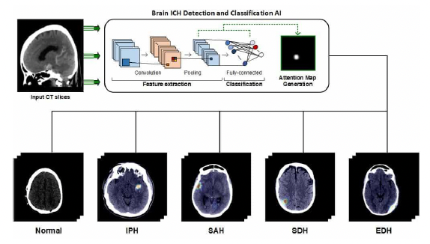
Figure 1: Workflow for ICH detection

RESULTS

In this study, the ResNet-152 pre-trained network was chosen as the neural network architecture for training the model. The ReLUactivation function was utilized, and the model was trained for 10 epochs using the Adam optimizer with a learning rate of 0.0001. The obtained results showed a training accuracy of 82.37% and a validation accuracy of 91.60%. Although the achieved accuracies are substantial, there is a need to further improve the model's performance to meet the desired target accuracy of 99%. As part of future work, additional optimization techniques can be explored to enhance the model's accuracy. This could involve experimenting with different optimizers, such as Stochastic Gradient Descent (SGD), RMSprop, and fine-tuning their hyperparameters. By carefully selecting and optimizing the optimizer, learning rate, and other hyperparameters, it is possible to achieve higher accuracies. This can involve conducting an extensive hyperparameter search or utilizing techniques like learning rate schedules, regularization, and data augmentation to further improve the model's generalization capabilities.
Furthermore, increasing the training duration beyond 10 epochs could potentially lead to improved accuracy. However, it is crucial to balance the training time with computational resources and prevent overfitting by monitoring the model's performance on validation data. By applying these optimization strategies, it is expected that the model's performance can be significantly enhanced, potentially achieving the desired target accuracy of 99% for accurately classifying head hemorrhage cases based on CT scan images.
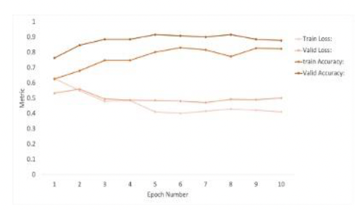
Figure 2: Training and testing accuracies

CONCLUSION

In conclusion, this research aimed to develop a neural network model for classifying head hemorrhage cases based on CT scan images. The ResNet-152 pre-trained network was utilized as the neural network architecture, and the model was trained using the Adam optimizer with a learning rate of 0.0001 for 10 epochs. The results obtained from the training process showed promising accuracies, with a training accuracy of 82.37% and a validation accuracy of 91.60%. However, further optimization techniques and hyperparameter tuning are required to achieve the desired target accuracy of 99%. Future work can involve exploring alternative optimization algorithms, such as Stochastic Gradient Descent (SGD), RMSprop, and fine-tuning their respective hyperparameters. Additionally, increasing the training duration, implementing learning rate schedules, regularization techniques, and data augmentation strategies can further enhance the model's performance.

