Introduction to Ethics
Summer Session A

Sam Berstler
Yale University
email: sam.berstler@yale.edu
phone: [removed]
website: campuspress.yale.com/samberstlerteaching/

Class time: T/Th 9 am-12:15 pm
Location TBD

Office hours: T/Th 2-4 pm and by appointment
Location: Bass Library foyer

Textbook and Website.

I will make sure that this textbook is available in the Yale bookstore, but I recommend that you purchase the electronic version, at a significantly reduced cost. Where possible, I’ll also make chapters available online.

The Routledge Companion to Ethics. Edited by John Skorupski. London: Routledge, 2010.

My website is campuspress.yale.edu/samberstlerteaching. The syllabus is hosted there, and as we get closer to May, I’ll host more supplementary class material there as well.

Prerequisites.

Absolutely none. This course will assume no background in philosophy or college-level philosophical writing.

Introduction.

The domain of inquiry. Ethical theory concerns itself with questions of rightness and wrongness, obligation and permissibility, moral decision-making, virtue, and so on. At its grandest and most ambitious, ethical theory tells us how to live and explain why we ought to live that particular way. Many of us engage in informal ethical theorizing all the time, when we think about what we ought to do, read about government policy, make major life decisions, or just ask abstract questions about “what it all means.” Philosophers of ethics pursue these kinds of questions systematically and rigorously.
We can distinguish three primary sub-branches of ethical theory. Meta-ethics investigates what we are doing when we make moral judgments. Are we giving our own opinion, are we expressing an emotion like commendation or disgust, or are we making a factual statement? Normative ethics tries to formulate general principles that govern whether an act is right or wrong and investigates the nature of rightness and wrongness. Applied ethics studies ethical conundrums associated with a specific empirical issue, like poverty, war, abortion, sexuality, and medical procedures. The majority of this course will concern itself with normative ethics but from time to time, we’ll venture into meta-ethics and applied ethics and discuss how the three fields interact with each other.

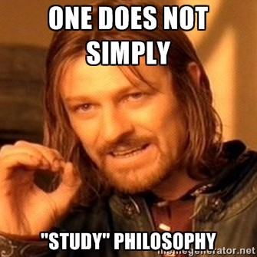
A skills-based approach to philosophy. Here’s what this class isn’t. We won’t be learning to persuade each other of our own viewpoints using rhetoric, statistics, public policy, or presentation skills. Nor is the aim of the course exclusively to figure out what your own positions on ethical theory are (although, of course, that is an important part of philosophical theorizing). In this sense, this course is very different from what you might have encountered in classes on debate, public speaking, or English composition.
This is an introduction to philosophical argumentation, with particular focus on ethical theory. As such, the emphasis will be on working with abstract, theoretical systems. We will learn how to construct a philosophical theory, what makes one theory better than another, how to object to theories, how to change theories, and what kinds of explanatory power philosophical theories ought to have. The primary way we will learn this is through the objection – reply – objection model. We’ll discuss a philosophical theory in broad terms. You’ll be invited to raise an objection to the theory. Then you’ll be asked to respond to your own objection, on behalf of a proponent of the original theory. Then you’ll be asked to object again to your own response to your objection. That might sound intimidating and heady right now, but as you gain practice in the method, you’ll find that it is an extremely exciting and dynamic way of engaging with philosophy.
This skills-based approach means this course will not only introduce you to the discipline of professional analytic philosophy but it will also increase the clarity and precision of your thought in both discussion and writing.

Course Objectives

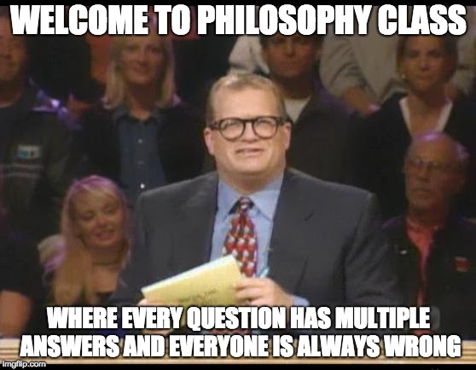
This course is an introduction to the method of analytic philosophical thought, with a particular focus on ethical theory. The student will hone her ability to:

- Identify assumptions within a theory
- Identify the problem the theory is attempting to solve
- Succinctly paraphrase the theory
- Demonstrate how different parts of the theory interact
- Raise further questions for the theory
- Object to the theory
- Defend the theory against objections
- Defend objections against the theory

In addition to aims (1-8), the student will also develop and refine a number of skills generalizable to all academic work, including the abilities to:

- Verbally deliver original thoughts
- Respond to interlocutors
- Practice the principle of charitable interpretation
- Write clear prose
- Identify thoughts worth developing into a paper
- Organize a paper

Format.

I’ll lecture for a while. Then we’ll have a seminar style discussion until the last half hour of class. Usually, we’ll spend the last half hour discussing how to prepare for and execute your papers.

Workload.

Participation 20%
Paper #1 20% due June 8 at 5 pm in my inbox
Paper #2 20% due June 15 at 5 pm in my inbox
Paper #3 40% due June 27 at 5 pm in my inbox

The first two papers will be 5 pages. I will give you prompts for the first two papers. The first paper will ask you to evaluate an argument and give one objection to the argument. The second paper will ask you to evaluate an argument, give an objection to the argument, and reply to the objection.

The third paper will be 7-10 pages. You will not have a prompt, but I will help each of you develop your own topic in office hours. In this paper, you will be asked to give an objection, a reply, and a second objection.

Writing will be evaluated for clarity, accuracy, and philosophical sophistication. The papers shouldn’t stress you out. We will spend time in class discussing what makes a good philosophical argument and looking at samples papers. You will also have plenty of chances to receive feedback on your writing.

Participation.

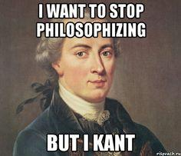
Participation in this course is qualitatively graded. This shouldn’t stress you out, but it does mean that you need to prepare for seminar discussion in advance. During the first week, I will talk about how to do this. Generally, it will mean reading the assigned reading three times: first, to get a feel for the reading; second, to work through the argument slowly and outline its major moves; and third, to develop objections and thoughts in response to it.

I know that participation is class can feel scary and overwhelming. For this reason, your participation towards the end of the class will count more than your participation in the beginning.

If you’re feeling intimidated or overwhelmed in seminar, please (!!!) email me or visit me in office hours, so that we can work together to develop strategies to help you feel comfortable and confident in class.

Office hours.

Please come visit me to discuss any aspect of the course or philosophy. See the header for details. A particularly good way to use office hours is to pay me a visit before your paper is due so that I can give you feedback on it. If you don’t feel comfortable visiting me in person, feel free to send me an email. You can also come to office hours with a friend or in a group.

Topics, Readings, Etc.

Week 1

Tuesday 28 May: Subjectivism, Relativism, Realism

Textbook Reading: None

Guiding questions: What is the difference between normative and descriptive claims? What are we doing when we say that
something is right or wrong? Is ethics a matter of mere opinion? Does what is ethical change from culture to culture or from time period to time period? Is ethics like science? What good are ethical intuitions?

General: What’s a philosophical argument?

Thursday 31 May: What is Good? What is Right?

Textbook Readings:
Chapter 54: “Welfare” (Heathwood)

Guiding questions: Is there a difference between what is good and what is right? What kinds of things to do we value? Why do we value them? What’s an intrinsic good? How do the things we value relate to our psychological states? Why do these questions matter for morality?

General: What do we look for in a good philosophical argument?

Week 2

Tuesday 5 June: Consequentialism

Textbook Reading:
Chapter 37: “Consequentialism” (Hooker)

Guiding questions: What is consequentialism? What are the different ways we can cash out consequentialism? What is the difference between pure act consequentialism and rule consequentialism? Classic puzzles including the trolley problem, the evil surgeon, and the drowning child.

General: What are the basics of a philosophy course paper?

Thursday 7 June: Deontology Part 1

Textbook Reading:
Chapter 38: “Contemporary Kantian Ethics” (Reath)

Guiding questions: What distinguishes deontology from consequentialism? What kinds of factors can explain deontology? What is Kantianism? Are genuine moral dilemmas possible? Is there a difference between doing and allowing? Classic puzzles including the trolley problem, the evil surgeon, and the drowning child.

General: What are the basics of a philosophy paper?

First paper due Friday 8 June by 5:00 pm

Week 3

Tuesday 12 June: Deontology, part 2

Textbook Reading:
Chapter 56: “Rights” (Campbell)

Guiding questions: What distinguishes deontology from consequentialism? What kinds of factors can explain deontology? What is Kantianism? Are genuine moral dilemmas possible? Is there a difference between doing and allowing? Classic puzzles including the trolley problem, the evil surgeon, and the drowning child.

General: What makes a good objection?

Thursday 14 June: Virtue Ethics
Textbook Readings:
Chapter 40: “Virtue Ethics” (Slote)

Guiding questions: What is virtue? What is unusual about virtue ethics? Can virtue ethics explain obligation? Is virtue ethics too demanding?

General: What makes a good objection?

Second paper due Friday 15 June by 5:00 pm

Week 4

Tuesday 19 June: Contractualism
Textbook Readings:
Chapter 41: “Contractualism” (Kumar)

Guiding questions: What is justice? What is fairness? Why does deliberation matter? Does it matter that this deliberation is hypothetical or counterfactual? Who are the deliberators? What is the process of deliberation?

General: What does a research paper look like in philosophy?

Thursday 21 June: Responsibility
Textbook Readings:
Chapter 50: “Responsibility: Intention and Consequence” (Uniacke)

Guiding questions: What kinds of things are and aren’t we responsible for? What is moral luck? How much do our intentions matter? How much do consequences matter? How does our theory of responsibility relate to our theory of rightness and wrongess?

General: What does a research paper look like in philosophy?

Week 5

Tuesday 26 June: What’s the point of ethics?
Textbook Readings:
None.

Guiding questions: What should an ethical theory do? What kinds of questions do we want an ethical theory to explain? What are the difficulties of ethical theorizing? How does our theory of ethics help us figure out what to do in the world? Do we need an ethical theory to live a good life? Why do so many professional ethicists do bad things? Does being a good person matter for philosophizing about ethics?

Third paper due Wednesday 27 June by 5:00 pm

Thursday 28 June: Ethics challenge
You’ll work in teams to use normative philosophy to debate issues in applied ethics.

