Consequentialism: A Guide
Sam Berstler * Phil 175 * 5 June 2018

This guide is developed to help you understand Brad Hooker’s chapter, “Consequentialism,” in The Routledge Companion to Ethics. I’ve simplified and condensed much of what Hooker has said. I have also added some classical objections that Hooker does not discuss. We will be discussing this on 5 June 2018.

What is consequentialism?
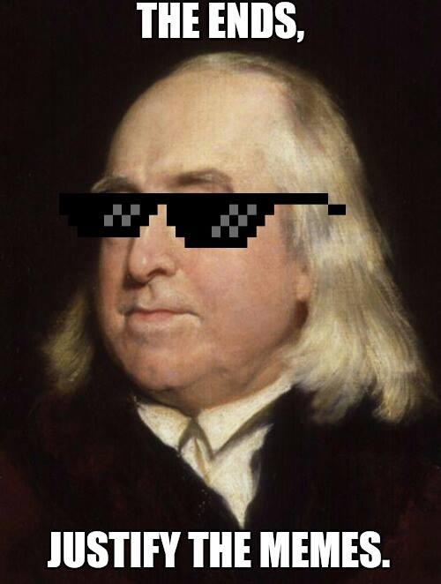
Strictly speaking, a theory is consequentialist just in case it explains or evaluates its target in terms of consequences. For our purposes, consequentialism is the view that an action’s consequences determine the action’s moral status.

Notice that we still haven’t specified what kinds of consequences matter. We will here only consider welfare consequentialism, the view that we should morally evaluate an action according to how much welfare the action causes or eliminates. This is also sometimes called utilitarianism.

From here on out, when I use the word “consequentialism” I will mean “welfare consequentialism.”

Rightness flows from goodness

According to the consequentialist, what we ought to do, what the right act is, what we have categorical reason to do is a function of how much goodness for us (welfare) our act creates or eliminates.

How much welfare matters?

According to maximizing consequentialism, we ought to perform the act that leads to the most overall welfare.

According to satisficing consequentialism, we ought to perform the act that leads to a sufficient degree of welfare. Since there is usually only one (or in the case of a tie, a few) acts that maximize welfare, but there are plausibly many acts that lead to a sufficient degree of welfare, satisficing consequentialism gives us many more options for what we ought to do.

According to desert-based consequentialism, we ought to perform the act that leads to people receiving the amount of welfare they deserve.

According to scalar consequentialism, it is a mistake to talk about what we morally ought to do. We can only rank acts. For example, we can say that it would be better to maximize outcomes, and that an outcome that leads to a 50 percent increase in welfare is better than an outcome that leads to a 10 percent increase in welfare. But we can’t say that any such act is required.

How do we calculate the overall welfare?

Consequentialists typically assume an agglomeration principle for welfare. They think that we can calculate the total overall welfare of an act by:

- finding the welfare of each relevant individual before the act
- finding the welfare of each relevant individual after the act
- finding the difference
- summing the difference

Once we have this procedure, we can ask two further questions: for the purposes of determining what we ought to do: (a) which individuals should we include in our calculation; (b) how much should we weigh the welfare difference associated with any individual.

Whom should we include?
- Egalitarianism: we should include everyone in our calculation
- Egoism: we only include ourselves in our calculation
- Altruism: we should include everyone except ourselves in our calculation

How should we weigh their welfare?
- Impartialism: we should weigh equally the welfare of everyone included
- Agent-relative partialism: we should weigh unequally the welfare of everyone included. We determine the weight we assigned by considering the person’s relationship to us. For example, we might weigh more heavily our own welfare or we might weigh more heavily the welfare of those who stand in special relationships to us, such as our children or parents.
- Agent-neutral partialism: we should weigh unequally the welfare of everyone included. However, we determine the weight we assign without making reference to the relationships we have. For example, we might weigh more heavily the welfare of good people.

We call egoism, altruism, and agent-relative partialism forms of agent relative consequentialism, because in order to calculate the overall welfare, we need to consider the relationship each agent has relative to us.

Distribution of welfare

Remember that the consequentialist posits exactly one moral principle: we ought to do the act that maximizes welfare.

But some impure consequentialists want to posit more than one moral principle: we ought to do the act that maximizes the welfare and we ought to do the act that promotes the distribution of welfare in a particular way. Impure consequentialists will need to give us a decision procedure for when maximizing the welfare and promoting the distribution of welfare conflict.

Equality impure consequentialists: Equality of distribution is itself good. So we have a moral principle that tells us that we ought to equalize welfare.

Prioritarian impure consequentialists: We should seek to improve the welfare of the worst off before we improve the welfare of anyone else. So we have a moral principle that tells us that we ought to promote the welfare of the least well-off person.

Threshold impure consequentialists: We only care about improving the welfare of the worst off when they are below a certain threshold for wellness. So we have a moral principle that tells us that if any group of people are below a particular threshold, then we ought to promote the welfare of the least well-off person among that group.

Dealing with the uncertainty of outcomes

Consequentialism must confront the problem that we often aren’t sure what outcomes our acts will have. Furthermore, when we anticipate the outcomes, we often get it wrong. There is an expression: “People make plans, and God laughs.” We might amend it: “People calculate their acts’ outcomes, and God laughs.”

There are typically two ways of dealing with this problem:

Subjective Consequentialism: This consequentialist amends her moral principle. She says that we ought to do the act that we believe will maximize the overall welfare (or insert whatever other principle you like).

Distinguishing blame and rightness: This consequentialist does not amend her moral principle. However, she says that as along as someone does the act that she believes will maximize the overall welfare (or insert whatever other principle you like), we don’t blame that person if she inadvertently does the wrong thing.

Making decision in real time

Consequentialism must also confront the problem that, in real time, we often simply can’t calculate what outcomes our acts will have. So how should people try to figure out what to do in real time?

Notice that this is a moral question, so the consequentialist need only appeal to her moral principle to answer it. People ought to figure out what to do in a way that leads to the best overall outcome.

This is an empirical matter, but many philosophers are drawn to the existence of deontological heuristics. The idea is that the overall welfare is maximized when we rely on rules of thumb like “Don’t kill people.” Of course, these are just rules of thumbs. In a case like the trolley problem, the rules of thumb might fail, and we ought to disregard them. Furthermore, because they are just rules of thumbs, an act isn’t right because it accords with the rule of thumb. An act is right because it maximizes the welfare (or whatever).

Rule-consequentialism is not, despite its name, a form of consequentialism, and I am mildly irritated that Hooker includes it here. Rule-consequentialism, in fact, is not even a theory about our moral principles. The rule-consequentialist is a theory about the foundations of our moral principles and, as such, is not part of the primary subject matter of this course.

Well-known problems for consequentialism

These are famous problems for some views of consequentialism. Ask yourself whether all consequentialists face these problems or whether some of the variants discussed above can circumvent them:

- The Movie Ticket. I decide to spend $10 on a movie ticket to see the new Star Wars movie. I could have spent that money by donating it to an overseas charity. While it might have been praiseworthy for me to have donated the money, it still seems too extreme to say that I did something wrong. But this is just what many forms of consequentialism predict.

- The Fat Man. You’re on a bridge overlooking trolley tracks with Arnold Schwarzenegger. You see that five people are tied to the tracks. The only way to stop the approaching trolley, and save these people’s lives, is to push Arnold off the bridge. The trolley will run over Arnold and stop, killing Arnold but saving five lives. Many people intuit that we shouldn’t push Arnold. But this is just what many forms of consequentialism predict we should do.

- Chop Up Chuck. This is a variant of the fat man case. You are a surgeon, and you have five patients who will certainly die if they do not receive an organ transplant. You have a patient who comes in for a routine check-up. If you kill this patient, you can use his organs to save the other five patients. Let’s further stipulate that no one will ever know that you do this. Many people intuit that the doctor shouldn’t cut up the patient. But this is just what many forms of consequentialism predict the doctor should do.

- The Angry Mob. Another variant on the fat man case. You are a cop in a precinct in which a terrible crime has been committed. Everyone is angry, and if a suspect isn’t caught and punished, you know that the mob will riot, killing many people. You realize that you are in a position to manufacture damning evidence against a random person, ensuring that she is caught and convicted for the crime that she did not commit. Let’s further stipulate that no one will ever know that you did this. Many people intuit that the cop shouldn’t frame an innocent person. But this is just what many forms of consequentialism predict that cop should do.

