Brief Notes for beginning of 4/19 meeting
-examples: Reid’s case of seeing one’s fingers and a distant wall; bent oar illusion vs. moon illusion
-Key idea of Reid’s philosophy of perception: We perceive a material world (we come to have conceptions and beliefs about material objects having various properties) by means of sensations that are not at all like the material objects we perceive, nor do we take them to be at all like the material objects we perceive
-Terms Reid uses for the relation in our ordinary thought between sensations and those properties of bodies that the sensations cause us to believe in:
-sensations are signs (natural signs, of the 3rd type) for the properties they indicate
-we confound sensations with the properties they indicate
-remarks on the organization of the Inquiry and the challenge of the sense of sight
-a few introductory remarks about Shepherd. A key idea for Shepherd: We perceive material objects by means of “latent reasoning” from our sensations
-Central case of perception for Reid’s theory: perception of primary qualities by sense of touch

4/21
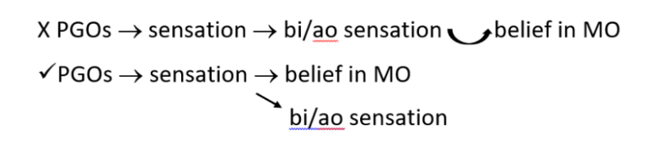
Question: Why might one think that if we are to know / be justified in believing in MOs, this must come by way of inference from our sensations?
- Beliefs about what sensations we’re having and what they’re like is all we’re given by nature, before we start inferring
- Even if we arrive at belief in MOs by a non-inferential “natural instinct,” that belief would depend for its rational justification (and for its attaining the status of knowledge) on our having a good reason for accepting it—a reason drawn from a source we are justified in trusting: Reason or Consciousness

