Phil. 270/570, 3/5: Conservatism, Part 3: “Seems” / Regress and Evidentialism / Dogmatism

1. (point 2 on 2/28 handout) A general account of “seems” and “appears”: KDR, 3H, pp. 27-28 (incl. notes)
2. The Regress Argument, from a general evidentialist requirement
3. Evidentialism and Conservatism, given the propositionality of evidence
4. What is dogmatism?
-James Pryor, “The Skeptic and the Dogmatist,” Noûs, 2000
-Broad vs. narrow dogmatism
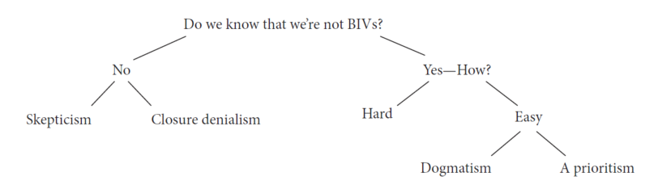
(App. of Ig, p. 231)
-Siegal’s characterization: S, p. 208t
-need to specify the nature of some of the p’s: perceptual beliefs about the external world
-and some of the things that don’t count as defeaters: skeptical hypotheses, in normal circumstances

