3/9/17: Reid (reading #13), Appearances (reading #14) Phil. 270
Reid on the process by which we come to believe in material objects
-terminology: “material object” vs. “physical object”/“body”. Question: How, oh how, can we ever be justified (ordinarily?, philosophically?) in accepting/believing that there are material objects?
-How, according to Reid, his predecessors saw the process by which we come to believe in MOs (Reid may be roughly right about Berkeley)
-Reid’s own account of the process
-some of Reid’s predecessors may largely agree with him on the process (or be willing to grant him his account), but disagree with him about the epistemological evaluation of beliefs so arrived at (they thinking they are not/would not be rationally justified), and are instead proposing an account of how beliefs in m.o.s could be (not-so-naturally) arrived at so as to be justified
Reid on the epistemic evaluation of our beliefs in material objects
-Berkeley’s “epistemological argument” (as an example of evidentialist arguments) and the evidentialist requirement
-Reid’s conservative/i-u-p-g account and his rejection
-Reid’s “argument for trust”: Reid’s conservatism vs. “thorough and consistent skeptics” and “semi-skeptics”
Conservatism vs. Evidentialism
-Conservatives like Reid (and Huemer, whose spat with BonJour eerily recreates Reid’s 18th Century debate with his foes) like to see their opponents not only as “semi-skeptics,” but also as (what is really the flip-side of the same coin) “semi-conservatives”: as (arbitrarily) choosey conservatives.
-But their opponents may well instead view themselves as something very different: as evidentialists: “No, I’m not picking some natural sources of belief to get some kind of favored status. I don’t care about any natural sources of belief, how things appear to me, or anything like that. For me, rational justification results from having beliefs that are supported by one’s evidence!”
I fight this out with Descartes (or his ghost) in the long footnote (#30) on the bottom of p. 46 (spilling over a bit to the bottom of 47) of reading #22.
Appearances: “appears” and “seems” claims
-appearance claims seem (!) to me to report inclinations to believe: “It appears that p” seems to mean something like: At stage S of cognitive processing, I’m inclined to believe that p (where S can vary with context)
-Huemer’s case against appearances being inclinations to believe: paragraph fully on p. 31
-I think we should treat Huemer’s key case as one of a resisted inclination
-Two appearance claims (& the Müller-Lyer illusion)
-Two special cases: “all-in” and “personal all-in” uses of “appears”
-“I’m inclined to believe”?, or “we”?: “seems” as an appeal
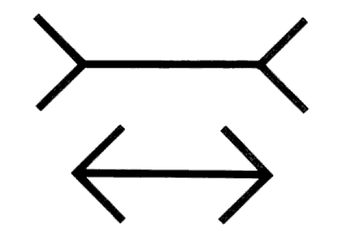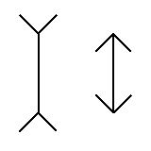
Berkeley’s epistemological argument: A Treatise concerning the Principles of Human Knowledge [Principles, 1710], Part I, sects. 18-20

18. But, though it were possible that solid, figured, movable substances may exist without the mind, corresponding to the ideas we have of bodies, yet how is it possible for us to know this? Either we must know it by sense or by reason. As for our senses, by them we have the knowledge only of our sensations, ideas, or those things that are immediately perceived by sense, call them what you will: but they do not inform us that things exist without the mind, or unperceived, like to those which are perceived. This the materialists themselves acknowledge. It remains therefore that if we have any knowledge at all of external things, it must be by reason, inferring their existence from what is immediately perceived by sense. But what reason can induce us to believe the existence of bodies without the mind, from what we perceive, since the very patrons of Matter themselves do not pretend there is any necessary connexion betwixt them and our ideas? I say it is granted on all hands (and what happens in dreams, phrensies, and the like, puts it beyond dispute) that it is possible we might be affected with all the ideas we have now, though there were no bodies existing without resembling them. Hence, it is evident the supposition of external bodies is not necessary for the producing our ideas; since it is granted they are produced sometimes, and might possibly be produced always in the same order, we see them in at present, without their concurrence.

19. But, though we might possibly have all our sensations without them, yet perhaps it may be thought easier to conceive and explain the manner of their production, by supposing external bodies in their likeness rather than otherwise; and so it might be at least probable there are such things as bodies that excite their ideas in our minds. But neither can this be said; for, though we give the materialists their external bodies, they by their own confession are never the nearer knowing how our ideas are produced; since they own themselves unable to comprehend in what manner body can act upon spirit, or how it is possible it should imprint any idea in the mind. Hence it is evident the production of ideas or sensations in our minds can be no reason why we should suppose Matter or corporeal substances, since that is acknowledged to remain equally inexplicable with or without this supposition. If therefore it were possible for bodies to exist without the mind, yet to hold they do so, must needs be a very precarious opinion; since it is to suppose, without any reason at all, that God has created innumerable beings that are entirely useless, and serve to no manner of purpose.

20. In short, if there were external bodies, it is impossible we should ever come to know it; and if there were not, we might have the very same reasons to think there were that we have now. Suppose- what no one can deny possible- an intelligence without the help of external bodies, to be affected with the same train of sensations or ideas that you are, imprinted in the same order and with like vividness in his mind. I ask whether that intelligence hath not all the reason to believe the existence of corporeal substances, represented by his ideas, and exciting them in his mind, that you can possibly have for believing the same thing? Of this there can be no question- which one consideration were enough to make any reasonable person suspect the strength of whatever arguments be may think himself to have, for the existence of bodies without the mind.

