3. Bavarian Appropriations of a French Ornament

1. What made a creation such as the pulpit in Oppolding possible? There is of course no simple answer. A great many things had to come together. In the course of this seminar I shall touch on quite a number of these presuppositions. But this much at least is clear: the creator of the pulpit must have acquired an extraordinary facility working with stucco. He also must have made the style rocaille his own. Where did he learn his craft? And where did he acquire his mastery of an essentially French style? Let me begin with the first question.
I mentioned that Johann Anton Bader, like so many craftsmen of the period, followed in the footsteps of his father, a stuccoer, who in turn was following his father. Johann Anton Bader was indeed the last of five generations of generations of Baders who practiced this trade.
The family tree is of some interest and should help orient you.

Jakob(1)

Isaak (1 ) Melchior
/ /
Wilhelm Jakob(2) Kaspar Isaak 2 Konstantin / /
Pankraz? Johann Georg Alexius Georg Josef Johann (1) Tobias
/
Johann Anton

2. As is so often the case when studying the Bavarian Rococo, the story of the Bader (or Pader) clan, too, has its beginning in Wessobrunn, this village, or rather collection of scattered farms at the heart of what was even then called the Pfaffenwinkel, the priests corner, SW of Munich, within walking distance of a half dozen of the masterpieces of the Bavarian Rococo. In the 18th century his sprawling collection of farms was presided over by a splendid Benedictine monastery. Most of it, including its church was to become a victim of the fervor of the Enlightenment. We get an impression of its former splendor by this engraving dating from 1700 by Michael Wening. (Fig. 1) The author of the represented master plan was Johann Schmuzer, who was at the time the

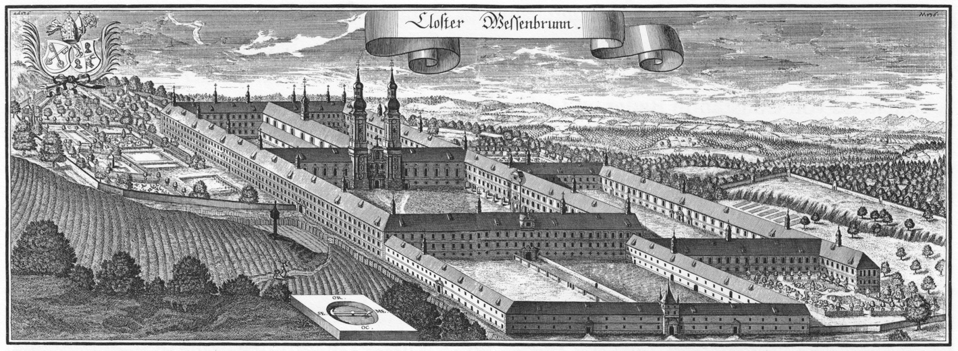

Fig. 1. The Monastery of Wessobrunn by Michael Wening, 1700.

monastery’s architect. The plan deserves a careful look in that it gives us an idea where the Bavarian monasteries looked for a model: to Spain, to the Escorial (Fig. 2), both monastery and royal residence, which in turn looked for its model to Solomon’s temple

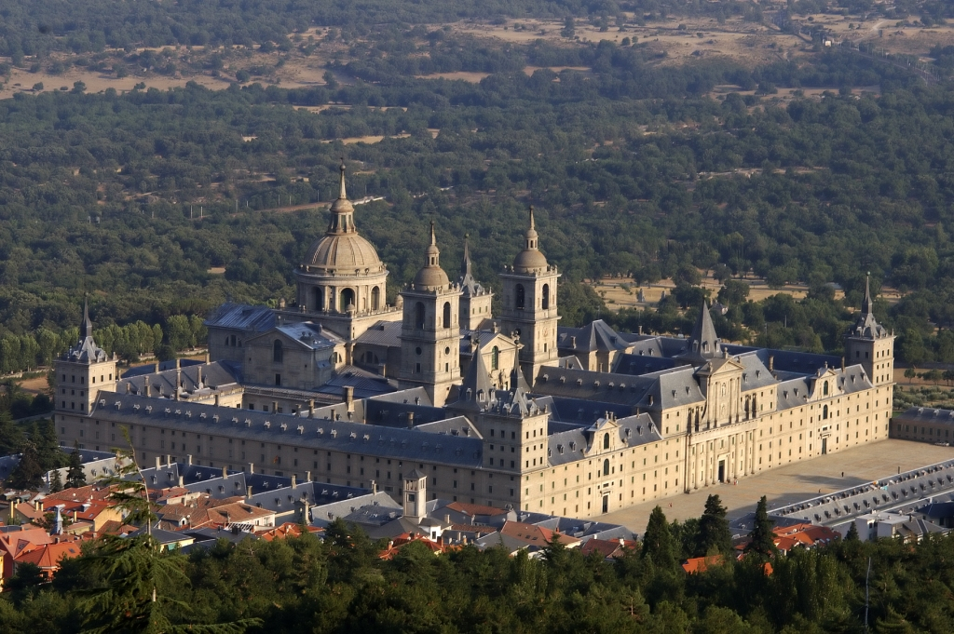

Fig. 2 Escorial, Juan Bautista de Toledo, Juan de Herrera, 1563ff.
in Jerusalem. Since that temple was supposed to have been built on a plan finally

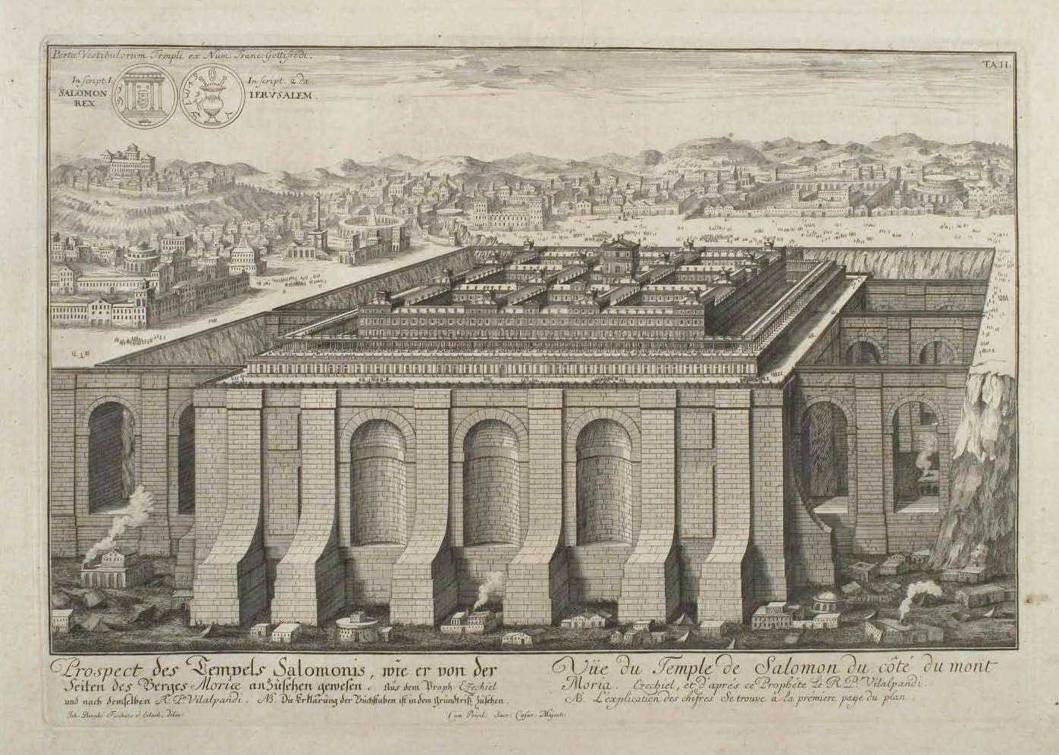

Fig. 3. Fischer von Erlach, The Temple of Solomon, Jerusalem, Entwurf einer historischen Architektur, 1721
authored by God, it was widely thought of as an ideal that should guide sacred architecture. Speculation concerning how it might have looked was at the very center of the architectural theory of the Baroque. (Fig. 3) And the abbots of the large monasteries of southern Germany did indeed have good reason to think of themselves as both spiritual shepherds and worldly rulers in the image of Solomon.
The master plan of Wessobrunn was never fully realized and of what was actually built today only fragments remain — three quarters of the buildings were torn down in 1810, including what must have been an especially splendid abbey church, the work of Johann Schmuzer’s son and successor as the monastery’s architect Josef Schmuzer, who was also responsible for the interior of Rottenbuch (Fig. 1,5), although the church in Wessobrunn was rebuilt already in 1721-1724 and its decoration would have been more like that of the abbey churches in Weissenau and Weingarten (Fig. 9), for which his brother Franz was responsible.
The abbey church in Wessobrunn, too, was torn down by the by the newly enlightened Bavarian government. In its appropriation of church property, their secularization, it was encouraged by a France that under Napoleon had annexed all German territories west of the Rhine, including the Rhenish Palatinate, which had been ruled by the Bavarian House of Wittelsbach. Napoleon now encouraged the Bavarian elector Max IV Joseph, who, with his support was to become king Max I Joseph in 1806, to seek compensation by appropriating the vast land holdings and other assets held by the Catholic church. In 1803 the assets of all bishoprics and monasteries were thus taken over by the Bavarian government. Although driven first of all by financial considerations, such secularization was also supported by the enlightenment conviction that religion needed to rid itself of the kind of superstition and ostentation that the monasteries especially were thought to have encouraged with their images and art. What do such extravagant expenditures contribute to the public welfare? What need was there for such a big church? Was the small village church that was spared not quite sufficient?

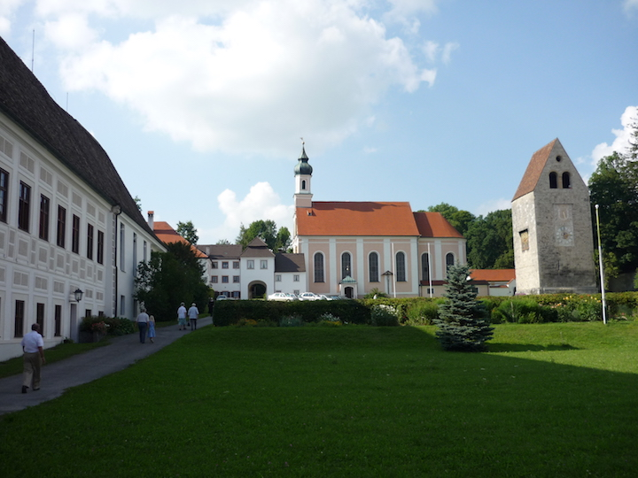

Fig. 4. Wessobrunn
(Fig. 4) In this connection you may want to read what Kant had to say about religion and superstition. He would hardly have objected to the secularization of church property.
What remains today of the monastery — perhaps a quarter of the original buildings, the small village church, and a Romanesque tower, together with many of the 18th century farm houses — hints at a world that has perished. Much of what has survived remains significant, especially the Fürsten- und Gästetrakt, the part of the monastery meant to house visiting princes and guests, with its characteristic leafy stuccoes. (Fig. 5)

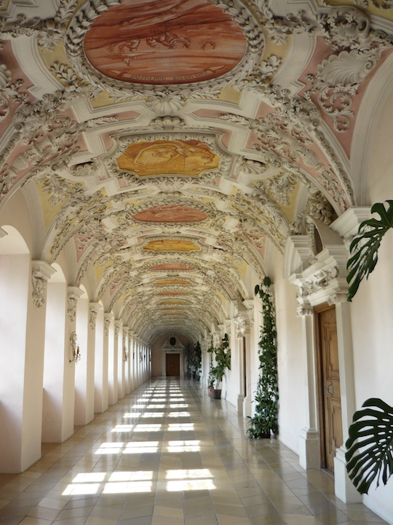

Fig. 5. Wessobrunn, Fürsten- und Gästetrakt, Johann Schmuzer, ca. 1690

In just about every year from the mid-seventeenth to the late 18th century
some building activity took place either in the monastery or in one of the many churches that belonged to it. This provided employment, but also served the monastery’s attempt to systematically train its subjects in the highly profitable building trades.
The phenomenon of Wessobrunn leads us to the very center of the artistic culture of the Bavarian rococo. Its destruction also casts light on the end of this style and the forces that helped bring it about. Thus it casts light on the collision of Catholicism and Enlightenment. And it casts light still on today’s Bavaria and its special place in Germany: what the Catholic church and more especially the Benedictine order contributed to the evolution of Bavaria can scarcely be exaggerated.
As already mentioned, the monastery of Wessobrunn supported the building trades, and not just with commissions, but also by keeping its craftsmen in touch with the most recent developments in Italy and France. For most of the 17th and 18th centuries Wessobrunners, mostly masons and stuccoers, but also sculptors and painters, travelled all over Central Europe and beyond, working e.g. in Paris and Moscow, spending only the winter months at home. Well over six hundred names have been recorded. Their absence from home during the summer months is reflected in the birth statistics. To most of the masterpieces of the German Rococo, whether churches, such as Balthasar Neumann’s Vierzehnheiligen, with which I began this seminar (Fig. 1, 1), or palaces, such as Fredrick the Great’s Sanssouci in Potsdam, Wessobrunners made significant contributions. The brothers Johann Baptist and Diminikus Zimmermann, the creators of die Wies (Fig. 1, 2) and perhaps the central figures of the Bavarian rococo, were born and trained in Wessobrunn. I shall have much more to say about them and other Wessobrunners in the following sessions.
The significance of the rural Wessobrunn helps to remind us that the culture that supported the art of the Bavarian Rococo had its roots in the peasantry and was sustained by the Church, especially by the monasteries, and, more especially still, by the Benedictine order, a culture, still medieval in many ways and very different from that of the mostly Protestant parts of Germany, where the cities came to be more important as the carriers of culture, a culture that was word- rather than eye-centered. The future was to belong to this Protestant culture, which in the 18th century began to assert itself ever more forcefully in the German speaking world, especially in such cities as Leipzig, which liked to think of itself as a little Paris, in Hamburg and in the Swiss Zürich. This was a culture supported by an increasingly self-confident bourgeoisie that looked to Holland, France, and increasingly to England for its models, rather than to Italy or Spain. Kant belonged to this culture and he shared its suspicion of what was considered superstitious Catholicism.
The monastery of Wessobrunn was founded in 753. Soon after that the oldest German literary text, the prayer of Wessobrunn was written down there. In Bavaria these monasteries played the part of urban centers. They provided for both body and soul, offered schooling, medical care, banking, police functions, and saw to it that everyone was employed. To that end they fostered professional training. As mentioned, in Wessobrunn the focus was on the building trades.

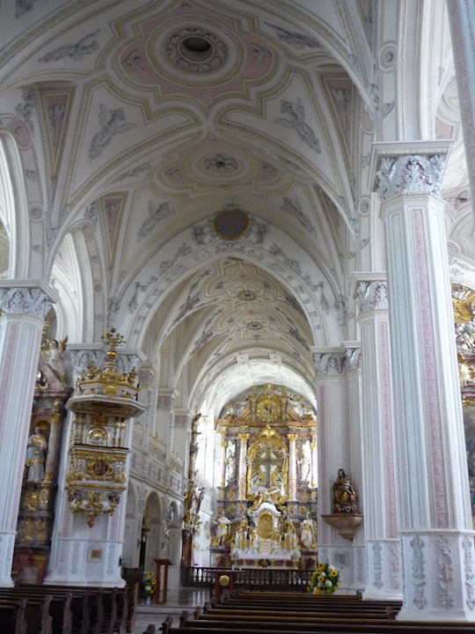

Fig. 6. Polling, Augustinian Abbey Church Heilig Kreuz, Stucco Work by Georg Schmuzer, 1621-27
3. The most significant of the Wessobrunn families were the Schmuzer. Beginning in the late 16th century, we can trace six generations of stuccoers and builders. An early example is provided by the decoration Georg Schmuzer created for the Augustinian monastery of Polling, not far from Wessobrunn, in 1621/27. He was working under the direction of Hans Krumper from nearby Weilheim, who had risen to become the leading sculptor and artistic voice at the court in Munich, where in the wake of the Counter-Reformation one was looking to Italy and Spain for religious and artistic leadership.
But let us take another look at the kind of ornament still found in what remains of the monastery and for which the Wessobrunners became famous. (Fig. 7) Wessobrunn’s

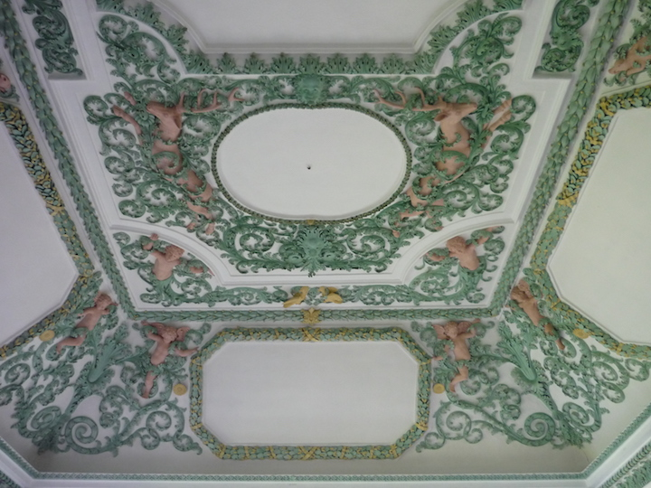

Fig. 7. Wessobrunn, Aula Tassilonis, Johann Schmuzer, 1699/1700

Aula Tassilonis (1699/1700) provides a good example, where we should not forget the now missing paintings, victims of the secularization. Ornament here mediated between painting and architecture. That mediating function helps to explain the significance of figural ornament, where we should note the attraction to plant and animal forms, so characteristic of Wessobrunn decoration. This is ornament that does not just frame pictures, but mediates between supporting ceiling and painting. Instead of just serving the supporting architecture, ornament here almost elides it. Such elision of architecture will become a significant characteristic of rococo ornament. There is a sense in which such ornament is anti-architectural in its very essence, something that was to profoundly disturb defenders of the Enlightenment.
How the stuccoers from Wessobrunn used the acanthus ornament just after the death of Johann Schmuzer in 1701 is shown by this detail from the church in Kaufering

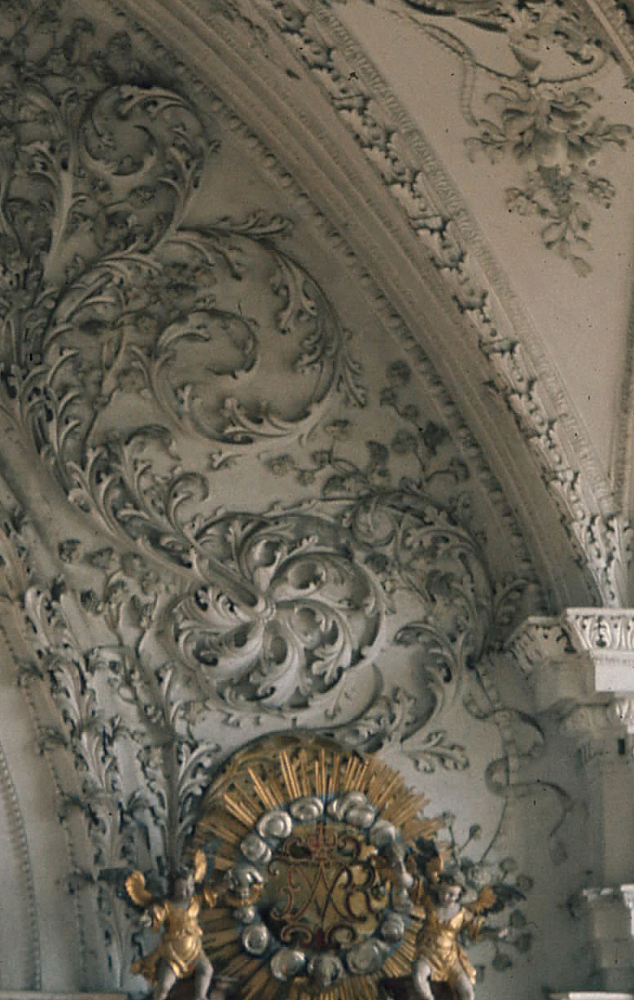
Fig. 8. Kaufering, John the Baptist, Stucco Detail, ca. 1704

(Fig. 8). The stuccoer responsible for these elegant forms was probably Johann’s son Joseph, who three decades later was to create the decoration of Rottenbuch, although the execution there was left to his assistants, especially to his son Franz Xaver. (Fig. 9) With

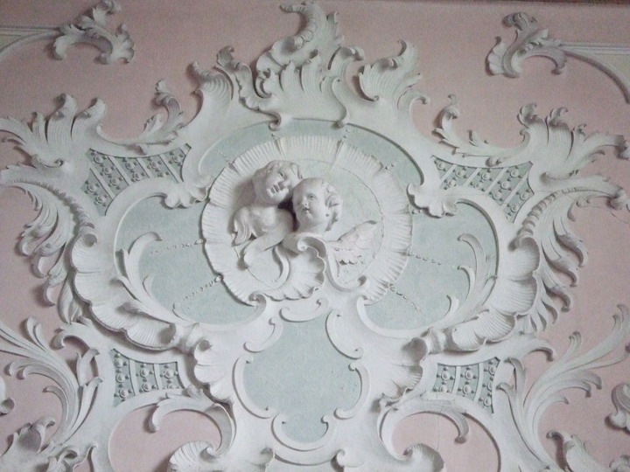

Fig. 9. Rottenbuch, Stucco Detail, 1737 ff.

the decoration of Rottenbuch we are at the beginning of the mature Rococo: rocaille is already clearly present. The acanthus ornament in Kaufering, on the other hand, is still Baroque and yet Baroque foliage here has lost its heaviness; it has become more elegant, linear and dynamic. One senses the coming of the Rococo.
Between these two examples lies the impact of the Régence style, a style that originated in France during the regency (1715–23) of Philippe, duc d'Orléans, but has
earlier roots, as demonstrated by this arabesque by Jean Bérain (ca. 1690). (Fig. 10)

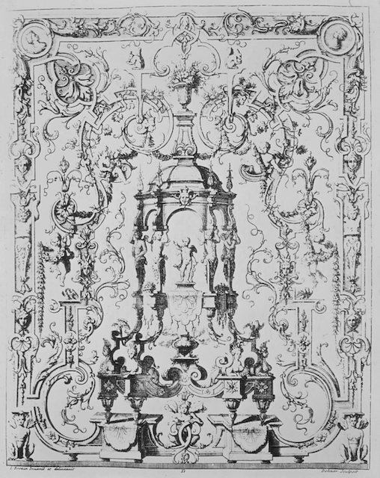

Fig. 10. Jean Berain, Arabesque, ca. 1690

Important is the transformation of bands into vines, of two-dimensional into three-dimensional elements and the implied subversion of the pictorial logic that presided over painting.
That the Bavarians would have found this new fashion appealing is not surprising, given the use of the acanthus motif in Kaufering. Consider the stuccoes Joseph’s brother Franz created in the Benedictine abbey church of Weingarten in 1718-25 (Fig. 10).
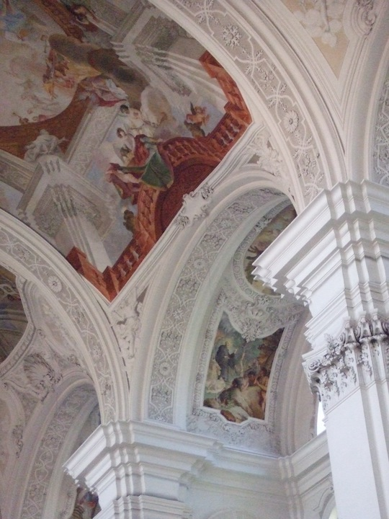

Fig. 10. Weingarten, Benedictine Abbey Church St. Martin and Oswald, Stucco
4. But let me leave the Schmuzer clan for the time being and return to the Bader clan, to which the creator of the Oppolding pulpit belonged. As I pointed out already, its story, too, begins in Wessobrunn, with the mason Jakob, born ca. 1544. Joined by two sons, Melchior and Isaak, he moved to Munich, where new building projects, especially the building of the Jesuit church and the associate college of St. Michael offered unusual opportunities to skilled masons and stuccoers. As far as influence is concerned, this was the most significant church built north of the Alps since the Counter-Reformation. With it the Jesuit order gave its militant spirituality a particularly striking expression. (Fig. 11)

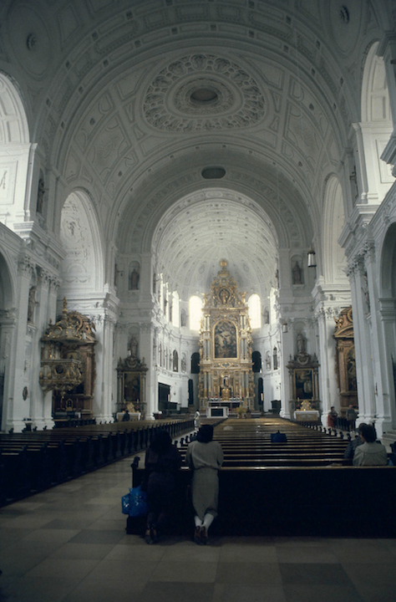

Fig. 11. Munich, St. Michael, 1583-97

The fact that it was built in Munich was no accident: The Bavarian dukes were the Holy Roman Empire’s most committed defenders of the Catholic faith. Duke Maximilian’s vigorous defense of Catholicism in the Thirty Years War (1618-48) was indeed to have much to do with the fact that Germany and Austria did not become totally Protestant countries in the first half of the 17th century.
In St. Michael the craftsmen from Wessobrunn could acquaint themselves with an altogether new approach to church architecture and a Flemish-Italian mode of decoration that had left behind the medieval past. But the Bavarians tended to put that language to an interestingly different use. Thus while in St. Michael ornament most definitely serves the ornament bearer, re-presenting the structure of this space, while also suggesting its spiritual significance, in Bavarian work ornament often refuses such service, to serve the work’s spiritual significance all the better.
Especially the sons of Jakob Bader did well for themselves in the Bavarian capital, even in the difficult years of the Thirty Years War, working for both city and court, both as stuccoers and as masons, Isaak rising even to the position of court architect.

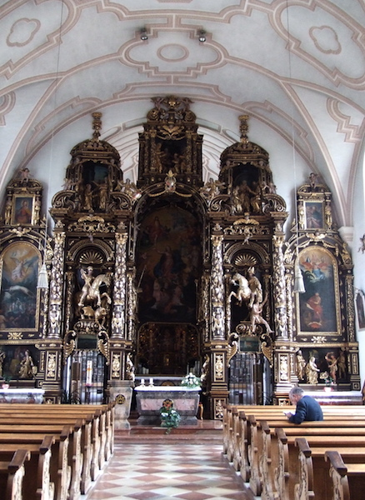

Fig. 12. Sammarei, 1628-31, Isaak Bader

He was the architect responsible for such significant works as the trefoil choir of Munich’s St. Peter and the pilgrimage church Sammarei (1628-31), which is only slightly later than Jörg Schmuzer’s more ambitious refurbishing of Polling, both created while the Thirty Years War was still raging. (Fig. 12) The ornament here most definitely
does not help to articulate the nave’s division into bays; instead it engages it in an almost contrapuntal manner. Note the way the stucco decoration relates to the vault and meets the choir arch. The figures formed by the molded frames are here almost brutally cut in half. Why did the Bavarians embrace what might seem an easily avoided problem? Why did they not articulate the organization of the nave more clearly with rib bands separating its different bays? The same questions are raised already by the net vaults of many late Gothic village churches. So one answer is that the sensibility of the Bavarian stuccoers remained close to that of the creators of these Gothic vaults, even as they were embracing a new artistic language. In his Principles of Art History Heinrich Wölfflin’s opposes a concern with multiplicity to a concern with unity: the former seeks to build up the artistic whole out of distinct parts, while the latter seeks to subordinate the parts to a more organic whole. Throughout the centuries Bavarian architects and decorators, much more than their Italian counterparts, were drawn to the latter, supporting Wölfflin’s generalizations.
What is the significance of the persistent contrapuntal dialogue between architecture and ornament? As we shall see, this dialogue will be raised to the level of great architecture, especially by the Dientzenhofer brothers and by Balthasar Neumann — as in Vierzehnheiligen (Fig. 1, 1), with which I began this seminar. Creations such as Sammarei cannot claim such significance. They remain of interest mostly to those living in the area and to historians of Bavarian architecture.
Isaak's son, also named Isaak, followed in his father's footsteps, but never could match the successes of his cousin, Melchior's son Konstantin, who as sculptor, stuccoer, and architect established an enormously successful practice, first in Dachau, later in
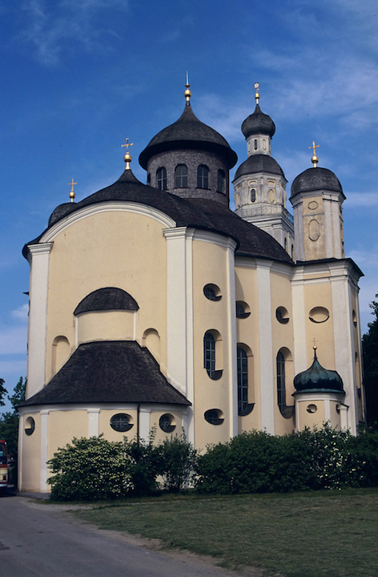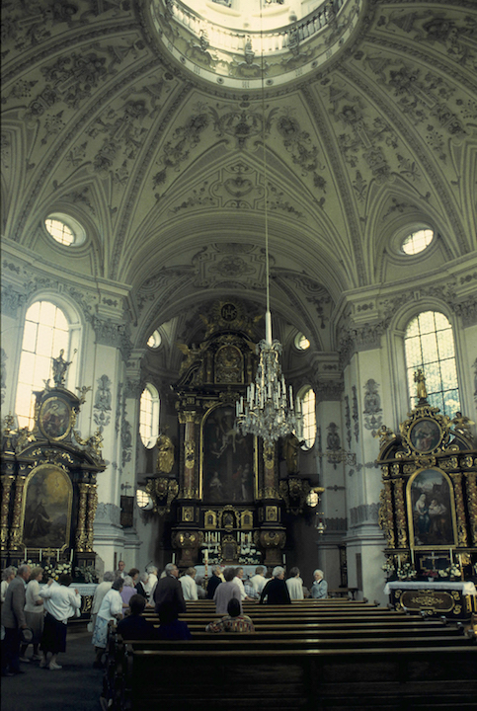
Fig. 13. Maria Birnbaum, Konstantin Pader, 1661-1668

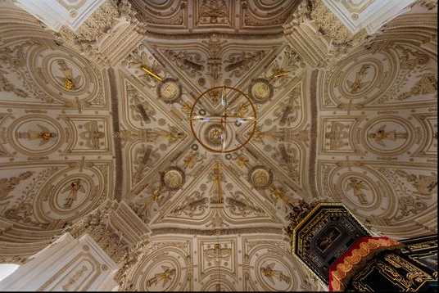
Fig. 14. Westerndorf, Heilig Kreuz, Konstantin Pader, 1668-1671 (Fotocommunity)
Munich, where he was received into the sculptor's guild. The works for which he is best know today include the pilgrimage churches of Maria Birnbaum (1661-68) (Fig. 12)
and of Westerndorf, Holy Cross (1668) (Fig. 14). The fact that one is consecrated to the Virgin, the other to the Holy Cross finds expression both in the architecture and in the decoration. Westerndorf especially is remarkable for its cruciform plan and its symbol-laden stucco work, here not the work of stuccoers from Wessobrunn, but from a rival troup, based in Schliersee and Miesbach. To give you a better image of the kind of stuccowork for which they were to became popular, here the ceiling decoration of the

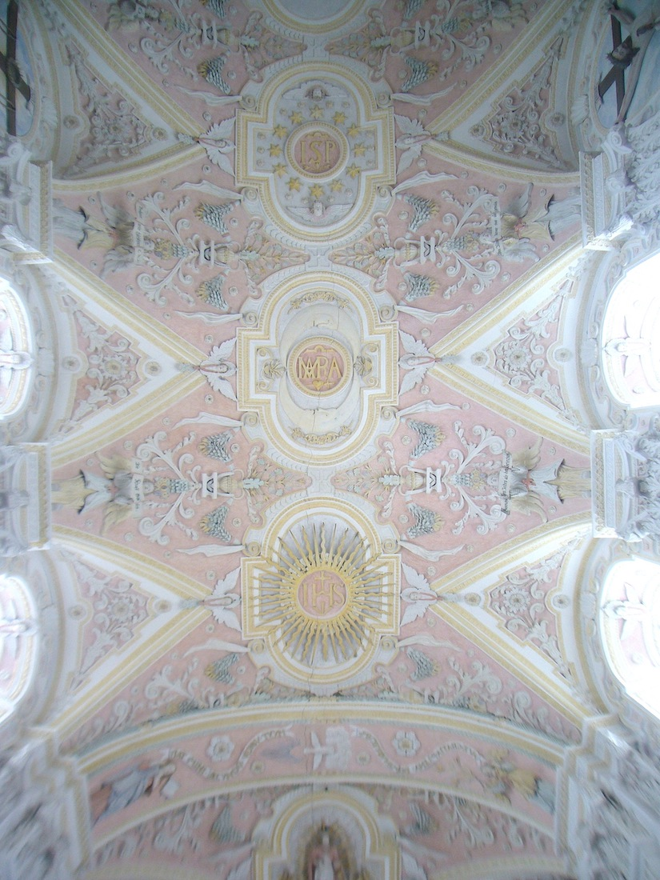

Fig. 15. Elbach, Cemetery Church, Heilig Blut, 1669-70, Georg Zwerger

cemetery church of Elbach (1670) (Fig. 16), which places the monogram of Mary at the
nave’s center, between those of Christ and Joseph.
But let me return to the younger Isaak Bader, who never managed to match the successes of his cousin Konstantin and, after working for almost a decade for the margrave of Baden and settling in the provincial Landsberg, returned to Munich in 1675. He never did succeed in his attempt to be appointed stuccoer to the court, although the timing of his return to Munich does seem significant. At that time the essentially Italian Theatinerkirche had just been finished (1663-75). (Fig. 16) The architect was Enrico

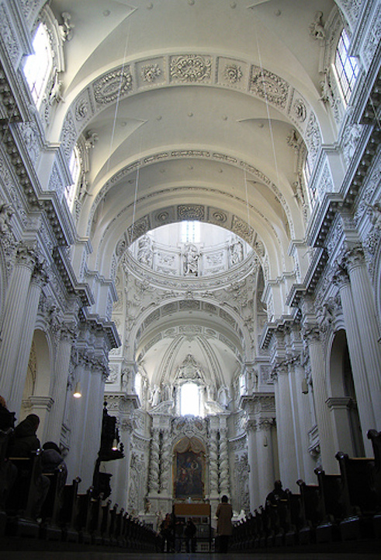

Fig. 16. München, Theatinerkirche St. Kajetan, A. Barelli, A. Spinelli, E. Zuccalli, 1663-1688
Zuccalli, the stuccoers Giovanni Nicolo Perti and Abraham Leuthner, 1674). It was this
church that more than any other helped to introduce the Italian High Baroque to Bavaria. Note the heavy, three-dimensional stuccoes.
Once again Wessobrunners were employed in its decoration, although responsibility lay with the Italians. The Bavarians had a rather different understanding of the vault and how to decorate it than did the Italians. Consider once more the nave vault of the cemetery chapel in Elbach. The different attitude to architectural space is unmistakable. In the Theatinerkirche, the decoration, heavy as it is, yet respects the priority of the architecture and helps to articulate the division of the space, as it had in St. Michael.
Having returned to Munich just after the Theatinerkirche had been essentially completed, the younger Isaak would have had no part in this decoration. Nor would the move to Munich seem to have gotten him the professional recognition or rather business he had hoped for. But his three sons certainly seem to have benefitted from this move, especially the oldest, Johann Georg (1675-1726), who soon became one of the most sought after stuccoers of the turn of the century in the region. A characteristic example

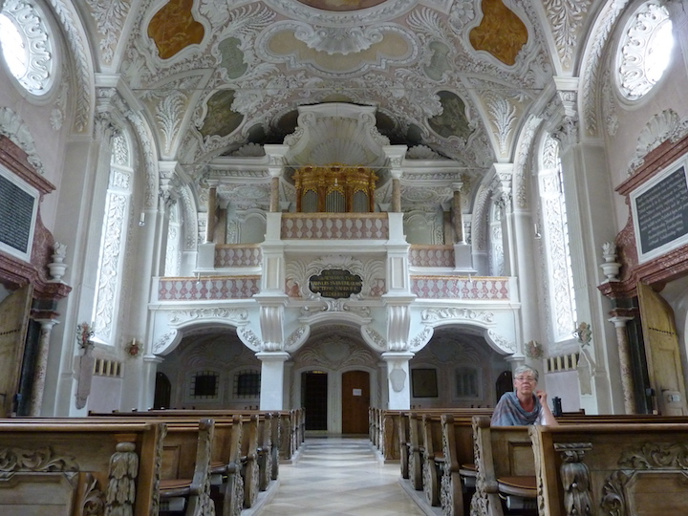

Fig. 17. Erding, Heilig Blut, Johann Georg Bader, 1704
and one of his first and most important works, is the decoration of the pilgrimage church Hl. Blut in Erding (1704 ff), (Fig. 17) not far from Oppolding, which would have given
the family a good name in the region. The stucco decoration of two Munich churches, the Bürgersaal (1710) and the Dreifaltigkeitskirche (1714/15) confirmed his position as perhaps the leading stuccoer in Munich at the time of the Austrian occupation of Bavaria (1704-1714), a result of the War of Spanish Succession.
Let me say just a few words about that war: When Max Emanuel became elector of Bavaria in 1680 one of the first things he did was to modernize his army. This led to his being courted by both Louis XIV and Emperor Leopold. Max Emmanuel entered into an alliance with Leopold, who was then fighting both the French and the Ottoman Turks. When in 1683 the Turks appeared before the gates of Vienna, the dashing elector was one of the first to come to the rescue. The next 5 years he was occupied fighting the Turks. The daring capture of Belgrade made him a European hero. What did he get out of all this? — The hand of the emperor’s daughter Maria Antonia, who, although considered ugly, because of her mother had a claim to the Spanish crown.
The young elector proved a daring and highly successful general, returning in triumph from his wars in Hungary in 1688, only to spend the next four years fighting the French with much less success in the West, the Rhineland, and in Savoy. The king of Spain rewarded him by making him stadholder of the Spanish Netherlands. For Bavaria it meant a mountain of debts; for the elector dreams of royal and even imperial glory. In a new palace in Schleissheim, north of Munich, these dreams were to find their architectural expression. (Fig. 18) Work began in 1702 under the direction of the Italian architect Enrico Zuccalli, whom the Elector had sent to Paris to study the newest fashion and look for available artists.
Meanwhile the Austrian Emperor offered Max Emanuel little support. In 1692 the Emperors daughter had died in childbed; but the child survived and with him the elector’s hopes for the Spanish crown. These were greatly raised when the Spanish King Charles II declared the child, prince Josef Ferdinand, heir of all Spanish possessions. But all the elector’s hopes were dashed when in 1699 that child died in Brussels. It was the question of who would rule the Spanish possessions that led to the war of the Spanish Succession, which pitted Austria against France. Once again courted by both sides, the elector this time sided with the French, who in 1702 had lured him with promises of royal or perhaps even imperial status. After initial successes, the war took a disastrous turn for the French and especially the allied Bavarians with the battle of Blenheim. All of Bavaria came under Austrian administration. For a while, Max Emanuel was able to hold on as stadholder of the Spanish Netherlands, but finally he had to escape to France. He even offered to exchange Bavaria for the Spanish Netherlands and Sicily, betraying the loyalty of his Bavarian subjects, who quite ineffectively revolted against the Austrian occupation. The elector returned only in 1715, following the peace of Rastatt, 1714, still dreaming of royal and perhaps imperial grandeur. Despite his disastrous alliance with France, he had not given up hope of becoming king of the Spanish Netherlands and even Spain, perhaps even emperor. Not surprising therefore that his return to Munich led to a

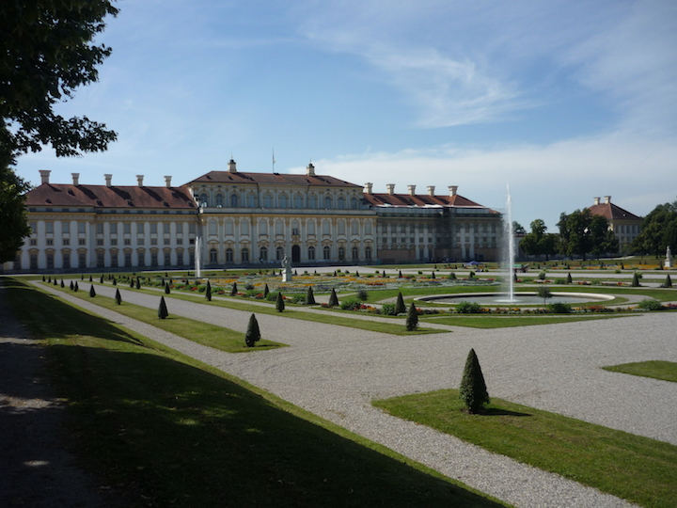

Fig. 18. Schleissheim, Neues Schloss, Enrico Zuccalli, 1701-1704, Joseph Effner, 1719-1726

tremendous surge in building activity. Johan Georg Bader and his brothers, too, were once again in much demand. But by then the elector had turned away from the Swiss-Italian Enrico Zuccallli (1642-1724), who now seemed old-fashioned, to a new, younger, and local architect, Joseph Effner (1687-1745), trained first as a gardener and coming from a family of gardeners serving the court. The elector had sent Effner, too, to Paris for prolonged study. Among the first things the Elector asked Effner to build him, following his return, is a small pleasure palace, which he helped to design, in the most recent French, or rather Rococo-Chinese manner, the Pagodenburg in the park of Nymphenburg (Fig. 19). In 1719 work resumed in Schleissheim. The elector had already more than enough perfectly good palaces, but the transformation of Schleissheim

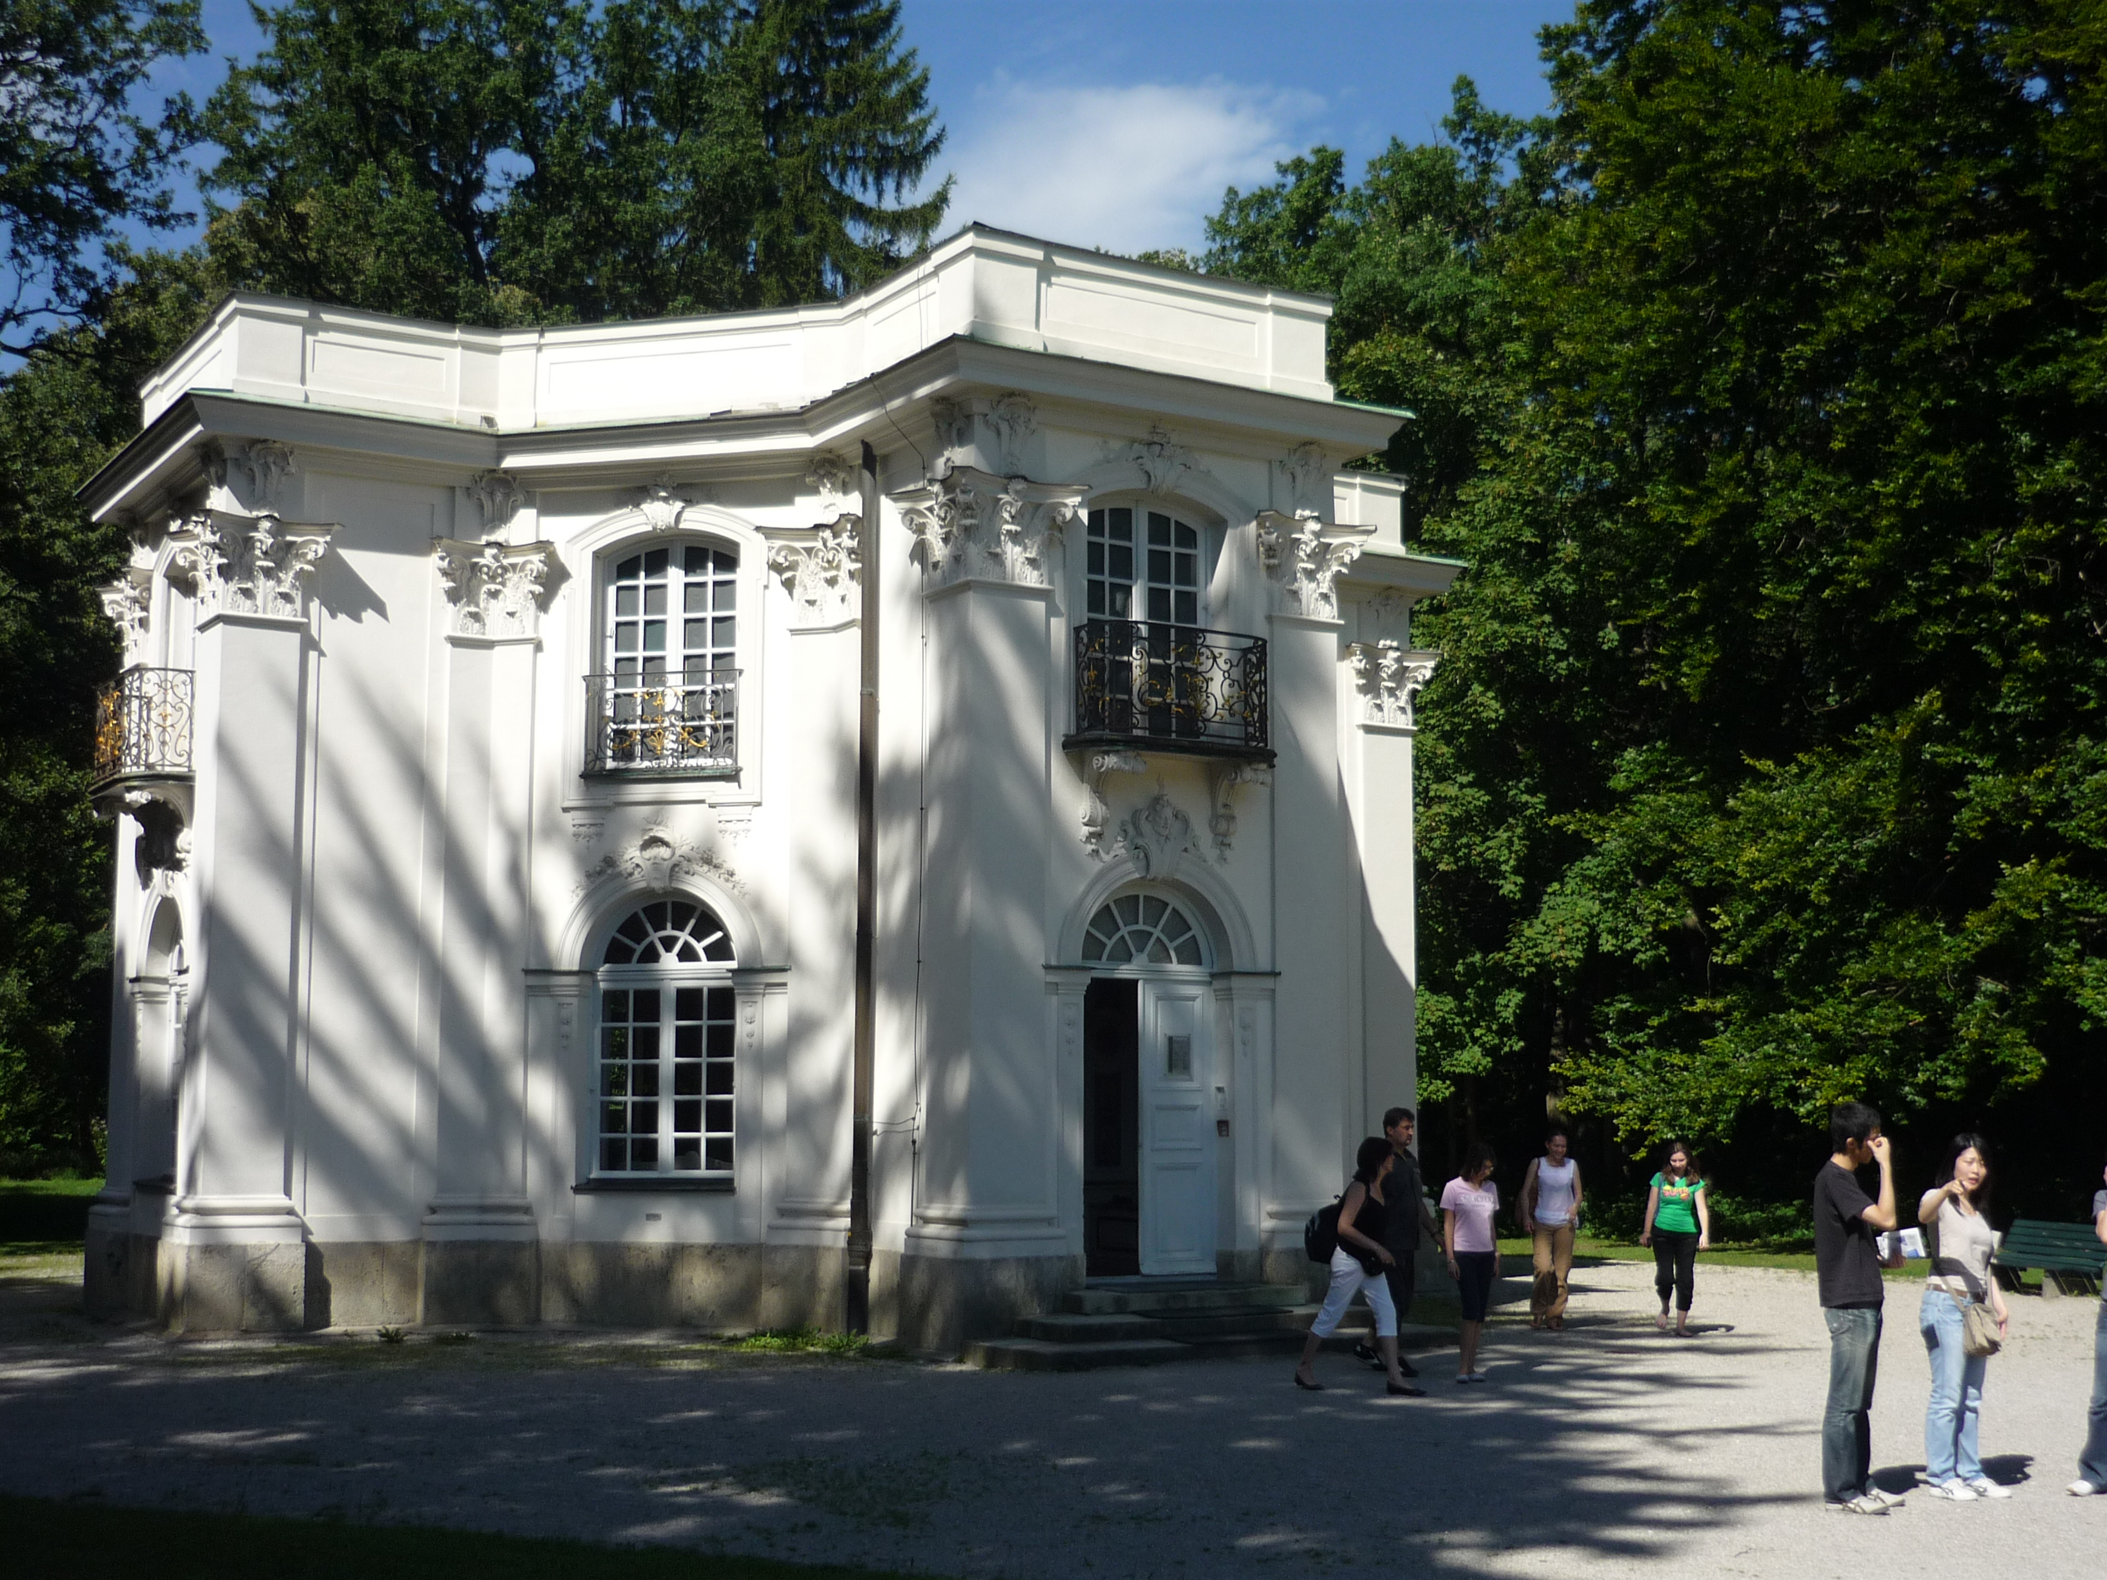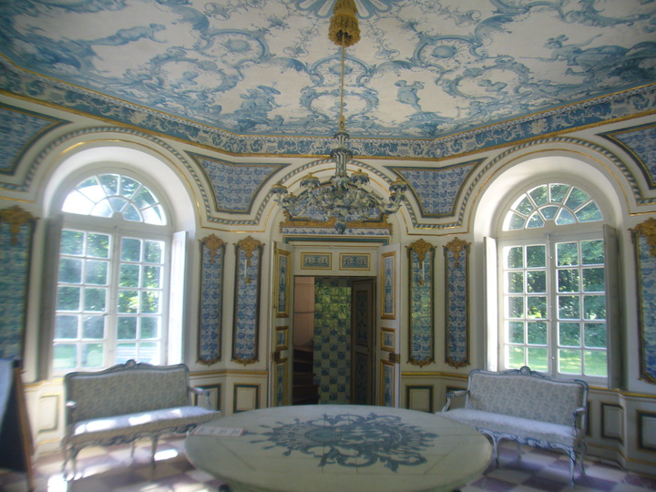

Fig. 18. München, Nymphenburg, Pagodenburg, Joseph Effner, 1716-1719

into a residence worthy of an emperor was meant to give expression to the elector’s continuing royal or even imperial ambitions.
Given this sudden surge in building activity, it is not surprising that Hans Georg Bader and a number of his relatives readily found work in Schleissheim and at the same time become acquainted with the most recent developments in Paris. Hans Georg Bader must have been given significant responsibilities, since from 1723-25 he received the, for the time, extraordinary large sum of 4950fl and was able to smooth the way for his two younger brothers. But while in his church decorations Johann Georg Bader enjoyed considerable independence, now he was expected to execute, as usual in such cases, designs by others, especially the architect in charge, in this case the French trained Effner and his team. The room for creativity was much reduced. French and French trained artists now called the tune. And furthermore, more than on Bader, Effner came to rely increasingly on another stuccoer from Wessobrunn, the 5 years younger Johann Baptist Zimmermann. (Fig. 19) I shall have a great deal more to say about him.
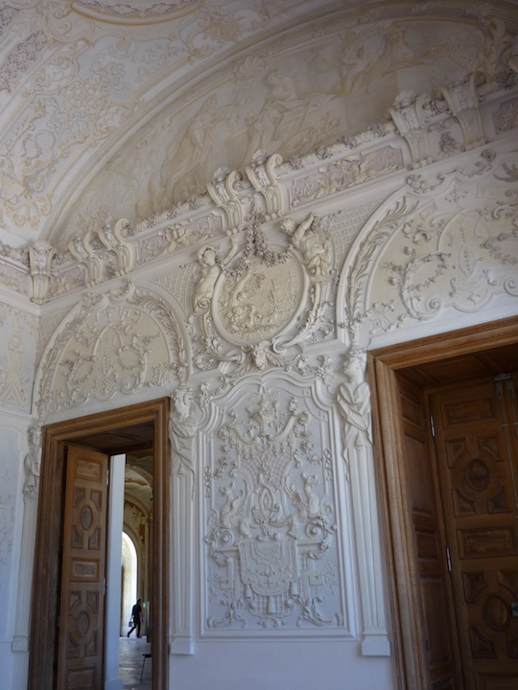

Fig.19. Schleissheim, Neues Schloss, Südlicher Gartensaal, Johann Baptist Zimmermann, ca. 1723

But first a few more words about the Bader clan. If Johann Georg Bader was little more than a good craftsman, not a creative artist in his own right, this would seem to
have even more true of his younger brother and frequent collaborator, Alexius, the father of the master of Oppolding. Like his more successful brother, Alexius, too, was employed by the court — a cornice in the antechamber of the Electress is documented for him — but we know of no really major commission he received. Throughout his life he would appear to have worked in his brother's shadow, often as a member of his troop. Nor was he able to take over his brother's workshop when the latter died in 1726 — the youngest of the three brothers, Georg Josef, had predeceased him by two years. And while Johann Georg Bader's most promising assistant and brother in law Martin Hörmannstorffer decided to join the team of the successful Johann Baptist Zimmermann, Alexius, like his father, appears to have had difficulty establishing himself in Munich as a master. This may help to explain his decision to settle in the small market town of Dorfen east of Munich, where he bought a house in 1720 that he passed on to his son Johann Anton, the master of Oppolding.
That brief overview offers all too cursory glimpse of two of the important Wessobrunn families and at the same time a first overview of the evolution of ornament from the 16th to the 18th century. We should note the importance of both the Church and the court, also the importance of first Italy and then France, the latter very much tied to the Bavarian elector’s fateful political alliance with France against the Habsburg Emperor in Vienna, an alliance that, as pointed out, ended disastrously for the Bavarian elector, forcing him to flee. If any year can be said to be the beginning of the Bavarian rococo, 1715, the year of his return to Bavaria, is a good candidate, where we must keep in mind, however, that this is not yet the style rocaille, but the more delicate régency style, often relying on delicate interlacing band-work, and also that in much Bavarian stucco work done in the years 1700 – 1715 one can already detect proto-rococo tendencies.

5. But let me now turn to that younger decorator in whom Effner had greater confidence than he did in Hans Georg Bader, to Johann Baptist Zimmermann (1680-1758), who, together with his brother Dominikus, was to create the two churches that almost have come to define the Bavarian rococo church, Steinhausen and die Wies. I shall turn to Steinhausen next time.
Zimmermann had presumably been recommended to Effner by the painter Jacopo (or Giacomo) Amigoni, the Venetian painter who, until Tiepolo made his mark, was perhaps the highest paid and most in demand fresco painter of the time. Amigoni had encountered Zimmermann in the Benedictine monastery of Ottobeuren, where both had worked just before building recommenced in Schleissheim. The painter had been impressed by what he had seen. And Zimmermann disappointed neither Effner nor the elector. From then on Zimmermann was to remain the court’s preferred stuccoer, at first executing designs supplied by Effner, where the program at Schleissheim was very much dictated by the elector’s desire to present himself as a warrior in the image of Aeneas, celebrated in the frescoes, a warrior famous for his many victories, especially over the Turks. One has a sense that the heroic program of these show rooms called for a decoration that suited Zimmermann less than more intimate spaces. How much more convincing are the decorations that he executed for Effner in Munich’s Residenz. Max Emanuel had died in 1726. But the imperial ambition of the house of Wittelsbach did not die with him. To show that he was worthy of such honors his son and successor, Karl Albrecht asked Effner to create the Ahnengalerie, a gallery with images of his noble ancestors. Karl Albrecht was indeed to become emperor in 1742, although the fulfillment of this long cherished dream brought him only unhappiness until his death in 1745: war with Austria and exile. But the gallery and the adjacent china cabinet place us on the threshold of the mature Rococo. The elegant decoration suggests that Effner was collaborating with his younger and more gifted and up to date colleague François de Cuvilliés. The stucco work was entrusted to Johann Baptist Zimmermann. (Fig.20)
Cuvilliés (1695-1768) was Belgian — so diminutive that it was as a court dwarf he first came to the notice of the exiled Max Emanuel, who was then residing in Mons and brought Cuvilliés with him to Munich when he returned in 1715. The elector soon discovered Cuvilliés’ very special gifts and saw to it that he was properly trained, first by Effner and subsequently in Paris, where Cuvilliés spent four years in the atelier of Jean-François Blondel (1720-24). When he rejoined the elector in Munich, he was appointed court architect in 1725, working under Effner.
Following the elector's death in 1726, Cuvilliés worked for a time in the Rhineland, for the new elector Karl Albrecht’s (1726-1745) brother, Clemens August of Bavaria, the arch bishop of Cologne. But he remained in Munich, where in 1728 he was made Effner’s equal. Until 1738 his was to be the leading voice in architectural matters at the Munich court. In 1745, the year of the death of Karl Albrecht, Johann Baptist Gunetzrhainer was to replace him as Oberhofbaumeister. The new elector, Max III Joseph was less interested in architecture than in reducing the staggering debt with which his flamboyant father and grandfather had burdened the Bavarian state.

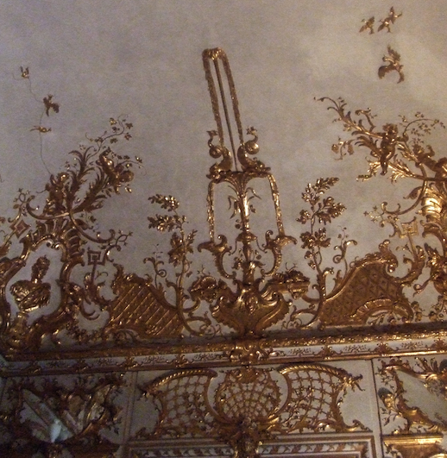

Fig. 21. Munich, Residenz, Reiche Zimmer, Porzellankabinett, stuccoes by Johann Baptist Zimmermann

When in 1729 a fire destroyed part of Munich’s Residenz the elector turned to Cuvilliés to create a sequence of splendid rooms in keeping with his political ambitions.
With what came to be called the Reiche Zimmer (the rich rooms) Cuvilliés introduced the mature Rococo into Bavaria (1730-1733). Once again he found in Zimmermann a congenial collaborator. (Fig. 21). And he still relied on Zimmermann when he followed

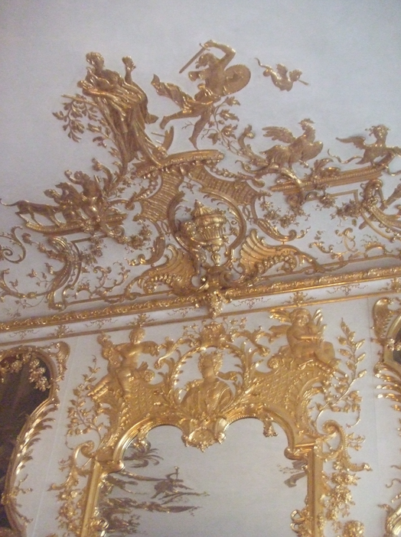

Fig. 21. Munich, Residenz, Reiche Zimmer, Konferenzzimmer

up the \Reiche Zimmer with what was to be his masterpiece, the Amalienburg in the park at Nymphenburg, built 1734-39.
Let me introduce the Amalienburg by considering briefly one of Cuvilliés’ ornamental engravings. (Fig. 22) As in the Nilson engraving I showed you earlier (Fig. 2, 12), a frame appears in a landscape as if it were a thing and could share the same space

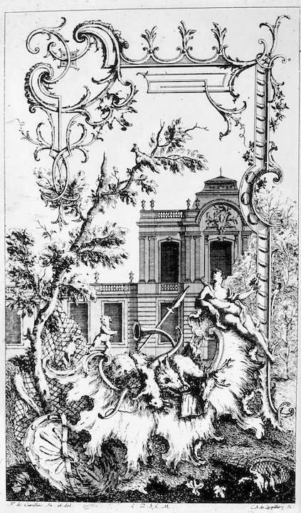
Fig. 22. François de Cuvilliés, Hunting Cartouche, Livre Nouveau de Morceaux de fantasie, ca. 1740.

and light with trees and palace. The impossibility of such introductions of the frame into the picture, given a commitment to Albertian perspective, requires no comment. The comparison of these two engravings reveals the close relation between rocaille and frame or, to be more precise, with a frame that is allowed to invade the picture. Here, too, a frame appears in a landscape, as if it were a thing and could share the same space and light with trees and palace. The impossibility of such introductions of the frame into the picture requires no comment. A look at the origin of rocaille in French ornamental engravings of the 1730's, such as this one by Juste Aurèle Meissonier (16951750) Meissonier, (Fig. 23), suggests that the subversion of the picture by the frame offers a key
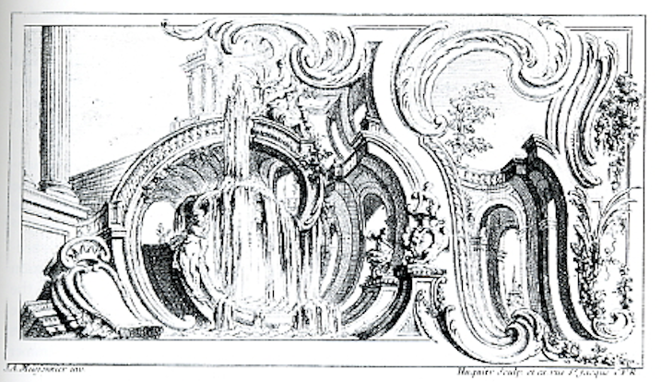
Fig. 23. Juste Aurèle Meissonier, Engraving, Livre d’ornemens, 1734

to the rococo style. Pictorial representation here suffers shipwreck on the reef of ornament. What is the significance of this shipwreck?
With this in mind let me turn to the Amalienburg (1734-39), built by the elector Karl Albrecht for is wife Maria Amalia, who liked to hunt, especially pheasants. Already the choice of colors is surprising, inverting what one might expect. The goddess Diana offers the key to the program of the whole. (Fig. 24) Diana is the huntress. Associated with the moon, she presides over the eastern façade. (Fig. 25) The stucco sculpture representing a scene with the goddess Diana is by Zimmermann, who no doubt was following Cuvilliés’ instructions.
Feminine silver is associated with the moon, as masculine gold is associated with the sun. As opposed to the gold ornament of the Reiche Zimmer, the ornament in the Amalienburg is silver, changing from blue to yellow to the blue on the central Hall of Mirrors (Fig. 26), then back to yellow and finally back to blue. Once again all the stucco work is by Zimmermann, following Cuvilliés’ designs. The Amalienburg also includes a room for the dogs and an enchanting kitchen. But what matters to me more here than the iconography is once more the way the ornament affects our experience of the ceiling, and more generally of the architecture. (Fig. 27)
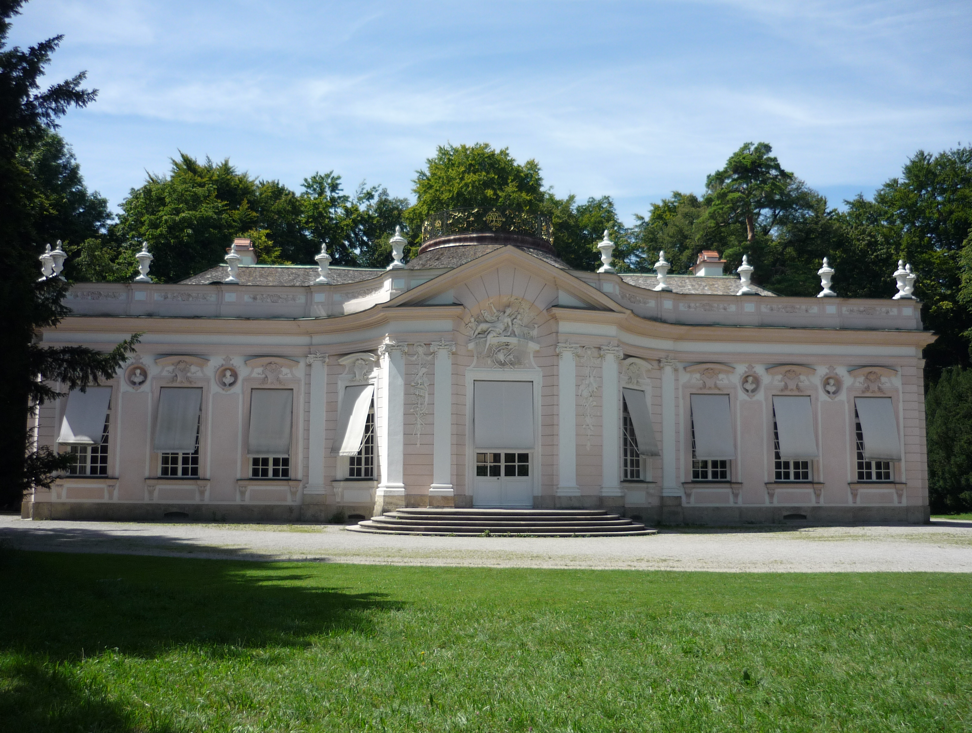

Fig. 24. Amalienburg

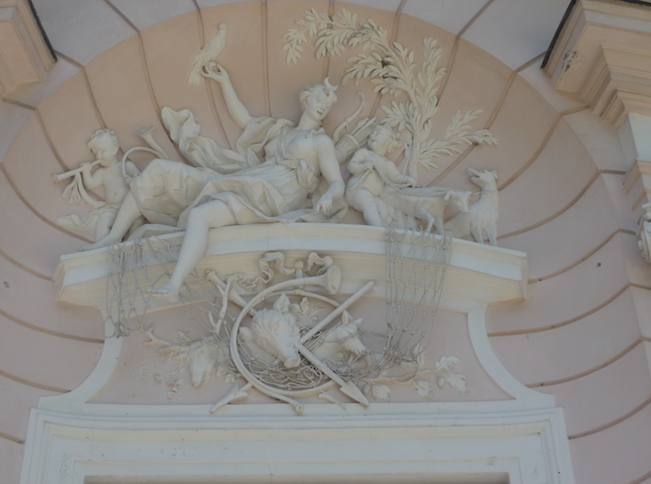

Fig. 25. Amalienburg, Diana

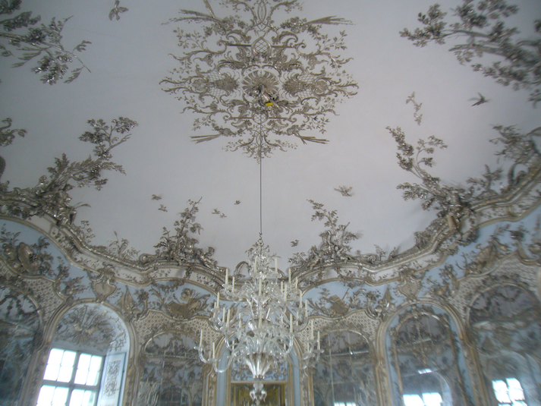

Fig. 26. Amalienburg, Hall of Mirrors

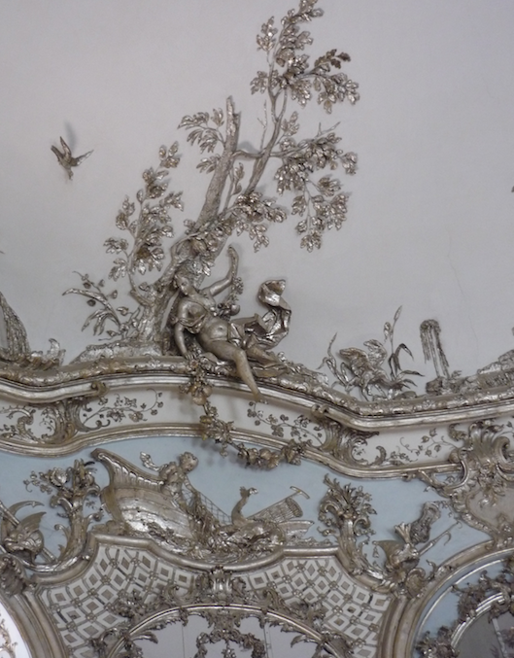

Fig. 27. Amalienburg, Hall of Mirrors, Amphritite
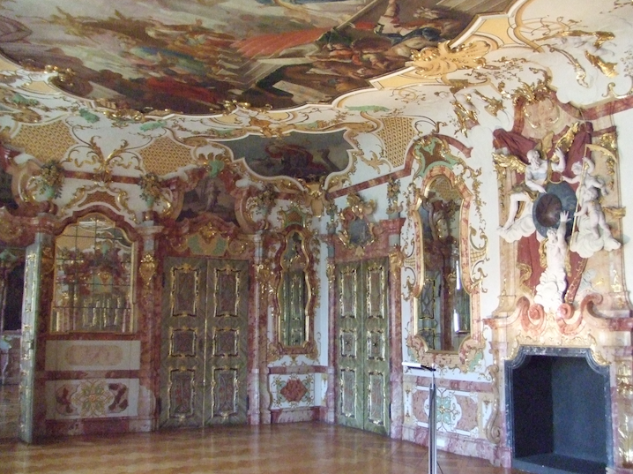

Fig. 28. Kempten, Residenz, Audienzzimmer

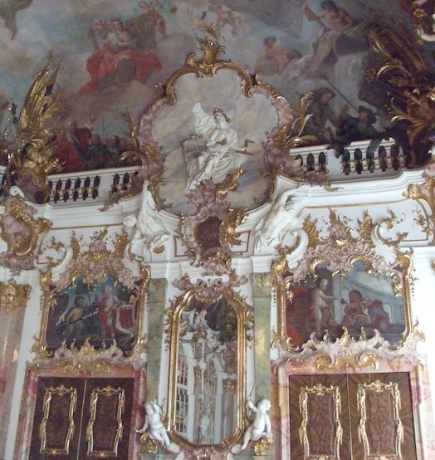

Fig. 29. Kempten, Residenz, Thronsaal

6. In conclusion I would like to take just a brief look at the Show Rooms of the Residenz in Kempten, 1730-42, decorated in the same decade as the Amalienburg. Just as the Reiche Zimmer in Munich’s Residenz served the self-representation of the elector, these Show Rooms served the self-representation of a lesser potentate, the prince-abbot of Kempten, who was not only the spiritual ruler of this important Benedictine monastery, but also the worldly ruler of a territory with more than 10,000 subjects.
What I am interested in is the very different tonality of these contemporary interiors: the Amalienburg is elegant and courtly in comparison. In Kempten, too, the stuccoers came from Wessobrunn, and included Johann Georg Schütz, Abraham Bader, Anton Rauch, and Johann Bader. (Fig. 28) Of special interest is the throne room by another Wessobrunner, Johann Georg Üblher, 1740-41, who had worked under Zimmermann in the Reiche Zimmer of the Residenz and the Amalienburg and was thus very familiar with the art of Cuvilliés (Fig. 29). But Cuvilliés’ courtly, in comparison more reticent, French vocabulary has here been translated into Bavarian. Striking is the use of color, crucial the mediating function of ornament between painting and architecture. Consider the function of the stuccoed balustrade in the Thronsaal. In the Amalienburg it is first of all the ornament that has the function of mediating between the aerial ceiling and the architecture below. That ceiling has no need for painting. In both the Amalienburg and the Kempten Show Rooms architecture is dressed up with stories. It is incomplete without the interpreting word. In the Amalienburg ornament is the vehicle of such story telling. But it was in the Baroque fresco that Bavarian Rococo architecture found its preferred way of including such stories. In this respect the Bavarian Rococo church may be said to continue the tradition of the Italian Baroque, leaving one wondering, however, how seriously such stories were still being taken.

Hugo Schnell and Uta Schedler, Lexikon der Wessobrunner (München: Schnell und Steiner, 1988).
Heinrich Wölfflin, Principles of Art History, first published in 1915, trans. M. D. Hottinger (Dover, 1929).

