12 Rococo and Enlightenment Revisited

1. Let me begin with a charge that Alastair Laing, an expert on the Rococo, especially on the French painter Boucher, raised in a generally favorable review of The Bavarian Rococo Church that appeared in Apollo, 1984. In that review Laing insists that "the Rococo did not die from within: it was put to death by the representatives of those whose voices had been raised against it from its very inception." I had written in my book: “The Bavarian Rococo died not violently but gradually, fading away to lead a kind of posthumous life in folk art (Fig. 1). And while this slow process of disintegration

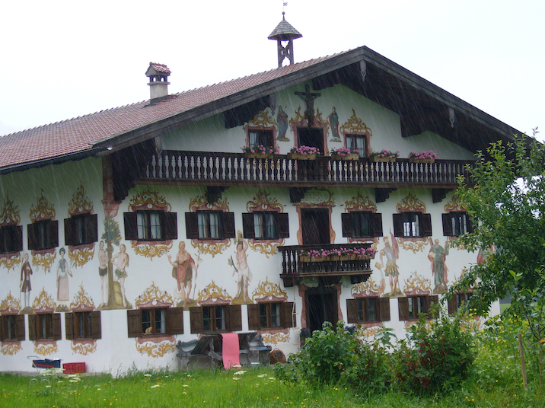

Fig.1. Jodlbauernhof, Hagenberg, Lüftlmalerei, Johann Böhamb, 1785

makes for a less dramatic — and much more complicated — story, it is only when this story is told that we begin to understand that what ends with the Bavarian Rococo church is not just another style, but an attitude to art and to life that lies irrecoverably behind us.” Laing was evidently not convinced. His claim places Rococo and Enlightenment in opposition. The Enlightenment is said to have put the Rococo to death. And, as we saw last time, there is indeed a great deal of evidence that supports this. Rococo and Enlightenment are indeed in opposition. The Enlightenment has faith that we can rely on reason to lead us to the good life. The Rococo presupposes a conviction that reason alone is insufficient. But the 18th century makes, it difficult to draw too sharp a sharp boundary separating these two attitudes. The Bavarian Rococo already presupposes an inability to take the pathos of the Italian Baroque born of the Counter-Reformation, its theatricality and illusionism, quite seriously. So it plays with both. Rococo ornament is an expression of such playfulness, which also means a new relationship to divine transcendence. Think of the importance of Mary to the Bavarian Rococo. But in the Catholic parts of Europe, too, the religious establishment could not shut out the culture of reason that was to shape

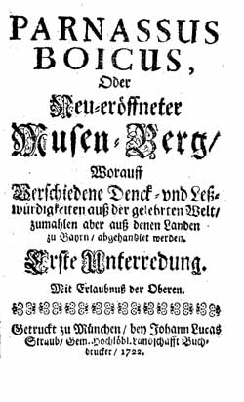
Fig. 2. Parnassus Boicus
the modern world. Monks played indeed a leading part in introducing the Enlightenment to Bavaria. An example is provided by the Parnassus Boicus, the name of both, a learned society and a journal, founded by three Augustinian monks (Fig. 2). They were by no means the only clerics engaged in such efforts.
More relevant to our topic is a consideration of the way the Rococo church evolved and developed, which makes it difficult to accept the claim that the Rococo died because it was put to death from without. Its own evolution necessitated that death.

2. But let me begin with some facts and images that could be cited to support Laing’s claim that "the Rococo did not die from within: it was put to death by the representatives of those whose voices had been raised against it from its very inception." How are we to understand "the Rococo … was put to death”? That phrase brings to mind the secularization of all the Bavarian monasteries and bishoprics in 1803, enforced by the Bavarian king, elevated from elector to king thanks to Napoleon. Secularization meant that their material assets were seized by the Bavarian state, which sought to make as much money as possible by auctioning them off. The most valuable books and paintings were brought to Munich.
One of the saddest examples is the Benedictine abbey of Wessobrunn, which had done so much to support the craft of stuccoing. As I mentioned, many of the artists we have considered in his seminar were born on one of the adjacent farms, among others the Zimmermann brothers. The monastery was secularized in 1803. In 1810 the greater part of the buildings, including its church, which had been decorated by Josef Schmuzer, who was also responsible for the interior of Rottenbuch (Fig. 1; 5), were torn down. It would have been one of his major works. What he was capable of is shown by his radical refurbishing of the abbey church of Ettal (1744ff.) (Fig. 3). To be sure, as mentioned before, the church in Wessobrunn was rebuilt already in 1721-1724 and its decoration would have been more like that of the abbey churches in Weingarten (3; 9) and Weissenau, for which Josef Schmuzer’s brother Franz was responsible at roughly the same time. This interior thus would have antedated the mature Rococo, representing the Rococo’s first régence phase. The abbey church in Wessobrunn was, as I pointed out, torn down in 1810. For the villagers, it was felt, their little parish church was more than sufficient. It was built in 1757-59 and can stand for countless other Bavarian village churches of the period.

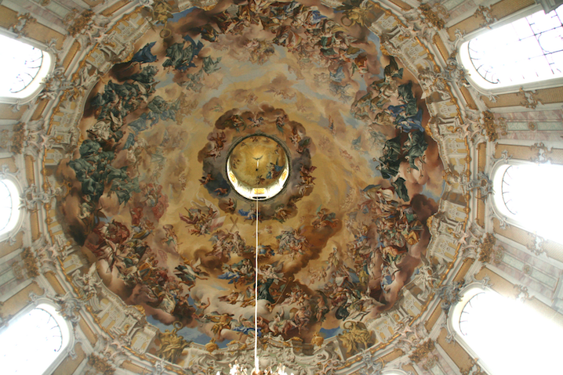

Fig. 3. Ettal dome, Joseph Schmuzer, fresco Johann Jacob Zeiller

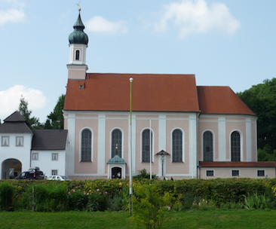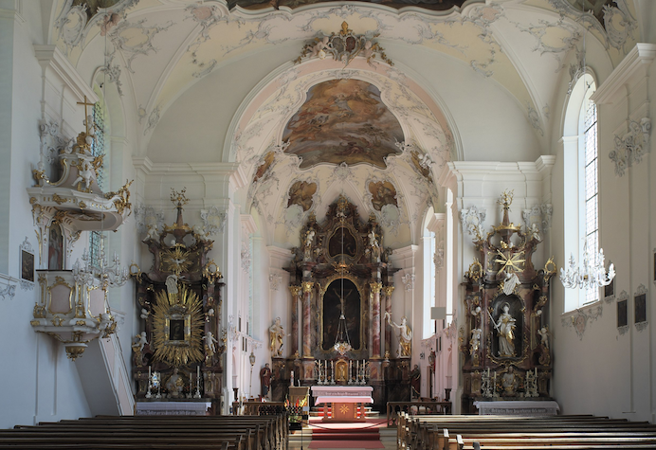

Fig. 4. Wessobrunn St. Johannes Baptist, 1757-1759
3. Let me give you another example. In my book I briefly tell the story of what happened to the Augustinian Abbey of Rottenbuch, which casts a bit of light on how the secularization was handled in Bavaria. The refurbishing of this medieval abbey church, too, was the work of Josef Schmuzer. About countless monastery churches we can tell some such story. On March 21, 1803 a judge, Franz Xaver Schönhamer, appeared and announced that the monastery had ceased to exist. Some of the inventory was sent to Munich, the church was plundered, what remained was put up for auction. His first task was to turn into money whatever could be sold or auctioned off. But the judge could find no one to buy the church or the monastery buildings. This was a general problem to which we owe the survival of many of these churches. And despite the more modest and much easier to maintain church that served the parish, the local farmers made a fuss and insisted on holding on to the much more splendid monastery church. So it was the parish church that was auctioned off and torn down. The judge still wanted to make money, auctioning off some of the relics. And he finally found a buyer for the church’s particularly splendid organ (Fig. 4), which he felt drowned out the singing of the congregation. He wanted to use the proceeds to tear down the church’s choir and side aisles, which needed repair and, given the size of the congregation, were unnecessary anyway. Economic considerations trumped both religious and aesthetic sensibilities. Fortunately that deal fell through.
Even this sketchy account suggests that at the time the authorities were interested mostly in maximizing financial gain from what remained of an institution that in their opinion had no longer any place in a newly enlightened age. Not only is there an insensitivity to the religion of the people, but, and equally striking, also to aesthetic values. As an artwork the church would have been butchered had the judge’s ideas been enacted. And fortunately, only 20 years later the climate had changed, as the more conservative king Ludwig I (king 1825-48) sought to reverse some of the changes brought about by his more enlightened father Max Joseph and once again supported the church.

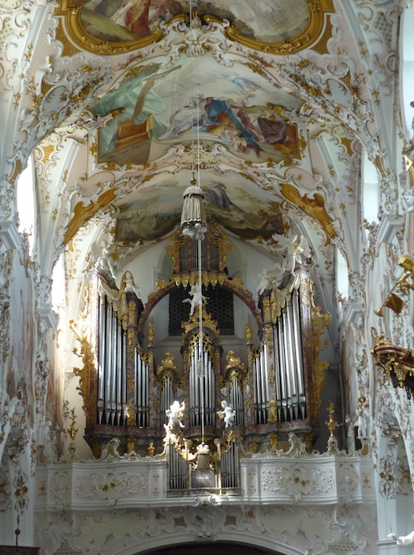

Fig. 5. Rottenbuch, Abbey Church, Organ

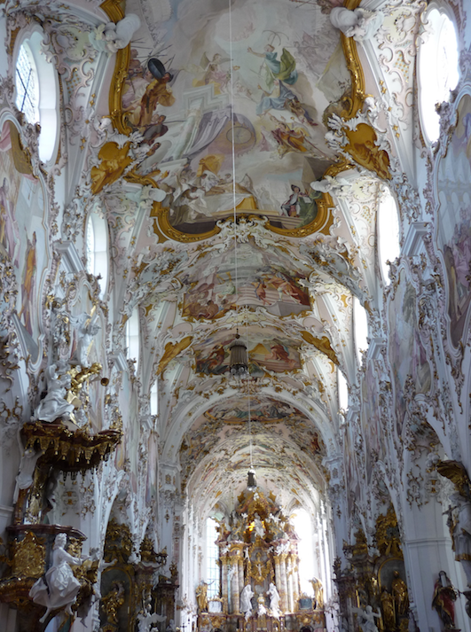

6. Rottenbuch, Abbey Church

4. Perhaps the greatest loss, from the point of view of art, that resulted from the secularization of the monasteries was the destruction of the Franconian Benedictine abbey church of Münsterschwarzach, the first of the three major churches built by

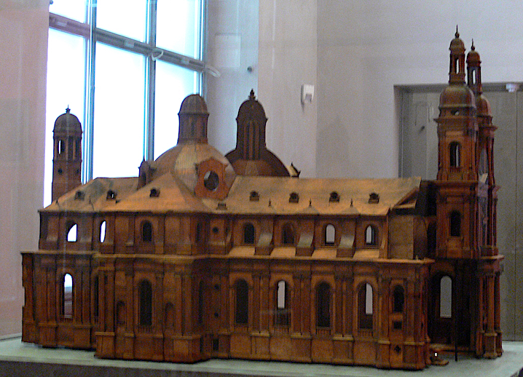

Fig.7. Münsterschwarzach Abbey Church, Model 1725/1726

Balthasar Neumann (1727-43). A model in the Bayerische Nationalmuseun gives us a good idea of what Neumann created (Fig.7). The frescoes were by Johann Evangelist Holzer, as I mentioned, perhaps the most gifted of the Augsburg fresco painters (Fig. 11; 12). He died when he was only 31. The Benedictine monks did eventually return to Münsterschwarzach, but only in 1913. They built themselves a monumental abbey church in 1935-1938 in a stripped down, modernized Neo-Romanesque style (arch. Albert Bosslet). In 1941 the Nazis confiscated the monastery and made it into a military hospital. It reopened as a Benedictine monastery in 1945.

5. Was the Rococo put to death from without? By 1802 and 1803, when the Bavarian state closed the monasteries, the Rococo had already died. One might still defend the thesis that the Rococo was killed from without and cite in support that ominous mandate issued the Bavarian elector Max III Joseph in 1770, very much in the spirit of the age.
In order to prevent all exaggeration when a new country church needs to be built, and so as not to leave the planning of the church to the self-centered whim of some priest or official, but rather to assure that a thoroughgoing uniformity in church architecture be observed as much as possible, following the example of Italy, we shall let experienced and skilled architects provide different model floor plans and elevations, depending on the number of parishioners, together with an estimate of the total cost, as accurately as this can be done, so that in this way a pure and regular architecture may be preserved, eliminating all superfluous stucco-work and other often nonsensical and ridiculous ornaments and showing in altars, pulpits, and statues a noble simplicity appropriate to the veneration of the sanctuary. (My emphases)
How did those who still built churches in Bavaria respond to this mandate? A good example is furnished by the parish church Mariä Himmelfahrt in Schwindkirchen, built in 1782-84 (Fig. 8). The church was the work of the Hofmaurermeister, i.e. master mason

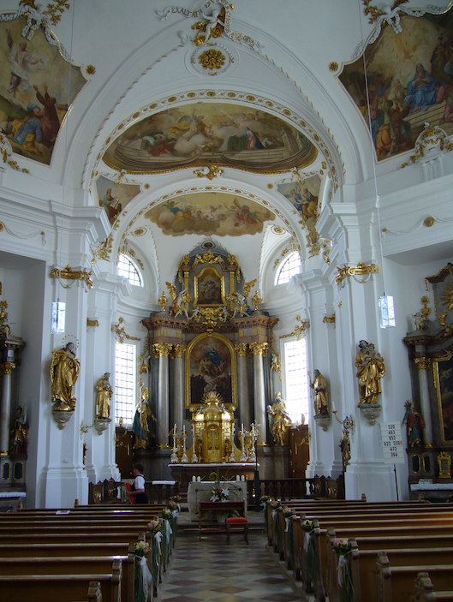

Fig. 8. Schwindkirchen, Mariä Himmelfahrt

to the court, Leonhard Matthäus Giessl, indeed the last work of this prolific architect (Fig. 8). Architecturally it is very much in the tradition of smaller churches by followers of Johann Michael Fischer, to which I shall return a bit later. The frescoes are by the equally prolific Christian Winck. He, too, was associated with the court as court-painter. In many ways this is still a Rococo church. But clear is the renunciation of rocaille ornament, which has been replaced with a by then more up-to-date classicizing ornamental vocabulary. Ornament has lost its mediating function. The reticent stucco work is by Franz Xaver Feichtmayer the Younger, who married the widow of Johannn Baptist Zimmermann, whom he succeeded as stuccoer to the court. Feichtmayer readily adapted himself to the new style, But there was less and less demand for such work so that eventually he had to supplement his income by opening a grocery store.
The shift in taste is obvious when we compare Schwindkirchen with the fifteen years earlier church St. John the Baptist in Inning on the Ammersee (Fig. 9). The

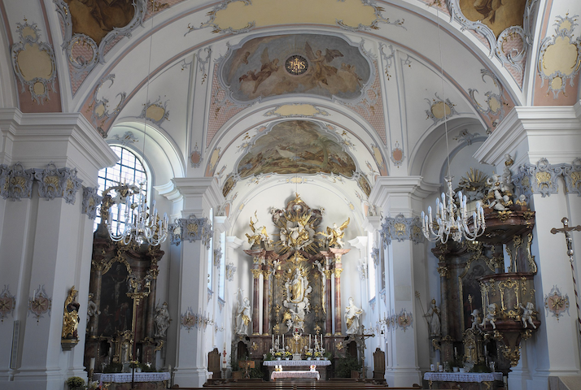

Fig. 9. Inning am Ammersee, St. John the Baptist, 1765-1767
architect of this delightful church is once again Giessl, the painter Winck. Rocaille, the work of the Wessobunn lay brother Thassilo Zöpf (1767), still retains something of its former framing function, but now, clearly subordinate to the work of architect and painter, it no longer attempts to mediate between the architecture and the frescoes.
There are not too many churches like Schwindkirchen. Fewer and fewer churches were being built after 1770. Stuccoers like the younger Feichtmayer soon were short of work. And, as the example of Inning hints, Rococo ornament all too often seems to become a bit tired in the late 1760’s.
The elector’s mandate was not altogether unexpected. Think once more of the attacks being launched at the Rococo by representatives of the newly enlightened bourgeoisie. The German center of that critique was Saxony, from which Winckelmann hailed, who had such a decisive impact on Neo-Classicism. But in Augsburg, too, the center of ornament production in Central Europe, the new spirit was having its effect. Here once more Johann Esaias Nilson’s renunciation of rocaille in 1770 (Fig. 10).

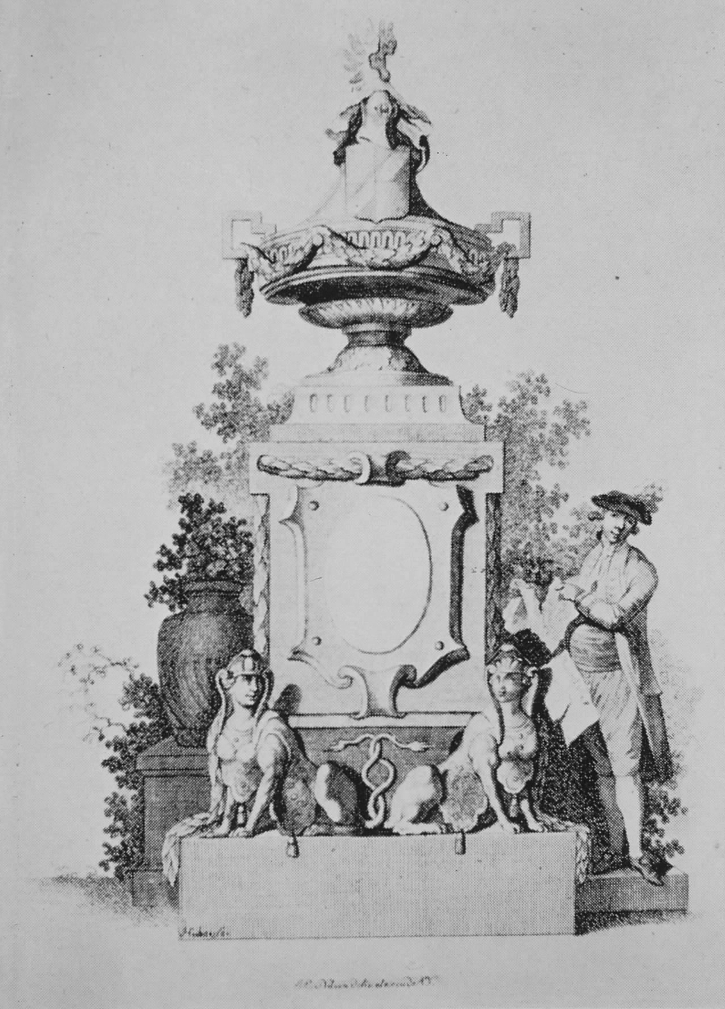

Fig. 10. Johann Esaias Nilson, Renunciation of Rocaille

Was it perhaps a somewhat ironic response to the Elector’s mandate issued that same year? As I pointed out, this renunciation was preceded by attacks such as that by the Saxon court architect Krubsacius, who accompanied his scathing critique with that parody of a rocaille, which I showed you last time (Fig. 11; 15). Only 23 years later the French revolution was going to place the Goddess of Reason on the high altar of Notre Dame to replace Mary. It took only a few months for the cult of reason to be repudiated.
But, as the publication of the Parnassus Boicus, initiated by three monks, shows, the Enlightenment had found its way also into the monasteries. Even within the church there were misgivings about the overabundance of ornament in Rococo churches. The Catholic Church was by no means immune to the forces of the Enlightenment. How else are we to explain the prince bishop of Würzburg’s request that Neumann build him two small churches, Gaibach and Etwashausen, with virtually no ornament (Fig. 12). Did his awareness of Protestant plans to build a church in the same area figure in the bishop’s

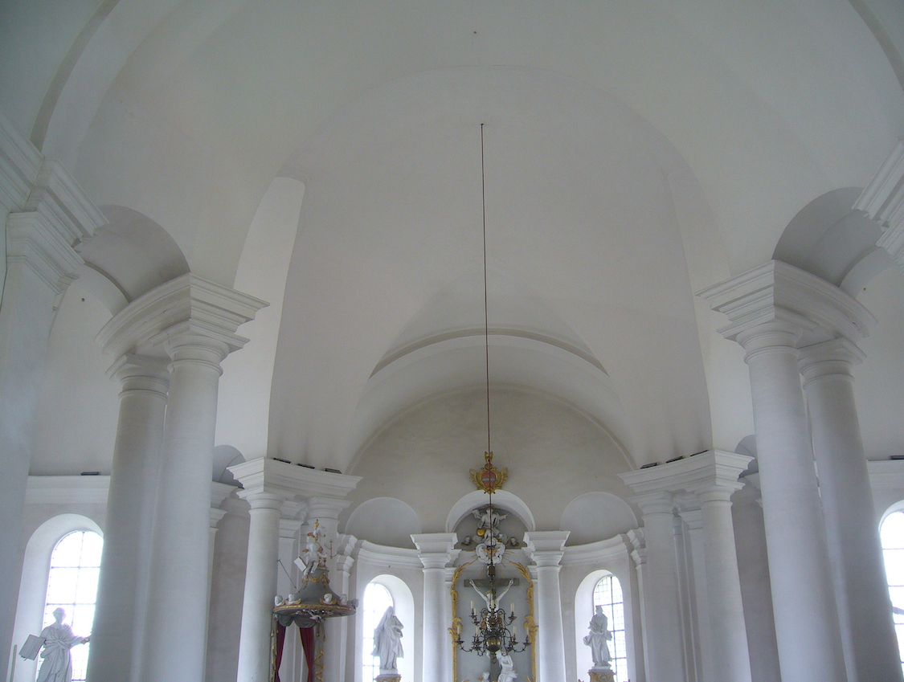

Fig. 12. Etwashausen, Kreuzkapelle, Balthasar Neumann, 1741-1745

decision? It is indeed fascinating to trace the way the Enlightenment made its way into the monasteries themselves long before they were abolished.

6. What killed the Rococo was the emerging age of reason that would render man not only the master and possessor of nature, but would also insist that reason should lead us to the good life. Religion, too was assigned its place by reason. But all this does not add up to the claim the Rococo was destroyed from without. The history of the Rococo church tells a different story. Without denying what was lost to the secularization, perhaps it would be more true to say that the Rococo carried the seeds of its own destruction within itself. Long before the elector’s decree of 1770 the Bavarian Rococo had thus already begun to disintegrate from within, where a question is how we are to account for that disintegration: is it to be understood in terms of a stylistic development, where the metaphor of the life of a person offer’s itself: we can speak of a style’s youth, maturity, and of a style that has grown old and tired. But what lets a style grow old?
Let me address the question by returning very briefly to the two main works of the Zimmermann brothers, Steinhausen (Fig. 13) and die Wies (Fig 14), which may stand

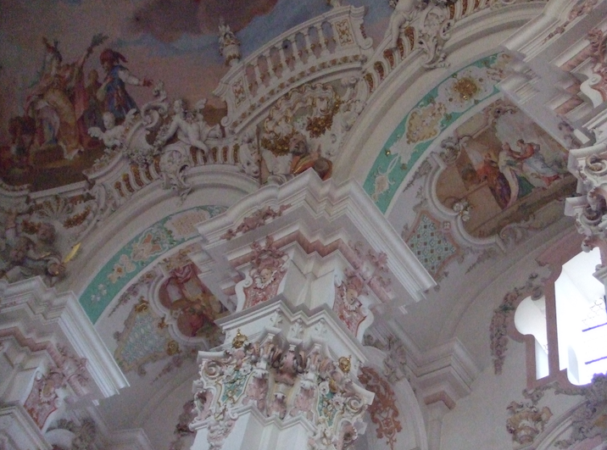

Fig. 13. Steinhausen, Stucco Detail
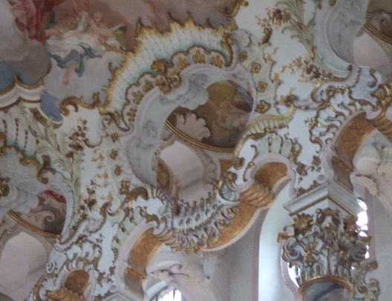

Fig. 14. Die Wies, Choir, Stucco Detail

for the youth and the maturity of the church rococo, and ask how a further evolution in this direction could be imagined. The Zimmermann brothers did indeed impress other, younger and more local architects. Here an example by Franz Xaver Kleinhans (1699-

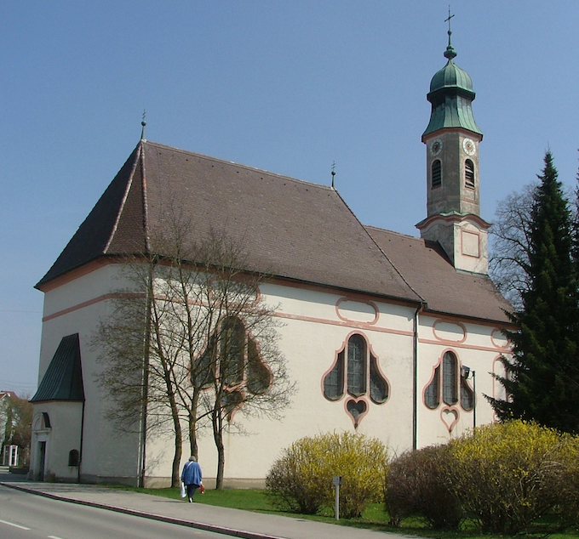

Fig. 15. Bobingen, Wallfahrtskirche zu Unserer Lieben Frau, 1749-51

1776), the Marian pilgrimage church in Bobingen (1749-51), where the ornamental window forms demand special attention. The walls seem to provide a paperlike foil for the architects ornamental designs. Dominikus Zimmermann had long provided the builders of the region with a much imitated model. Here an exampke from Zimmermann’s Liebfrauenkirche in Günzburg (11736-1741) (Fig. 16).

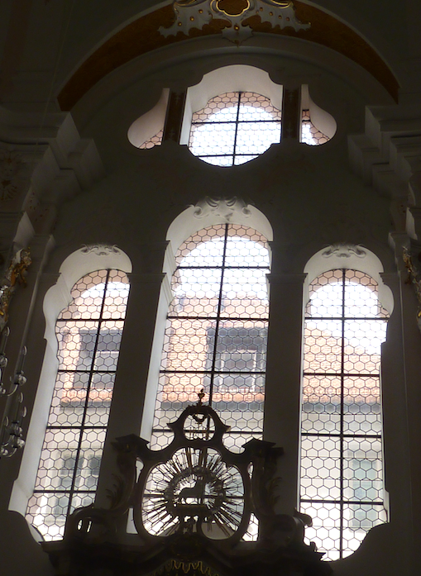

Fig. 16. Günzburg, Liebfrauenkirche, 1736-1741

Particularly successful among those who carried on the Zimmermann tradition was a pair of brothers, Hans Adam (1716-1759) and Joseph Dossenberger (1721-1785), the last in a chain of generations of masons. The main work of the older Dossenberger is St. Thekla in Welden (1756-58) (Figl. 17) . The proximity to Dominikus Zimmermann is

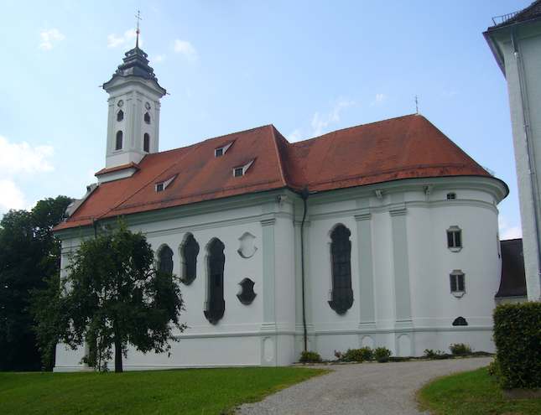

Fig. 17. Welden, St. Thekla, 1756-1758

indeed such that it was once attributed to him. This charming church was built on a hill overlooking the small town of Welden, west of Augsburg, which belonged to the territory of the Fugger of Augsburg, to whom I introduced you last time. The church itself looks at first a bit like a smaller Wies. The most striking thing about the exterior are once again perhaps the window forms, which already in Steinhausen had been a striking feature. Even more decisively, architectural elements are here ornamenalized. I am reminded of the way in the latest Gothic churches the ribs of the vault undergo an ornamental tranformation that no longer has anything to do with the structural function that such ribs once served. Here, too, we can speak of an ornamentalization of architecture.
In this respect Hans Adam Dossenberger seems to go even beyond Dominikus Zimmermann. An ornamental-pictorial approach takes over (Fig. 18). Striking is the now only painted architecture of the altars. Their ornamental treatment helps to dematerialize the architecture which has become the paper-light bearer of a captivating

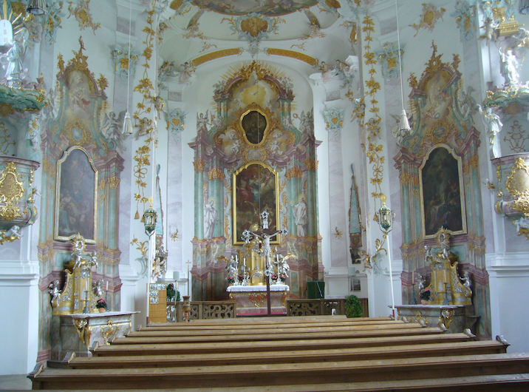

Fig. 18. Welden, St. Thekla, 1756-1758

ornamental play. Rocaille, by one of the most accomplished Wessobrunners, Franz Xaver Feichtmayer, father of the stuccoer in Schwindkirchen, has become much less important. It no longer mediates between fresco and architecture, as it still does in die Wies.
And different is the handling of light and the attitude to wall and vault or ceiling. Direct illumination has become much more important. The frescoes have lost much of the importance they had in Steinhausen or die Wies (Fig. 19).

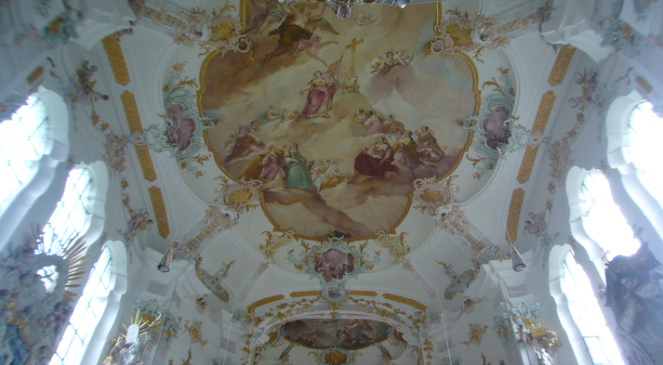

Fig.19. Welden, St. Thekla, Fresko, Johann Baptist Enderle (1758/59)

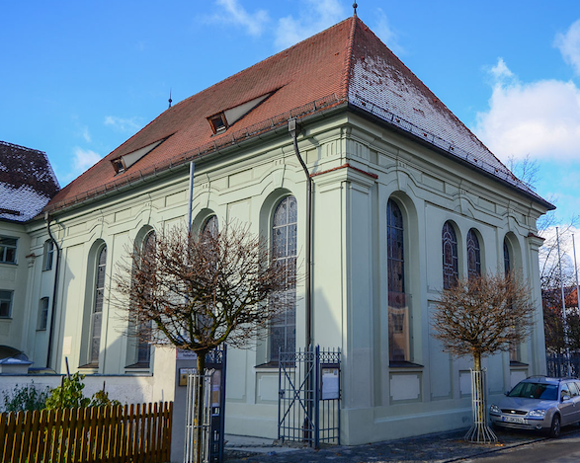

Fig. 20, Ichenhausen, Synagogue, Joseph Dossenberger, 1783

Where could the Dossenbergers go from here? Hans Adam died before the church was quite furnished. His younger brother Joseph continued to build a great many churches NW of Augsburg, also a synagogue in Ichenhausen (1783) (Fig. 20).
A good example of his work, showing how his style evolved, following the shifting taste of the time, is St. John the Baptist in Dischingen (1769-71). Its general

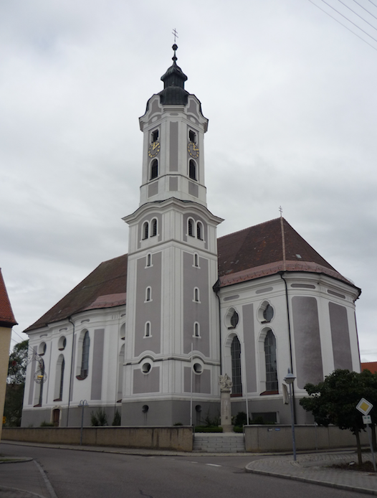

Fig. 20. Dischingen, St. John the Baptist, Joseph Dossenberger, 1769-71

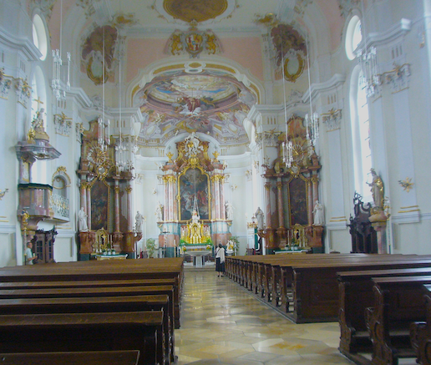

Fig. 21. Dischingen, St. John the Baptist
appearance —consider the tower or the window forms— still looks back to Dominikus Zimmermann, but the interior betrays the shift in taste (Fig. 21), in keeping with the elector’s mandate.
The ornamental treatment of architectural elements and the somewhat tired rocailles still make this a Rococo church. But this is no longer the exuberant Rococo of Dominikus Zimmermann. we sense the approaching end. (Fig. 22)

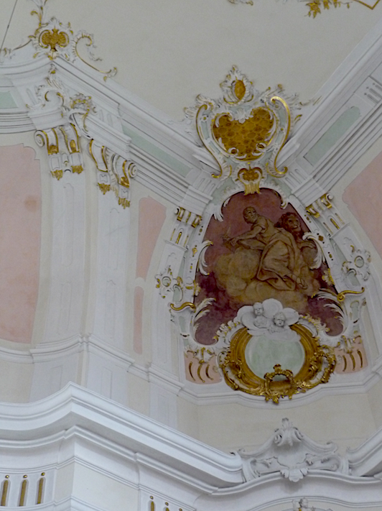

Fig. 22. Dischingen, Ornament Detail

7. As already suggested by a church like Schwindkirchen, this last phase of the Rococo looks rather different when we look at it from the perspective of Johann Michael Fischer (1691-1766) and his associates and successors, such as Balthasar Trischberger (1721-1777), who, as mentioned, completed Fischer’s monastery church in Altomünster (Fig. 23), Franz Anton Kirchgrabner, who followed a design by Fischer when building St. Clemens in Eschenlohe (1764-1782), or Leonhard Matthäus Giessl (1707-1785) (Figs. 8, 9). Unlike the Zimmermann brothers, who were first of all stuccoers, as such inclined to take a more ornamental approach to architectural design, Johann Michael Fischer

Fig. 23. Altomünster, Fig. 24, Eschenlohe, St. Clemens, 1764-1782

Fig. 25. Egling an der Paar, St. Vitus

was first of all a mason. His life-long infatuation with the octagon, which found perhaps its most convincing expression in Rott am Inn (Fig. 7; 3) carries over into the work of his epigons. Stuccoed ornament loses its former importance. Kirchgrabner’s St. Clemens in Egling an der Paar (1769-1777) with its sparse green stucco-work by Thassilo Zöpf furnishes a good example. The green of the stucco, often met with in churches of the fading Rococo, would seem to be part of a n attempt to show that the art of the stuccoer, too, had its foundation in nature, as Enlightenment aesthetics demanded.
The change in taste is particularly striking in the monumental Benedictine abbey church in Wiblingen. Already in 1750 Johann Michael Fischer had been asked to direct building of the monastery and the church. But when his association with the monastery ended in 1757 work on the church had not yet begun. Work started only in 1772, 6 years after Fischer’s death. The architect in charge was now Johann Georg Specht, who had trained and worked with the Vorarlberg architect Peter Thumb, whose late Baroque abbey church in St. Gallen may well have provided a model (Fig. 26). If Specht made some use of Fischer’s plans, he changed them decisively.

Fig. 26. St. Gallen, Abbey Church, Peter Thumb and Johann Michael Beer von Bildstein, 1760-1769

The façade of the Wiblingen church makes a strange impression (Fig. 27). Specht no doubt had in mind a façade closer to that of St. Gallen. The whole now seems

Fig. 27. Wiblingen, Abbey Church

unresolved. One has the feeling of a project not carried to a conclusion. And so indeed it was. Initially towers were planned, perhaps not unlike some of Fischer twin towers, e.g. those of Ottobeuren (Fig. 10; 9) or the towers of St. Gallen. Interesting is the decision to rotate the towers. But taste had changed. The Baroque look was no longer wanted.
In its present form the façade, with its truncated towers, preserves only an echo of the Baroque. Fischer’s or Peter Thumb’s churches seem far away. As building progressed, the abbot must have become dissatisfied with his architect, whom he dismissed in December 1777. He wanted something more up to date, something in that classical style that at the very same time was finding such powerful expression in the abbey church of St. Blasien (Figs. 10; 8 and 10). The building process, the abbot must have felt, had to be turned in a different direction. In the widely traveled Bavarian painter Januarius Zick (1730 - 1797) the abbot found someone familiar with the most

Fig. 28. Wiblingen,Abbey Church.

Fig. 29. Wiblingen, Abbey Church, Main Fresco, Januarius Zick

recent developments in Paris and Rome. Zick, who had also studied architecture, was put in charge of finishing what Specht had begun and especially of the interior decoration. From 1778-1783 we find him in Wiblingen. It is to him that the church owes its present appearance (Fig. 28). Very little room is left for improvisation and fantasy by this ornamental scheme, which has become subservient to the ornament bearer.
Trained by his father Johannes Zick, Januarius Zick is perhaps the last master of the large Rococo fresco. The main fresco in Wiblingen (Fig. 29), like the other frescoes, relates to the most important relic possessed by the abbey: a particle of the Holy Cross. The true cross was supposed to have been rediscovered by St. Helena, robbed by the Persians, and retrieved by Emperor Heraclius. The fresco is organized into three scenes: the Emperor receives the cross under a palm, he Emperor carries the cross up to Golgotha, and the central scene shows him holding the cross to whom all those feel drawn who suffer and are weighed down by sin. It is Zick’s frescoes more than its ornament that place this church on the threshold of Rococo and Neo-Classicism.

Fig. 30. Ebrach, Abbey Church, 1200-1285, 1778-1791

8. How taste had changed is shown strikingly when one compares the Rococo decoration of the Romanesque abbey church of Rottenbuch (Fig. 1; 5), forty
years earlier, with the decoration of the Gothic abbey church of Ebrach (1778-91) in Franconia (Fig. 30). Much more than in Rottenbuch, one still senses, beneath the decoration, the medieval, in this case Cistercian Gothic church. The decorator here is by Maderno Bossi from Porto Ceresio on Lake Lugano. With his decorative scheme he is looking to France.
And, as I mentioned in our previous session, it was a French architect, Michel d’Ixnard, who was responsible for the last great abbey church built in Southern Germany before the monasteries were secularized: the Benedictine Abbey church St. Blasien in the Black Forest (1768-83). The model here was the Roman Pantheon. By 1768 this Benedictine monastery, too, had become convinced that the antique style was appropriate to building a church, that decoration should be kept to a minimum since it would only disturb proper devotion. Given the increasingly rationalist understanding of God as a purely spiritual being, sacred architecture, too, should speak to reason, not answer to a free-wheeling eye-bound imagination. The Bavarian Rococo presupposed a religiosity that has much less faith in the power of reason to take the measure of reality, especially of the divine. This was most definitely not a religion, to use the title of one of Kant’s works, “within the limits of reason alone.” The Bavarian Rococo church is in the service of a God who transcends the limits of reason. And is very much present in the sensible.

9. In conclusion let me return to the question I raised in the beginning. How did the Rococo end? The key to the Bavarian Rococo church, I suggested, is provided by its ornament. The enthusiastic adoption of rocaille is to be explained by the way it lends itself to mediating between fresco and architecture. At its height this ornament gains a remarkable freedom and independence and with it an often extraordinary beauty (Fig. 31). It is in the forties that this development reaches its peak; in the fifties and sixties ornament increasingly claims our attention as an aesthetic object in its own right. Think of the pulpit in Oppolding (Fig. 32) or of the ornamental engravings I showed you. But essentially a serving function. One could thus construct an argument that it is its very beauty that lets rocaille die.

Fig. 31. Zwiefalten, Abbey Church, cartouche, Johann Michael Feuchtmayer, 1741-1747

When ornament becomes truly autonomous it has to die as ornament, for ornament has a serving function. Art for art’s sake has no place in a church, which should be for God’s sake. That is why I gave my book the subtitle: “Between Faith and Aestheticism.” N In striking fashion the Bavarian rococo church thus raises the question of the relationship of art and the sacred. I shall return to this relationship in our final session.

Fig. 31. Oppolding, Pulpit, Detail

Karsten Harries, The Bavarian Rococo Church: Between Faith and Aestheticism (New Haven: Yale University Press, 1983). p. 223.
Who appears to have worked with Balthasar Trischberger, who had worked with Johann Michael Fischer and completed Fischer’s monastery church in Altomünster.

