11. The Irrationality of Rocaille

1. Let me begin by returning briefly to the principles of art history that Heinrich Wölfflin’s gives us in his Principles of Art History. As I pointed out, they are presented in pairs. Let me briefly recall these:
1. Linear and painterly
2. Plane and recession
3. Closed and open or atectonic form
4. Multiplicity and unity
5. Absolute and relative clarity
I pointed out that Wölfflin claimed that, other things being equal, the Renaissance, in its painting, sculpture, and architecture tended towards the first member of each pair, the Baroque, and that includes the Bavarian Rococo, to the latter. Neo-Classicism decisively returns to the former.
Wölfflin also suggests that other things being equal, art south of the Alps tends towards the former, art north of the Alps towards the latter. In the Bavarian Rococo (Fig. 1), as already in Bavarian Late Gothic art (Fig. 2), as the two come together, they reach a certain extreme.
Wölflin does not offer us much of an explanation why this should be so. One interpretation that suggests itself is that once what we might call the grammar of a style has been established, subsequent generations feel impelled to complicate it, to play with it, until finally an extreme is reached that marks the end of that style. There is no doubt some truth to that. One might even want to draw from this a law of stylistic development.
But that does not explain why north of the Alps one kind of approach should have been preferred, south of the Alps another. What explains this? That question remains inadequately addressed in the art historical literature.
That the aesthetic approach inaugurated by Baumgarten, a characteristic expession of the Enligtenment, would support the first and be suspicious of the second
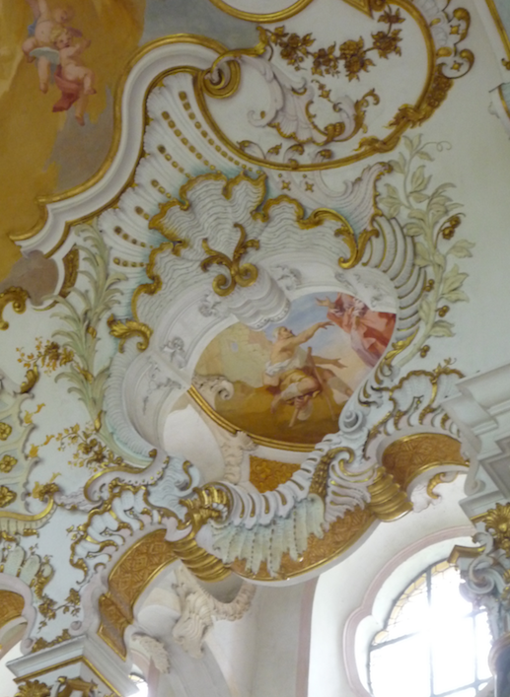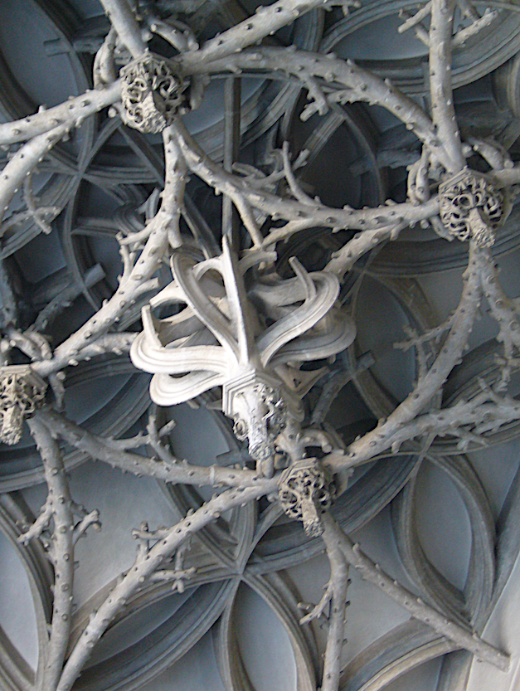

Fig. 1. Die Wies, Choir Fig. 2. Ingolstadt, Liebfrauenmünster, side chapel

term of Wölfflin’s concept pairs is to be expected. That approach insists that the artwork be a complete whole. It should be completely present. We may want to invoke here Wölfflin’s understanding of “absolute clarity.” As pointed out, the aesthetic aproach and Neo-Classicism belong together. Someone committed to the aesthetic approach will therefore be tempted to consider the vaults at Ingolstadt and the choir ornament of die Wies phenomena of decadence.
One thing is clear: as the pairs, closed or tectonic and and open or atectonic form suggest, the two approaches betray different attitudes to space. In one case the artwork offers us a kind of protection from nature and space, in the other it opens us to nature and space as transcending our attempts to master and comprehend them. That the Enlightenment, supported by the Cartesian promise that reason would render us the masters and possessors of nature, including our own nature, would side with the former is to be expected. The choir ornament of die Wies and the vaults at Ingolstadt hardly invite the label “rational.”
The struggle between Enlightenmant and Rococo places us on the threshold that separates the still faith-bound Baroque from modernity, the latter supported by the conviction that reason would not only render us masters of nature, but also lead us to the good life. My interest in the Bavarian Rococo is part of my intrerest in this threshold and that is to say in the tension between these two approaches.
That tension finds concentrated expression in the city of Augsburg, and especially in its art academy on which I want to concentrate today.

2. The art academy was founded in the year 1674 by Joachim von Sandrart (1606 –1688), painter, etcher, but especially an art pedagogue. When 15 he left home for Prague to study the art of engraving with Aegidius Sadeler. His teacher urged him to paint; so he went to Utrecht to study with Honthorst, where he met Rubens. Honthorst took him along when he went to England. From there Sandart went to Italy (1627), where he gained a reputation as a portrait painter. Meanwhile the ThrityYears War was raging in Germany. Sandrart did go back to Frankfurt to marry, but the ongoing war made him return to Holland, this time to Amsterdam, where he was quite successful. Especially a lucrative commission by an Amsterdam military company for a large commemorative piece for the state visit by Maria of Medici in 1638 made him well-known. He became known especially as a protrrait painter: here his portrait of the Bavarian elector Maximilian, who led the Catholic side in theThirtyYears War (Fig. 3). In 1645 he decided to go back to Germany, where he had inherited an estate. The Thirty Year as War was to end in 1648, not before his estate was burned down by the French. He went first to Nuremberg, then to Ausgsburg, before returning to Nuremberg. Today he is best known as an author of books on art, especially for his Deutsche Akademie, which included a compilation of short biographies of artists, indebted to Vasari. Before founding the Augsburg art academy, he had already founded a similar academy in Nuremberg a few years earlier, where he had setttled after his travels. But in the seventies he moved for a few years to Augsburg, to found there with his student Johann Siegmund Müller his academy, which he hoped would become a seedbed (Pflanzstätte) that after the devastations of the Thirty Years War would rejuvenate German art and also offer opportunities for employment. Sandrart had gotten the idea for such an academy in Italy.
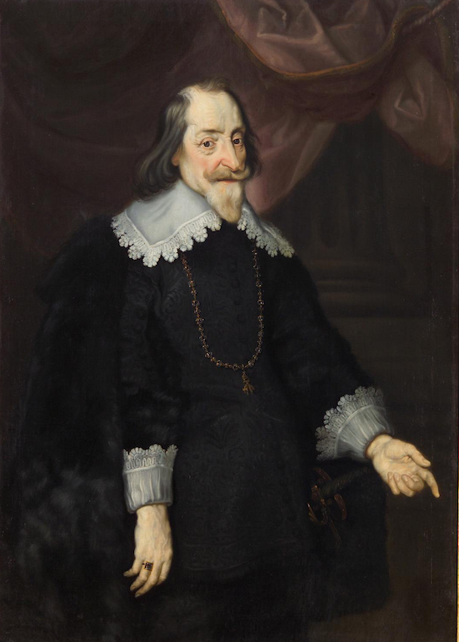

Fig. 3 Jochim von Sandrart, Portrait of the Bavarian Elector Maximilian, 1643

And he, too, looked to the ancients to provide direction to the moderns. He chose Nuremberg and Augsburg for his academies because they were free imperial cities, de facto independent countries, that with their freer constitutions promised less interfrence from the government.

3. By the end of the Middle Ages, Augsburg, like Nuremberg, had developed into one of the most important cities in Europe, an important link between northern Italy, especially Venice and the Low Countries. As Florence had its Medici, Augsburg had its Fugger and Welser. Jakob Fugger the Rich was banker to, among other rulers, the Emperor Charles the V, who could honestly say that in his empire, which literally circled the globe, the sun did not set (Fig. 4). Just about as rich was another Augsburger, Bartholomeus Welser. He, too, granted large loans to Charles V and in 1532 was made a

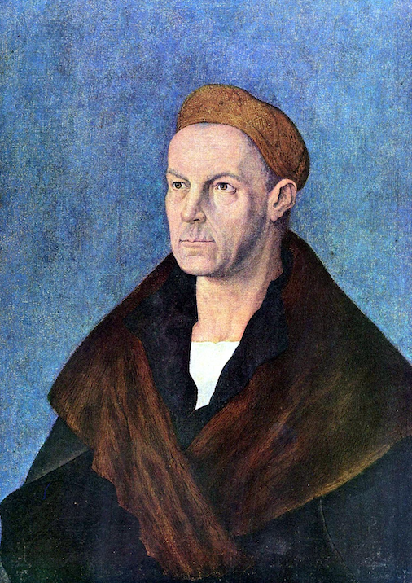

Fig. 4 Dürer, Jakob Fugger der Reiche

nobleman of the empire. In 1528 the Welsers received from the Spanish Crown the rights of supremacy in Venezuela. The first regent of the colony, Ambrosius Ehinger, explored the interior of Venezuela. Venezuela remained adminuistered by the Welsers until 1551; by legal decision it went back to the Spanish Crown in 1556. You still sense something of the former grandeur of Augsburg when today you walk down its main street or look at its city hall (Fig. 5).
It was the Jakob Fugger the Rich who founded in 1516 what is the oldest social housing project in the world, really a miniature walled city within the city of Augsburg (Fig. 6). It was founded as a place where indigent upstanding needy citizens could be
housed. The rent remains the equivalent of one Rheinischer Gulden per year (about a

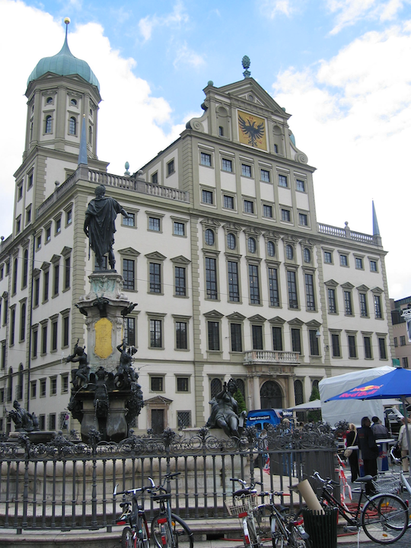

Fig. 5. Augsburg, City Hall, Elias Holl, 1615–1624

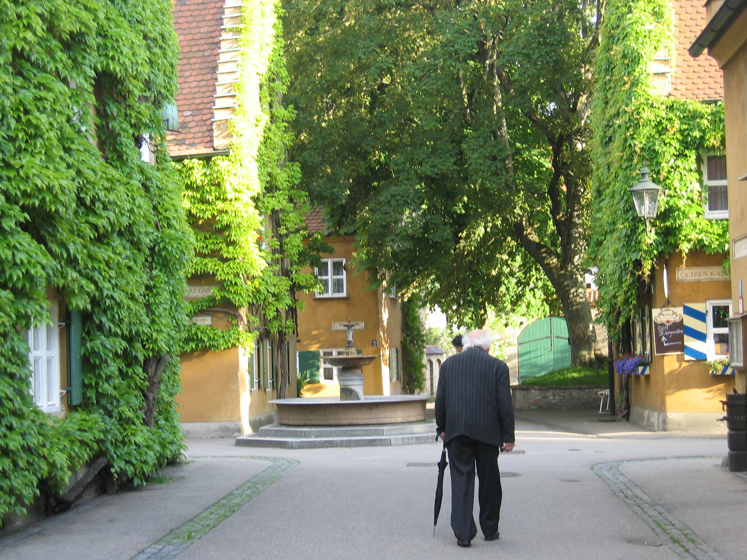

Fig. 6. Augsburg, Fuggerei

dollar), as well as three daily prayers for the current owners of the Fuggerei — the Lord's Prayer, Hail Mary, and the Nicene Creed. The conditions to live there remain the same as in the beginning: one must have lived at least two years in Augsburg, be of the Catholic faith and have become indigent without debt. The five gates are still locked every day at 10 PM.
It was the city fathers of Augsburg who saw in art an opportunity to help improve the declining economy of of the city. The city had become an important center for artful silver- and gold-work. Today you find it in countless museums. The painter’s guild too had considerable economic importance. Hans Burgkmair was the leading Augsburg painter at the time. i.e. the first half of the 16th century. Hans Holbein the Elder was another important Augsburg painter at the turn to the 16th century. Here a sketch by him of his two sons, Ambrosius and Hans (Fig. 7). The latter was eventually to become court

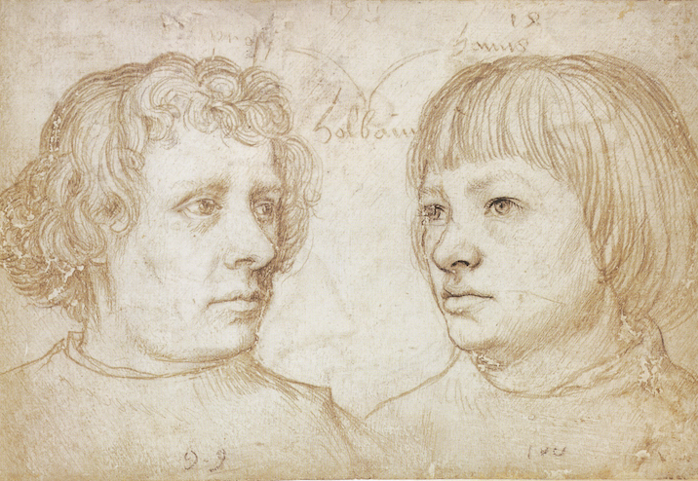

Fig. 7. Hans Holbein the Elder, His Sons Ambrosius and Hans

painter to Henry VIII. More than a century later, at the time of the Thirty Years War, the most important painter was Johann Heinrich Schönfeld (Fig. 8), but there were many other painters, including Anton Mozart (1573 - 1625) (Fig. 9).
It was in this city that Sandrart founded his academy. It took the city fathers some time to officially recognize it. But in 1684 the Protestant members of the city council, which was evenly divided between the two confessions, agreed to support the academy, which was referred to as the “Protestant Academy.” No doubt the significance that the crafts played in the econoomic life of the city were important here. In 1710 the whole council agreed to support what became now known as the "Reichsstädtische Kunstakademie," the art acdemy of the free imperial city of Augsburg, which was to be open to all citizens, and was given a home in two rooms in the attic of the Stadtmetzg (Fig.10). It now had to be given two directors, one Protestant the other Catholic. Interesting is that the Catholic directors were primarily painters, especially freco painters.

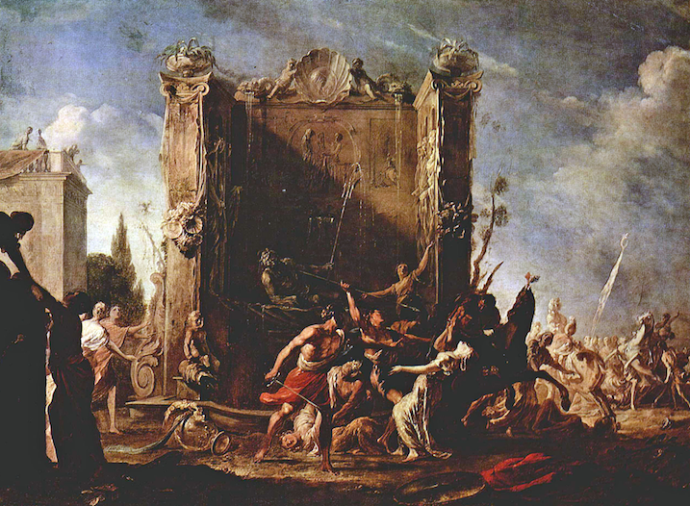

Fig.8. Johann Heinrich Schönfeld, Rape of the Sabine Women

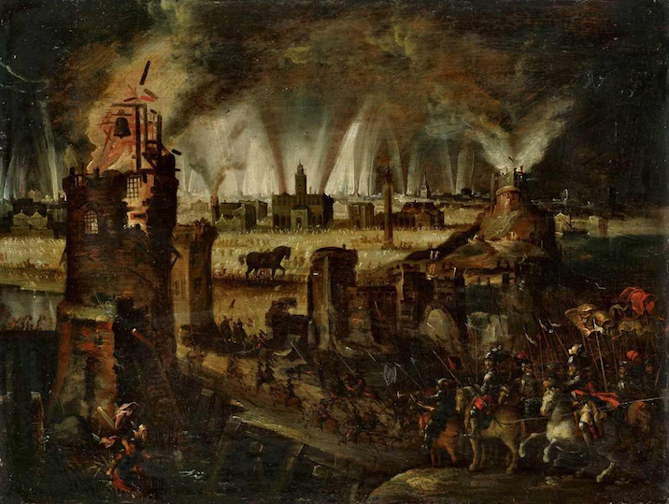

Fig. 9. Anton Mozart, Burning Troy, 1614

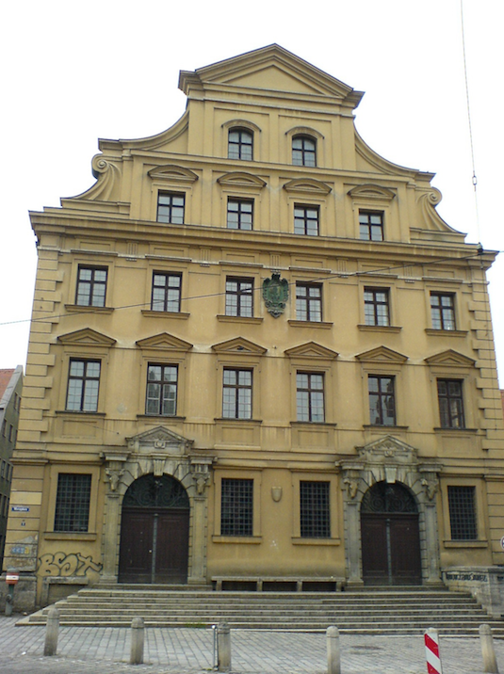

Fig. 10. Augsburg, Stadtmetzg, Elias Holl, 1606 und 1609

Their clients were first of all members of the clergy — especially important were the monasteries. The Protestant directors, on the other hand, were primarily engravers. They catered to a different audience, eager for images of important events and persons, also of curious animals or plants, and of unfamiliar places. There also was of course a demand for devotional images. But part of the function of the Augsburg artists was to inform. To some extent they satisfied a demand that much later was to be met by photography. Augsburg became the most important producer of such images in Central Europe and beyond.

4. The two most important catholic directors we have already encountered. The first is Johann Georg Bergmüller, who became director in 1730 and continued in that capacity through 1762. His most important surviving work are the frescoes in Diessen (Fig. 11). Bergmüller trained a large number of painters. I give you just one example:

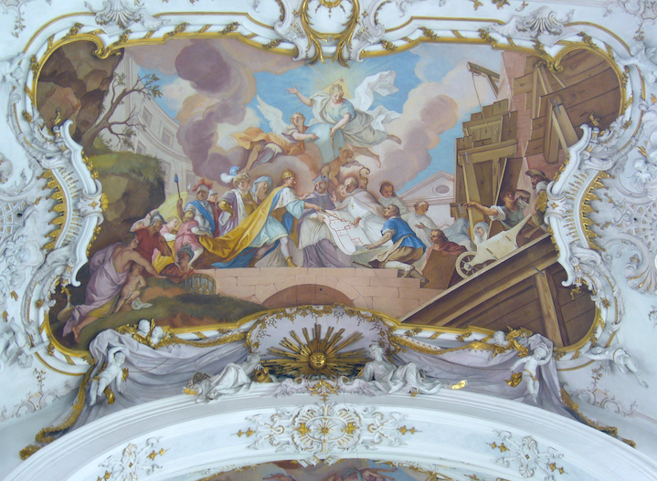

Fig. 11. Diessen, Founding of the Monastery’s Predecessor by St. Rathard, Johann Georg Bergmüller, 1736

Johann Evangelist Holzer (1709–1740), perhaps the most gifted of Bergmüller’s students. He assisted Bergmüller in Diessen. Here a detail of a fresco he painted in the pilgrimage church of St. Anton outside Partenkirchen (Fig. 12). When Holzer died, just 30, Matthäus Günther, who was to succeed Bergmüller as catholic director of the academy,

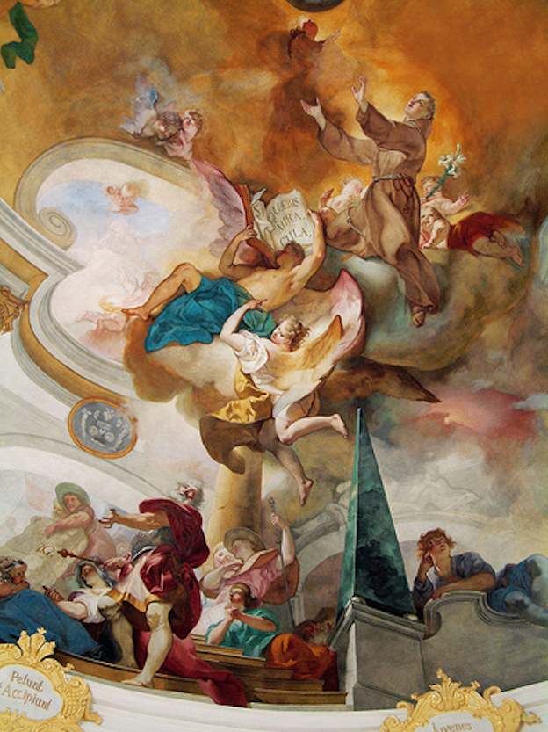

Fig. 12. Partenkirchen, St. Anton, Fresco Detail, Johann Evangelist Holzer, 1736

the sketches Holzer had left behind. Günther, director from 1762 to 1783, was perhaps the most prolific fresco painter of the Bavarian rococo. I have showed you a number of his frescoes: here once more a detail of the large fresco in Rott am Inn (Fig. 5, 19), based on a design by Holzer for the Benedictine abbey church of Münsterschwarzach (Fig. 13).

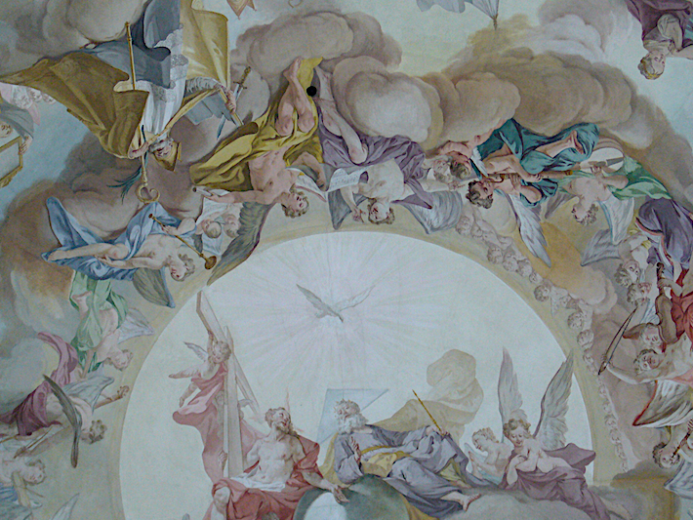

Fig. 13. Rott am Inn, Main Fresco, Detail, Matthäus Günther, 1761/1762

Holzer’s frescoes, like the splendid abbey church by Balthasar Neumann, became victims of the secularization, fire, and disinterest.

5. But here I am more interested in the graphic production of the Augsburg Academy, for it was above all this production that caused the 18th century to speak of the Augsburger Geschmack, the Augsburg taste that the Enlightenmentent detested and so vigorously attacked. Here an image that can stand for that attack, an attack more especially on rocaille, that here takes the form of a parody (Fig. 15). It was created by Johanna Dorothee Philipp, who was asked to illustrate the critique of the rococo taste advanced by the Saxon architect and theorist Friedrich August Krubsacius, who in 1764 was appointed Professor at the Academy of Arts in Dresden, and in 1776 was appointed Chief Court Architect. As an example of his architecture, here the State House in

Fig. 14. Dresden, State House

Dresden (Fig. 14), built from 1770-1775 in a reather cool, classicizing late Baroque.
In 1759 Krubsacius had published an essay in a publication edited by a leading exponent of the German Enlightenment, Johann Christoph Gottsched, in which he insisted that artists and craftsmen should use nothing for decoration that is not in accord with both nature and the building task so that everyone, including of course the artist, should be able to say why the artist made this particular decision. The artist’s invention must be subjected to the rule of reason. To show a hero resting in a sea-shell is unacceptable. It disregards proper scale. To answer that it is a grotesque or an arabesque or in the currently fashionable taste is insufficient. And to show that such an answer is indeed unacceptable, he offers the caricatured rocaille as an example and explains it with his footnotes: what is such a rocaille? According to Krubsacius a mish-mash; the footnotes explain all that is being thrown together:

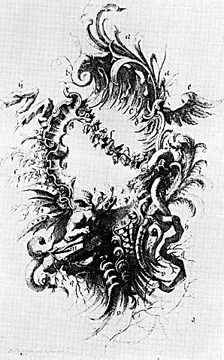

Fig. 15. Rocaille Caricature, Johanna Dorothee Philipp

a. reeds and straw
b. bones
c sherds
d. wood splinters
e. feather duster
f. wilted flowers
g broken seashells
h. rags
i. feathers
k. wood shavings
l. cut off curls of hair
m. stones
n. fish scales
o. fish bones
p. broom sticks full of dragons and snakes and other vermin, which it [rocaille] most looks like. Now some may object that this cartouche was invented precisely to make that point. I gladly admit this. Without insulting anyone I wanted to give an example that provides an abstract of today’s ornaments and I only regret that it was not drawn in an even more distorted fashion.
Note just what it is that Krubsacius objects to: not just the irrationality of rocaille is singled out, but its attraction to what he thinks is unattractive about nature, to nature in a state of decay. We sense here the proximity of rocaille and the 18th century love affair with ruins.

6. The importance of Augsburg is shown by the fact that in the 18th century the Rococo style in its entirety was often referred to simply as Augsburger Geschmack, the Augsburg taste. And the Art Academy was at the very heart of the ornamental fantasies that spread all over Germany, into achitecture, furniture making, china manufacture, goldsmith work, publishing, and much else, and that met with much resistance, not only from Krubsacius, who could claim to speak for all enlightened taste. Let me turn here to the work of one of these engravers, Johann Esaias Nilson, who in 1769 (Kant was then beginning to work out his critical philosophy in distant Königsberg) was appointed Protestant director of the art academy of Augsburg and served in that capacity until 1786. Three years earlier he had also become a member of a newly founded Imperial Academy, also in Augsburg, which represented the interests of the Enlightenment and could count Wiliam Hogarth among its honorary members.
With this in mind let me return to an engraving, dating from 1752: Wood and Stone (Fig. 16). It supports a number of the points made by Krubsacius. The German
inscription reads:
O strange nature; how delightfully you create.
With pleasure I look at you as you play.
You form wood and stone to human creations
And against stone and wood in brainless heads

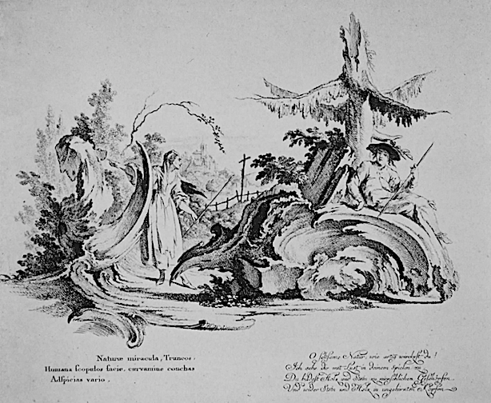

Fig. 16. Johann Esaias Nilson, Wood and Stone, 1752

There is just a hint of the erotic. Rocaille here turns to wood and stone. Here too we meet with nature in a state of decay.
The link of rocaille to the erotic sphere becomes more explicit in the following engraving (Fig. 17). Note the maypole. May is also the month of Mary.
The relationship of rocaille to nature is carried in some of the engravings to a point where rocaille has been almost totally naturalized — Here two ornamental capriccios by Gottlieb Leberecht Crusius (Fig. 18).

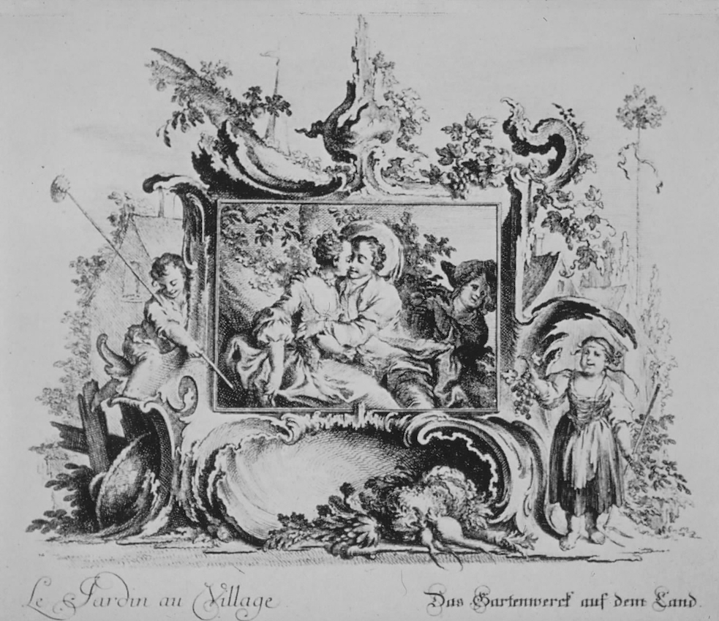

Fig. 17. Johann Esaias Nilson, Le Jardin au Village

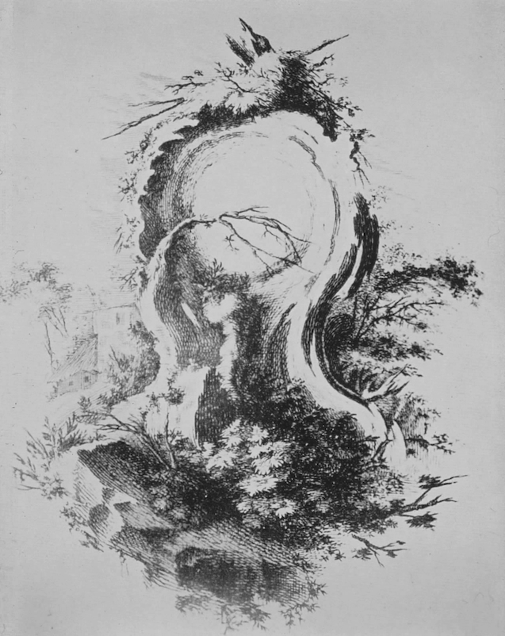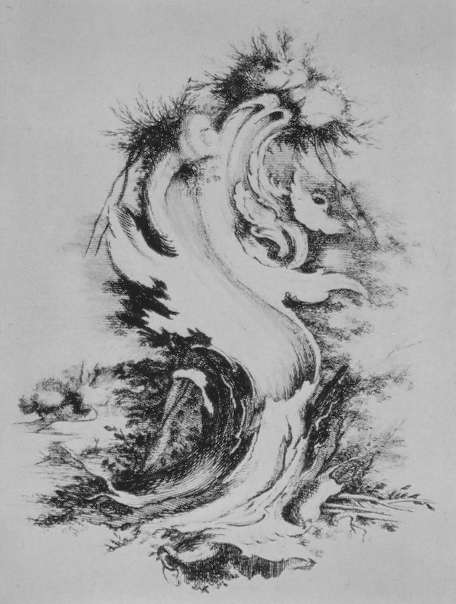

Fig. 18. Gottlieb Leberecht Crusius, Capriccio
In the San Francisco Museum of Art we find an unusually interesting engraving showing the earth by the Augsburg artist Johann Wolfgang Baumgartner. (Fig. 18).

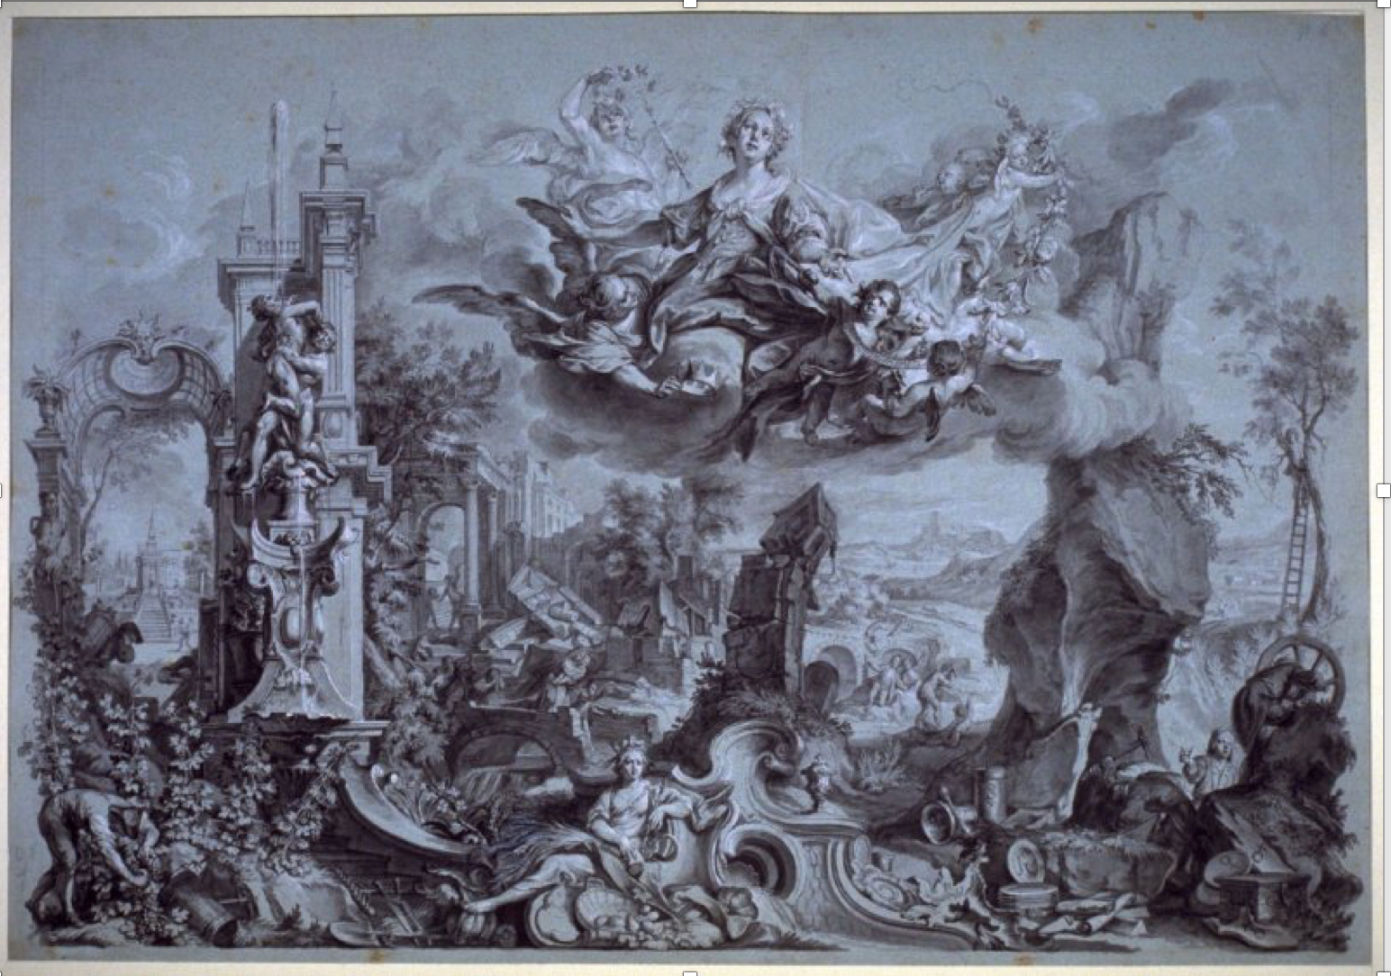

Fig. 18. Johann Wolfgang Baumgarter, The Element Earth, ca. 1750

Fig. 19. Johann Wolfgang Baumgarter, Prodigal Son With Harlots

What is fascinating about this representation of the earth is how much it suggests
quite common representations of the Virgin. And once again the prominene of ruins and nature is striking. Baumgartner, by the way, was the creator of the frescoes in Baitenhausen on which we spent some time earlier (6; 17, 18, 19). He is one of the most
interesting of the Augsburg paintters of the 18th century and an artist who derserves more
attention (Fig. 19).

Fig. 20. Johann Esaias Nilsion, Neues Caffehaus, 1756

7. Let me now return to an engraving by Nilson, dating from 1756 (Fig. 20) that I already showed you: it shows a house, not just a house, but a café, a building catering to this then often deplored, at the time a new and exotic fashion, associated with the infidel Turks. Note also the pipe. Tobacco was similarly suspect. But of greater interest than the house is the rocaille, which grows out of the frame, also represented, grows into the picture, wrapping itself around the bilding like ivy, or perhaps rather like an octopus that has found its prey. The proper order of ornament and ornament-bearer here is challenged, as is the order of frame and framed representation. Ornament and frame are here represented as essentially joined and place themselves quite literally before the represented. As the onament envelops the house, so the frame invades the picture, where the rules of proper perspective are happily subverted, a subversion underscored by the little flag atop the café, which is placed before the frame in a way that happily embraces the kind of false perspective satirized by William Hogarth in an engraving that, as a

Fig. 21. William Hogarth, False Perspective
caricature, invites comparison with the rocaille of Krubsacius (Fig 21). Nilson, in his
egraving, represents ornament pictorially as having in it essence a framing function, but at the same time calls such service into question by representing ornament as not so much servant as master, placing it on the threshold that separates and joins ornament and art for art's sake, that same threshold occupied by the pulpit in Oppolding and marked by Kant's remarks on ornament in the Critique of Judgment, which considers ornament as a self-sufficient aesthetic obejct only to later assign it a representational function.

8. That Nilson's engraving is anything but a unique example of such ornamental play is shown by the way ornament becomes architecture in Die Wies (Fig. 22) or by the altar to the fourteen saints in Vierzehnheiligen; or by the pulpit in Oppolding.

Fig. 22. Die Wies, Choir

The art historian Hermann Bauer, who follows Hans Sedlmayr, speaks of this invasion of painting by ornament as an "immoral play with the work of art."
Bauer calls the art of the Rococo immoral because, supposedly no longer able to take seriously the power of art to represent a transcendent reality, it plays with such art. This play demystifies the religious art of the Baroque, presents it as just art. "But at the same time the work of art appears to possess such power that it is able to put even non-representational ornament-forms under the spell of its illusion of reality. The result is a work of art before the work of art, a world of its own, which veils for a long time that what lies behind it has been lost. This is the irony of the rococo." Aesthetic play covers up lost religious content.
Is Nilson here celebrating or criticizing rocaille? That Nilson himself eventually came under the spell of the Enlightenment and publicly renounced his own earlier love affair with rocaille, is shown by this engraving (Fig. 23).

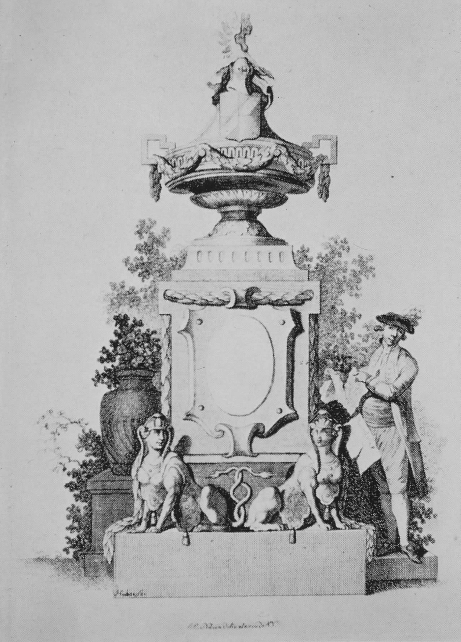

Fig. 23. Johann Esaias Nilson, The Artist Tearing a Sheet With Rocaille

10. Where did Nilson turn once he had said goodby to rocaille? A series of engravings representing the different times of day provides an answer (Fig. 24). At first these engravings, dating from ca. 1770, may seem to have left behind the Rococo:

Fig. 24. Johann Esaias Nilson, The Times of Day

nowhere is there a rocaille to be seen. Fashions had changed by then. But the change is not as profound as it may at first seem. The essence of rocaille has in fact been preserved, but transposed into a different key.
But let us consider the first of these engraving, The Dear Morning, in more detail: what attracts our attention is not so much the young woman in the window or the cowherd, who offers her his morning greeting as the strange monument that separates them: an incomplete frame supported by a crumbling base. To be sure, the erotic subtext may not be forgotten. But what is the point of the frame monument in the picture? By raising a frame on a pedestal, as if it were a statue, Nilson subverts its usual function. As already in The New Coffee House the frame is represented as an aesthetic object in its own right. Nilson thus translates conventions that had long governed the ornamental engravings of the Rococo into a more up to date classicizing vocabulary.

Fig. 25. François Cuvilliés, Ornamental Fantasy, 1750
Compare Nilson's engraving with this ornamental fantasy dating from 1750, by François Cuvilliés, the creator of the Amalienburg (Fig. 25). Here, too, a frame appears in a landscape, as if it were a thing and could share the same space and light with trees and palace. The impossibility of such introductions of the frame into the picture requires no comment. The comparison of these two engravings reveals once more the close relation between rocaille and frame or, more precisely, with a frame that is allowed to invade the picture. A look at French ornamental engravings such this engraving from Juste- Aurèle Meissonier’s Livre d’ornemens (Fig. 26), suggests that the subversion of the picture by

Fig. 26. Juste Aurèle Meissonier, Livre d’ornemens, 1734

the frame offers indeed a key to the Rococo style. Pictorial representation here suffers shipwreck on the reef of ornament. But at the same time this ornament at the edge of ornament illuminates the essential proximity of frame and ornament: both have a re-presentational function that is obscured presisely when they present themselves to us as aesthetic objects in their own right.

11. I have characerized rocaille as ornament that playfully challenges the essentially serving function of ornament, claiming something of the dignity of a self-sufficient aesthetic object for itself. Where rocaille has a framing function this means, often literally, an invasion of the work of art by the ornament, an invasion that subverts the logic of pictorial representation as it had come to be understood. And it was precisely such subversive play that enraged enlightened critics: was not the hegemony of nature and reason necessary to place all human practice on a firm base? Should art be exempted? The enlightened Reiffstein, for example, in a review of recent ornamental designs that appeared in 1746, ridicules recently published ornamental drawings. The inventive designer's "imagination" is said to have outstripped all probability. Someone who takes such liberties should be able to prove in advance that probability or the appearance of truth (Wahrscheinlichkeit) in such works of painting (Malerey) is superfluous and dispensable. Someone who had inquired into these matters with sufficient thoroughness, would, he continues, be likely to have the modesty to declare his reason captive in judging such inventions and to gratefully accept all sorts of thoughts. Rocaille ornamental phantasies may indeed be understood as the shipwreck of reason.

12. Hermann Bauer would have us understand the ornamental art of the Rococo as art that, unlike Baroque illusionism, no longer serves transcendence. But must we link what I have called the superficiality of the Rococo to a loss of transcendence? Bauer also suggests that the Rococo's, as he calls it, "immoral" play with representation is at the same time a play with the transitoriness of reality. It is this, he points out, that especially enraged the Leipzig classicists. Mourning, death, and seriousness seem to have been banished by the Bavarian rococo. According to Bauer, no ornament seems more transitory than rocaille. In a Rococo interior one believes oneself to be for a short, blissful moment witness of an improvisation of beauty. This, he suggests, is the great stylistic means of the Rococo. Just because art appears here so transitory, it intensifies aesthetic enjoyment in the extreme. With this the concept of beauty is inverted, just as is the Baroque principle of illusion.
To speak here of an inversion of beauty is to assume that beauty is properly understood only when it is thought against time. There is indeed what we call a perennial Platonism that supports such an understanding. But we should at least raise the question whether so understood beauty is not born of what Nietzsche called the spirit of revenge,
that ill will against time and its passing, which Nietzsche understood as the deepest source of human self-alienation? Is it necessary to think beauty in opposition to time, to link it to eternity and its temporal representation, the moment of absorption in aesthetic presence that in time allows us to forget time and its burden? What the art of the Rococo can teach us is to take delight in the transitory, in life. To claim that this inevitably means also a loss of transcendence is to insist that, like beauty, transcendence must be thought in opposition to time. Is this necessary? The art of the Bavarian rococo invites us to seek both beyond the opposition of eternity and time.

Fig. 25. Jacques de Lajoue, Naufrage, 1736
13. In the ornamental engravings of the Rococo, I suggested, proper pictorial representation, as understood by the Enlightenment, the kind of representration that reason demands, suffers shipwreck on the reef of ornament. Let me therefore conclude with an engraving by the French enrgaver Jacques de Lajoue, he too among the engravers criticized by Reiffstein and important to the Augsburg creators of ornamental fantasies, that playfully represents just such a shipwreck (Fig. 27). The rocaille here becomes a seascape, joining the forces of water, earth, and air in a vortex, enveloping the doomed ship, its anchor now uselessly turned skyward. That rocaille here has also an erotic significance is made clear by the nymph in the lower center. Rocaille, as Sedlmayr insists, belongs with Venus. But what place then does it have in a church? Is it not altogether inappropriate in that context? This invites a reconsideration of the relationshipo of the Virgin Mary to Venus. The Bavarian rococo, it would seem, refuses to separate them.

Hermann Bauer, Rocaille. Zu Herkunft und Wesen eines Ornament-Motivs. Phil. Diss.; De Gruyter, Berlin 1962. p. 66
Ibid., p. 63.

