Context for Partisan Gerrymandering of U.S. House Districts:
The 1970s through the 2010s
David R. Mayhew
Yale Workshop on Redistricting
November 2-3, 2018
(see Appendix B for post-election recap 12/18/18)

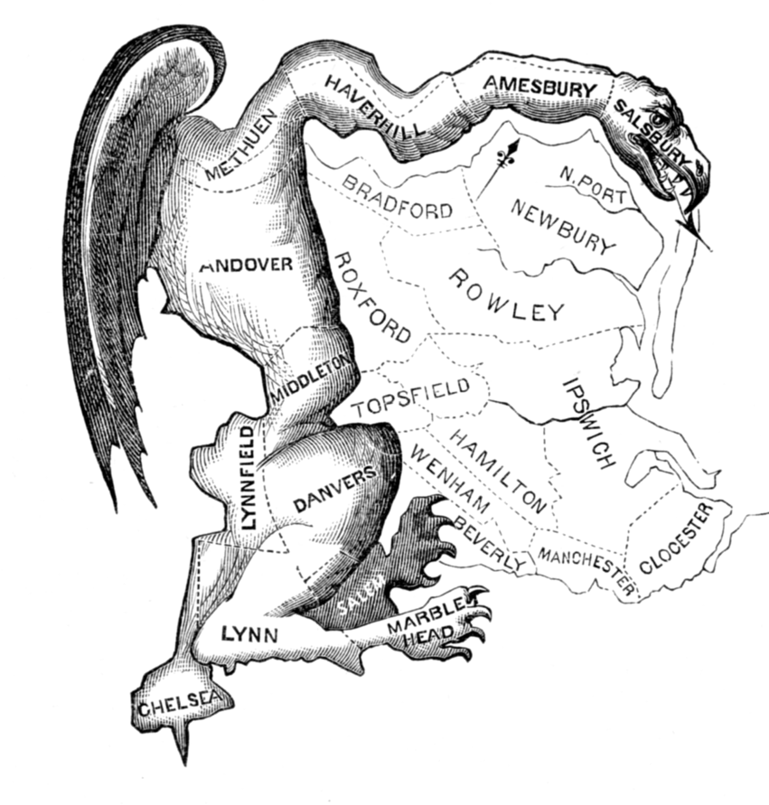
Elkanah Tisdale, “The Gerry-Mander,” Columbian Centinel (1812)

When can partisan gerrymandering take place? It is a necessary condition that a single party control all the elected branches of a government that have veto power. It’s not a sufficient condition, about which more below.

But it’s a necessary condition. Hence the possible utility of a metric clocking the incidence of that condition. In the drawing of U.S. House districts, how has such a metric played out since the 1960s? At that time, the Supreme Court shook the state legislatures into overhauling their state maps each new decade. Five times we have seen a familiar rhythm. A national Census occurs in a year ending in a zero. New district maps are drawn during years ending in X1-X2. The new maps are deployed in a November election in a year ending in X2. Generally speaking, these maps stay in place during a decade’s next four election years ending in X4, X4, X8, and X0. Often, geographic tinkering occurs after year X2, but the maps drawn in advance of year X2 have a good deal of lasting power. Lucky is the party that wins a national landslide election victory in a year ending in X0, as did the Republicans in 2010, allowing them to redraw many district maps in advance of November 2012.

Under inspection here is partisan gerrymandering. I bypass other patterns of gerrymandering, such as bipartisan deals and individual-incumbent deals, which can offer their own kinds of strategies and pathologies. At issue is thumb-on-the-scale partisan advantage.

It is worth stating that partisan gerrymandering is not a new thing. Notwithstanding the brutalism and high-tech maps of the current decade, the practice goes well back into the nineteenth century. It would be hard to beat Ohio of the 1880s and 1890s. Still legendary is Phil Burton’s California map of 1981-82—it predated computer wizardry—which helped loft that state’s Democrats from a 22-21 House seat edge in 1980 to a 27-18 edge in 1982.

The condition of single-party control needs clearer specification. Conventionally, in the American context, it means that a party controls all three of a state’s elected institutions—its governorship, its state senate majority, and its state assembly majority. But there are wrinkles. I try to accommodate them. Single-party control should also include cases where a party has two-thirds majorities in both of a state’s legislative houses, thus, assuming a conventional two-thirds veto rule (I haven’t tracked all the state constitutions on this point), demoting a governor of the opposite party into irrelevance. This supremacy was enjoyed by the Democrats in Texas in 1981-82, Alabama in 1991-92, Arkansas, Massachusetts, and Rhode Island in 2001-02, and the Republicans in New Hampshire in 2011-12. However the actual politics played out, those were the formal templates at those times in those states. Call that single-party control. Then there is North Carolina, where governors haven’t enjoyed any formal veto power at all over districting plans. There, simple legislative majorities of Democrats could ignore a Republican governor in 1991-92, and simple majorities of Republicans could ignore a Democratic governor in 2011-12. Call that single-party control, too.

For a summary portrait of House districts that have satisfied the single-party-control metric, and those that have not, see Figure 1. (See Appendix A for full dataset.) On the Y axis are Ns of House districts, capped at the full 435. On the X axis are the five biennial junctures since 1970 in which immediate post-Census redistricting has taken place. To make the district total a complete set of 435, I have stuffed a few odd cases into the residual territory at the top of the figure—the territory that exhibits absence of single-party control: Certain states (currently, there are seven) have only one House district, making partisan gerrymandering impossible. Nebraska has a formally nonpartisan legislature, making partisan gerrymandering of its (currently three) districts impossible, formally so anyway.

Figure 1: House Districts that have satisfied the Single-Party Control Metric.

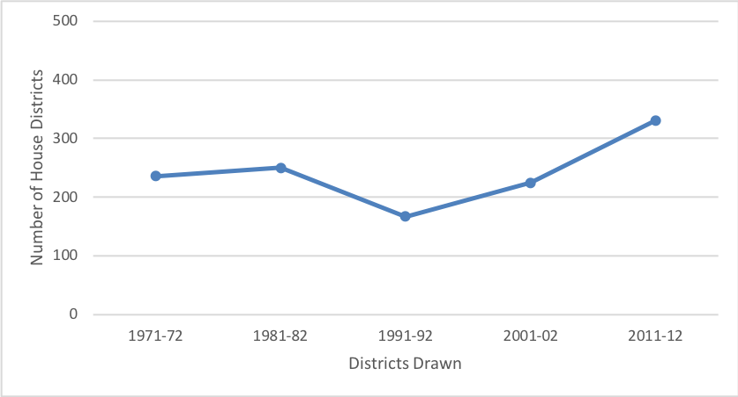
Source: Prepared by John A. Dearborn.

The gist of Figure 1: Until recently, the Ns of districts formally open to partisan gerrymandering in years X1-X2 averaged just over half the full count of the House—236, 250, 167, and 225. In 2011-12, the metric surged to roughly three quarters of the full count of the House—331.

Single-party control, the necessary condition, establishes a ceiling on partisan gerrymandering. But it is just that, a ceiling. It is not a sufficient condition. Parties are like five-year-olds in front of whom matches are placed. The kids will probably play with the matches, but they may not. They may take a pass, or they may bungle. Beyond that, parties may be impeded from self-serving gerrymandering for one reason or another. Processes or other players may constrain them. It is not possible to get anything like a precise measurement bead on the reluctances or constraints that might ward off partisan gerrymandering, even in the favorable circumstance of single-party control. For one thing, the deadly analytic factor of anticipated reactions can play a role. Suffice it to say that, in practice, partisan gerrymandering takes place somewhere nontrivially short of its formally possible ceiling as defined above. The clouding or impeding of partisan manipulation can be substantial. Here are some of the notable instances:
--In 1991-92, a new imperative to draw majority-minority districts veered the mapping strategies in many southern states.
--Iowa since 1980, Arizona since 2000, and California since 2010 have given over their redistricting to nonpartisan commissions. This is a reform trend of obvious and growing importance. It is not always clear what to make of it. Can the commissions be gamed? In Iowa that’s very unlikely, but there is controversy about California. In that state, the Democrats advanced from a 34-19 House seat edge in pre-commission 2010 to a 38-15 edge using a freshly drawn commission map in 2012.
--In New Jersey in recent decades, a commission process seems to have constrained either party from ravaging the other too badly.
--In Florida in 2011-12, how much did a preceding referendum decision aimed at purifying the line-drawing actually constrain the politicians?
--In Ohio in 2011-12, in the realm of anticipated reactions, wariness of a court challenge seems to have nudged the dominant Republicans into a bipartisan deal of satisficing appeal to the Democrats.
--Sometimes, when the elected institutions have deadlocked, the courts have taken control of redistricting. Instances include Kansas in 2001-02, Connecticut in 2001-02, Illinois at least twice.

And so on. Partisan gerrymandering does not perform up to its notional formal ceiling. That is clear. But obviously it does perform, or else we wouldn’t be having these discussions. The current decade stands out. In 2011-12, the Republicans drew ingenious self-serving maps in at least Florida, Michigan, North Carolina, Ohio, Pennsylvania, Texas, and Virginia. The Democrats did the same in Illinois and Maryland.

How does the Republican performance in the current decade stack up historically? Well, it is a new thing. At the root of it all, a Republican edge in the single-party-control metric as defined above is a new thing. It is spectacularly new. See Figure 2, which charts by party the Ns of House districts drawn according to metric’s conditions of single party control at the biennial junctures of 1971-72, 1981-82, 1991-92, 2001-02, and 2011-12. As seen here, the Democrats used to enjoy an immense advantage in matches available to play with. Now, in this decade, for the first time, courtesy of their 2010 landslide election, the Republicans came to enjoy a sizable advantage. Gerrymandering has surged as a concern during this decade, no doubt for several reasons including the sinuousness of the maps and the brazenness of the processes. Yet another plausible reason is that it is the Republicans, not the Democrats, who have lucked out in this decade’s turn of the election wheel. Not surprisingly, journalists, law school professors, and other academics have been pressing an agenda of analysis, alarm, and reform.

Figure 2: House Districts that have satisfied the Single-Party Control Metric, partitioned into which party was on top.

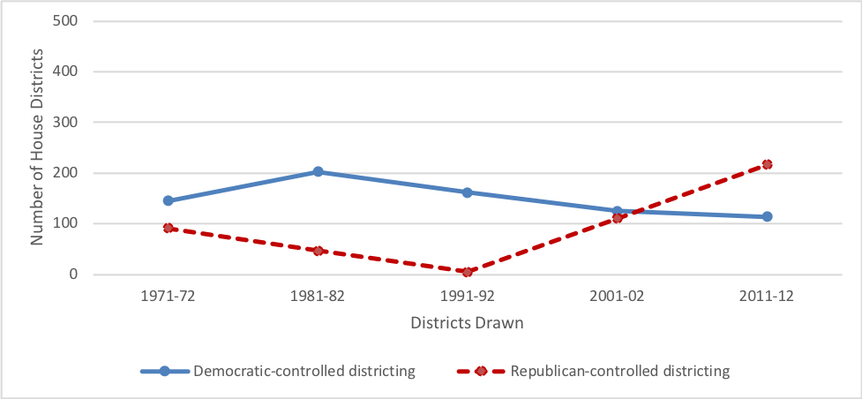
Source: Prepared by John A. Dearborn.

How bad is the problem of partisan gerrymandering at the level of the U.S. House? It is bad enough. For one thing, it helps spread an aroma of illegitimacy across the elections. Getting rid of the practice would be good. Yet note that the problem can be much worse in other domains—in the drawing of any state’s full complement of state legislative districts, or in shaping a state’s U.S. House delegation. In those cases, a whole universe of seats can be tilted one way. In contrast, at the level of the full U.S. House, there is always considerable constraint, offset, and balance. Leaving aside the various impediments to playing with the available matches, it is always true that a great many states enjoy divided party control as they draw their U.S. House districts, and that among the states that redistrict under unified party control, some will be controlled by Democrats and others by Republicans. Thus the decade-specific terrain of any party’s net possible nation-level advantage in the drawing of U.S. House districts, going by the metric employed here, compared with what can happen in redistricting a state legislature, has always been limited. For the five decades analyzed here, it has never exceeded 36% of the size of the House. See Figure 3 for the measure.
Subtracting one party’s stock of matches-are-available districts from the other party’s stock, the edges have been 54, 156, 157, and 15 districts to the Democrats’ favor at, respectively, the first four X1-X2 redistricting junctures, and 103 seats to the Republicans’ favor in 2011-12.

Figure 3: Net Party Edges in Districts Available for Gerrymandering.

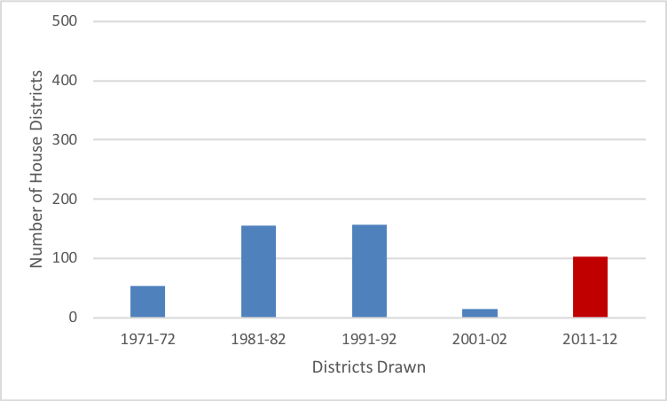
Note: All Democratic edges except for Republican edge in 2011-12.
Source: Prepared by John A. Dearborn.

Across the five decades, how have the new district maps drawn for election years X2 played out during the subsequent election years X4, X6, X8, and X0? One pattern to look for is churn, or turnover. What has been the lasting power of these districting designs? At the most general level, what share of the 435 districts have switched from one party to the other (in some cases switching back), in any of their November outcomes compared with their immediately preceding November outcomes, at any time during a decade’s four post-X2 elections? That is a question of general interest. Beyond that, what about the option of partisan gerrymandering? What happens if each decade’s universe of 435 districts is partitioned into a) those drawn under conditions satisfying the single-party metric and b) those not satisfying the metric? Yes, other independent variables no doubt butt into this analysis and swerve it. Even so, is there evidence that districts drawn under condition a) are distinctively “frozen” from churn or turnover during a decade? Or might they be less frozen? This is a fishing expedition. Do any differences at all turn up?

To confuse things, the current decade allows (as of November 1, 2018) an inspection of only its first two post-X2 elections, those of 2014 and 2016. For general illumination, the case of all four post-X2 elections is worth examining, and I do that here for the 1970s, 1980s, 1990s, and 2000s. But to rope in the current decade, I need to compare across just the X4 and X6 elections, and I do that here too. See Table 1.

Table 1: Churn/turnover in party control of House districts in the post-X2 election years of a decade.

 | 1970s | 1980s | 1990s | 2000s | 2010s
All 435 districts  --all years X4, X6, X8, X0  --just years X4, X6 | 31%  19% | 14%  9% | 25%  20% | 22%  10% | 6%
Districts satisfying the single-party control metric  --all years X4, X6, X8, X0  --just years X4, X6 | 30%  19% | 16%  10% | 26%  22% | 17%  6% | 5%
Districts not satisfying the single-party-control metric  --all years X4, X6, X8, X0  --just years X4, X6 | 33%  19% | 12%  8% | 24%  20% | 28%  15% | 9%

The results in the table are scanty. Whatever the theorizing might be, there isn’t much evidence that district “frozenness” has prevailed more often, or less often, among districts vulnerable to partisan gerrymandering as opposed to those not thus vulnerable. How does the current decade perform? So far, we see an especially low churn rate overall. Note the table’s low values in the right-hand column—6%, 5%, and 9%. Those values hinge on turnovers in 2014 or 2016 in respectively all 435 districts, the districts satisfying the single-party-control metric, and those not satisfying the metric. In this low-values respect, the 2010s resembles most closely the 1980s, whose Reagan years X4 and X6 also lacked a national “wave” election that swamped a party in power, at least regarding the House. During the 2010s, a lot of frozenness has been going on, period, regardless of circumstances of party control.

Briefly anyway, what can be said about any patterns of post-X2 partisan churn? Edgy national elections like those of 1974, 1994, 2006, and 2010 are an obvious major factor. Occasionally, for one reason or another, a state has redrawn its district lines at a juncture later than X2. The Republicans shook up the Texas map during 2003-04, netting themselves six new seats, after their historic full takeover of that state in the election of 2002. Courts can order redraws. Those have occurred in the current decade in at least Florida and Virginia, and in calendar 2018 in Pennsylvania. Districts can be showcases of ideological or demographic drift, as possibly instanced during in this decade in the party turnovers in GA12, IA1, ME2, NJ5, NY21, NC7, and UT4.

There is one striking pattern. “Open seats,” those lacking incumbents on the November ballot, are a friendly location of partisan churn. This is a calculation innocent of anything to do with conditions of party control. The causation here may be muddy, but the pattern is clear. See Table 2. Across the five decades, a range of 36% to 53% of post-X2 partisan seat turnovers have taken place where seats were “open.” The figure bounces around a bit using data for just the pair of X4 and X6 elections, but it is steadier using data for all four of any decade’s post-X2 elections. Put it this way: Nearly half the post-X2 partisan turnovers of the last half century have occurred in open-seat circumstances.

Table 2: Of districts hosting partisan turnovers, what share of the turnovers occurred in open-seat situations?

 | 1970s | 1980s | 1990s | 2000s | 2010s
Turnover occurred in year  X4, X6, X8, or X0  of a decade | 41% | 48% | 50% | 42%
Turnover occurred in  just year X4 or X6  of a decade | 39% | 53% | 46% | 36% | 42%

Appendix A: Numbers of states with single-party control after a census, and total numbers of congressional districts to be drawn within those states

Democratic-controlled states Republican-controlled states

N states N CDs therein N states N CDs therein

1970 census 16 145 7 91

1980 census 20 205 4 47

1990 census 19 162 2 5

2000 census 12 125 9 110

2010 census 10 114 20 217

Here are the lists of states along with their CD totals:

D-controlled 1970+ - AL 7, AR 4, FL 15, GA 10, HI 2, LA 8, MD 8, MS 5, MO 10, NM 2, NC 11, OK 6,
PA 25, RI 2, SC 6, TX 24
R-controlled 1970+ - AZ 4, CO 5, IL 24, IN 11, IA 6, NH 2, NY 39

D-controlled 1980+ – AL 7, AR 4, CA 45, CT 6, FL 19, GA 10, HI 2, KY 7, LA 8, MD 8, MA 11, MS 5, NJ 14,
NM 3, NC 11, OK 6, RI 2, SC 6, TX27, WV 4
R-controlled 1980+ – IN 10, IA 6, PA 23, WA 8

D-controlled 1990+ – AL7, AR 4, FL 23, GA 11, HI 2, KY 6, MD 8, MS 5, NV 2, NJ 13, NM 3, NC12, OK 6,
OR 5, RI 2, TN 9, TX 30, VA 11, WV 3
R-controlled 1990+ – NH 2, UT 3

D-controlled 2000+ - AL 7, AR4, CA 53, GA 13, HI 2, KY 6, MD 8, MA10, MS 4, NC 13, RI2, WV 3
R-controlled 2000+ - FL 25, ID 2, KS 4, MI 15, NJ 13, OH 18, PA 19, UT 3, VA 11

D-controlled 2010+ - AR 4, CA 53, CT 5, HI 2, IL 18, MD 8, MA 9, RI 2, WA 10, WV 3
R-controlled 2010+ - AL 7, AZ 9, FL 27, GA 14, ID 2, IN 9, KS 4, ME 2, MI 14, NH2, NC13, OH 16, OK 5,
PA18, SC 7, TN 9, TX 36, UT 4, VA 11, WI 8

Appendix B: Post-election recap 12/18/18

The Yale Workshop on Redistricting took place on November 2-3, 2018. That means it missed the 2018 midterm election that took place just a week later. Here is a post-election update of the paper’s data going into 2019-2020.

What is the outlook for the upcoming post-2020-Census round of redistricting? To be sure, relevant elections will keep taking place in calendar 2019, 2020, and even possibly 2021, that will affect the politics of redistricting following the Census. Many new relevant governors and state legislators have yet to be elected. Also, packets of U.S. House seats will be reapportioned across the states. But a lot of the situation is structured as of right now. Of key importance, most states elect their governors for 4-year terms in national midterm years. Thus, many governors to assume office in January 2019 will hang on through the redistricting cycle. Also, path dependence will no doubt favor many current state legislators running again in November 2000. As for the reapportionment of seats, that isn’t likely to make much difference to the parties’ new CD holdings—maybe on balance a very few seats to the GOP’s favor owing chiefly to ballooning population in Texas.

As in the logic of Appendix A, here are the figures for the single-party-control metric as of January 2019. Ns of CDs per state are as of that time (that is, not the projections for 2002+).

Democratic-controlled states Republican-controlled states

N states N CDs therein N states N CDs therein

January 2019 15 167 20 191

D-controlled – CA53, CO7, CT5, HI2, IL18, ME2, MD8, MA9, NV4, NJ12, NM3, NY27, OR5, RI2,
WA10
R-controlled – AL7, AR4, AZ9, FL27, GA14, ID2, IN9, IA4, KS4, KY6, MS4, MO8, NC13, OH16,
OK5, SC7, TN9, TX36, UT4, WV3

I hope I got all this right. As the coding rules allow, NC is classified as GOP because its R legislature can dominate a veto-less D governor, and KS as GOP because its 2/3 R legislature can override a D governor.

Generally speaking, on the redistricting front, the Republicans survived the 2018 midterm pretty well. Keeping the governorships of AZ, TX, FL, GA, OH, and IA helped. Also, compared to the situation in 2011-12, the GOP will now control in single-party terms a surprising total of six states that it didn’t fully control back then—AR, IA, KY, MS, MO, WV, chiefly southern and border states. Still, the Democrats did score major gains in the 2018 election. Compared to their holdings going in, they won full control of NY, they captured the IL governorship, and they won the governorships of MI and WI, thus switching those two rust-belt prizes (as with PA earlier in the 2014 midterm) out of the GOP column into the divided-government column.

Beyond all this, it is worth mentioning that voters seem to have erected new impediments to the chicanery of single party control, bipartisan commissions and such, in a number of additional states including apparently CO, MO, OH, and UT.

All told, the Republicans as of January 2019 will thus enjoy a net 24-seat edge (191 minus 167) in the single-party-control metric, compared with their 103-seat edge (217 minus 114) in the wake of the 2011-12 redraw that heralded the current decade. It is well to keep this GOP 24-seat edge in perspective. It pans out as 6% of the total House membership. That’s all. Once practical reality enters in—that is, once the various non-pathways to partisan gerrymandering line up—the glitches, the legislative deadlocks, the commissions, the inventive legal constraints (as now in Missouri?), the armies of lawyers, the intrusive judges, the alarmed media, not to mention just plain abstention from edginess by the parties—this formal 6% GOP edge in the arithmetic must be worth pretty close to zero.

An afterthought. My focus in this paper is the formally necessary condition for partisan gerrymandering. Among other things, I wanted to point out that that this condition is routinely not met. A can’t-do-it condition of divided party control has blanketed roughly half the CDs of the country at line-drawing time through the 2000s, albeit somewhat more than that in the 2010s. It is important to see this limitation. It is equally important to see that a necessary condition runs far short of signifying a sufficient condition. It is an outer-boundary condition. To find out what has actually happened, where and when and how, in the many redistricting contexts that have formally satisfied the single-party metric yet not actually given rise to partisan gerrymandering would be a back-breaking empirical task. Spotty at best is the existent secondary literature on the topic across the five decades.

Yet one comment is in order. Readers of Figures 2 and 3 might have scratched their chins. What’s going on with those Democratic edges in the single-party-control metric before calendar 2000—bonuses that were enormous in the 1980s and 1990s? Is it the “solid South”? Didn’t the Democrats have a lock on everything down there, thus rendering partisan gerrymandering gratuitous and unattempted? Maybe the region’s Democrats had no cause to play with the matches. So perhaps the single-party-control metric is irrelevant? Well, not really. For purposes here, I don’t see any reason to treat the South as if it existed on some other planet. At the level of U.S. House districts, the South was in play. From 1950 through 1990—that is, before the Republican explosion that hit the South in the 1994 midterm—some 65 southern CDs elected a Republican member of Congress at one time or another, including at least two in each of the eleven ex-Confederate states. Yes, the Democrats did ordinarily control the South’s state governments, but they had plenty of GOP targets to aim at. For example, they nearly wiped out Newt Gingrich after the 1990 Census. In North Carolina and Virginia, partisan blood feuds over districting in the Appalachian area went back a century. One analysis of redistricting after the 1970 Census hinges on “the seven states [anywhere in the country] which gained or lost House seats in reapportionment and which passed partisan district plans.” Three of the seven were in the South—Alabama, Florida, and Tennessee.

Sources on the party-control patterns: On 1970+, Richard G. Niemi and Laura R. Winsky, “The Persistence of Partisan Redistricting Effects in Congressional Elections in the 1970s,” Journal of Politics 54:2 (May 1992), 565-72, chart at 568. On 1980+, Andrew W. Robertson, “American Redistricting in the 1980s: The Effect on the Mid-Term Elections,” Electoral Studies 2:2 (1983), 113-19, chart at 121. On 1990+ and 2000+, FairVote Archives, online. On 2011+, chiefly Michael Barone and Chuck McCutcheon, The Almanac of American Politics 2014 (Chicago: University of Chicago Press, 2013). Otherwise, scattered internet sources for occasional fugitive data.
This particular calculation hinges on the first instance of any seat’s partisan turnover post-X2 during a decade. That is, I ignore here any subsequent change in a seat’s party outcome. I regret that this open-seats analysis needs a tune-up. I have ignored the rat-a-tat of off-calendar special elections to vacated House seats. Those are not all that many, and I doubt that including them would affect the results much, but they should be accommodated.
Peverill Squire, “Results of Partisan Districting in Seven U.S. States during the 1970s,” Legislative Studies Quarterly 10:2 (May 1985), 259-66, quotation at 259.

